1. **What is coupling?**

Normally you will get this question as what is coupling or what is high coupling.  
In order to understand what coupling is, we need to understand what dependency is.So dependency is an essential functionality, library, component service or even a piece of code that is necessary for different parts of the system to work.

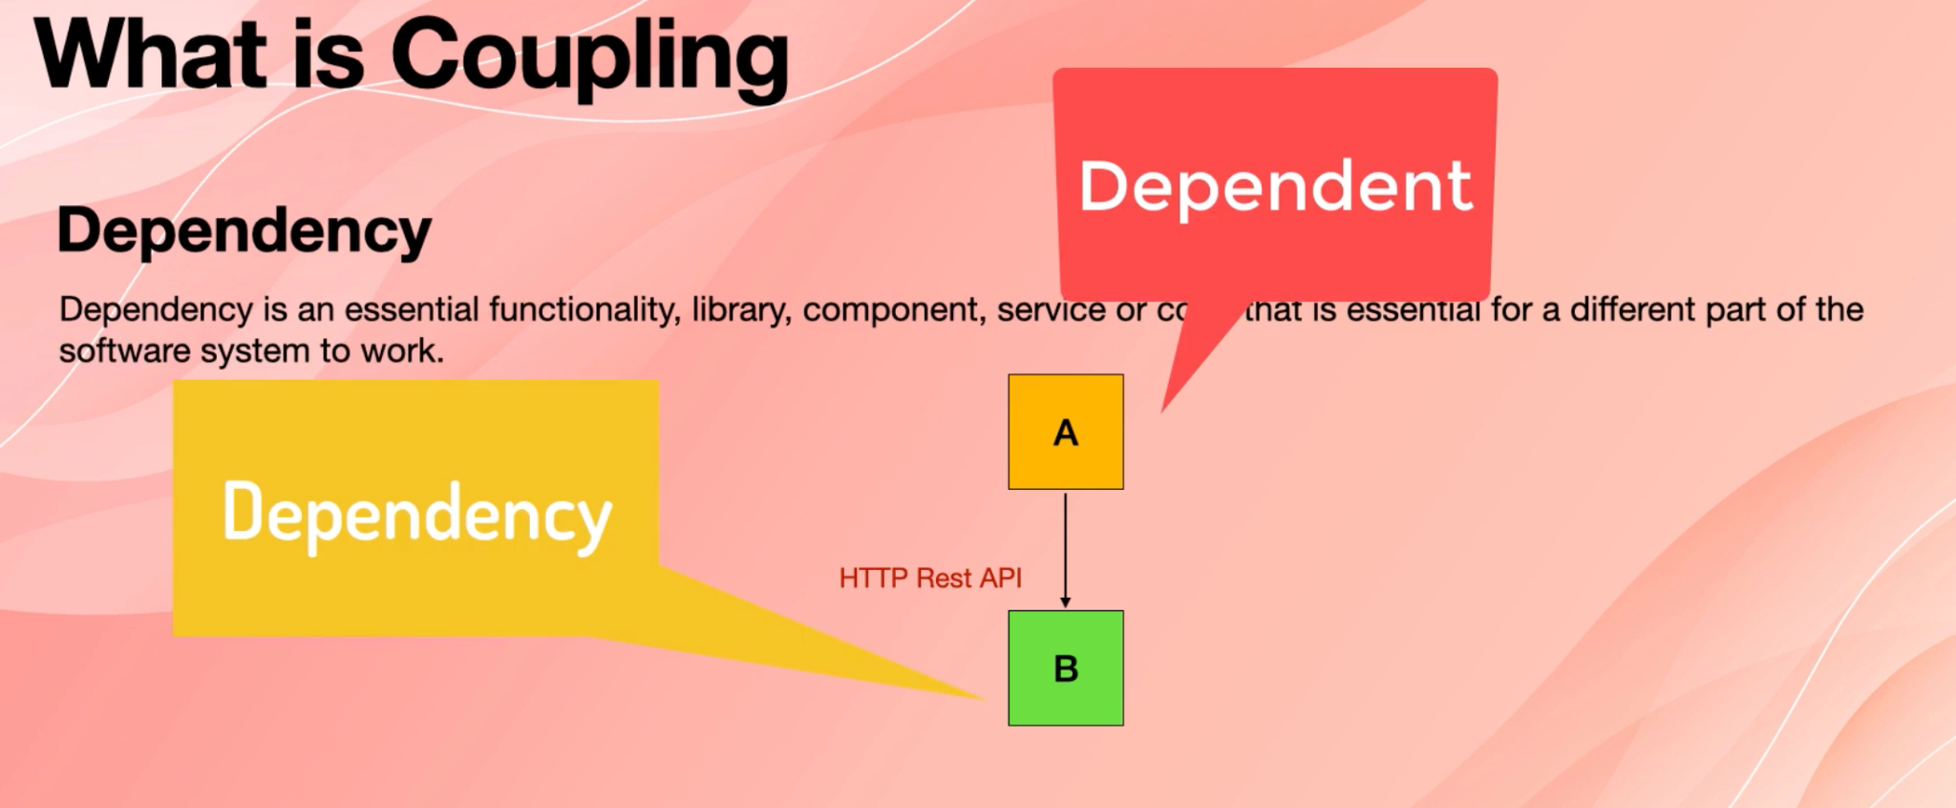

Imagine in a software system, we have two components or two services called A and B. Now A is dependent on B. If we remove B, A cannot work anymore.

So there are different ways that we can use b.For example, if B had restful APIs, then A could make call to those restful API.Now, if we removed B and replaced it with another component that implemented exactly the same APIs with same contract and same everything, A would continue using that API and it still would work.

So as you see, there is a dependency but dependency isn't too strong.

Now, if B wasn't an API, if it was a library file, if you don't know what the DLL is, it stands for dynamic linked library. And basically, Windows is made of thousands of dynamic linking to libraries. They are just compiled and packaged binaries.

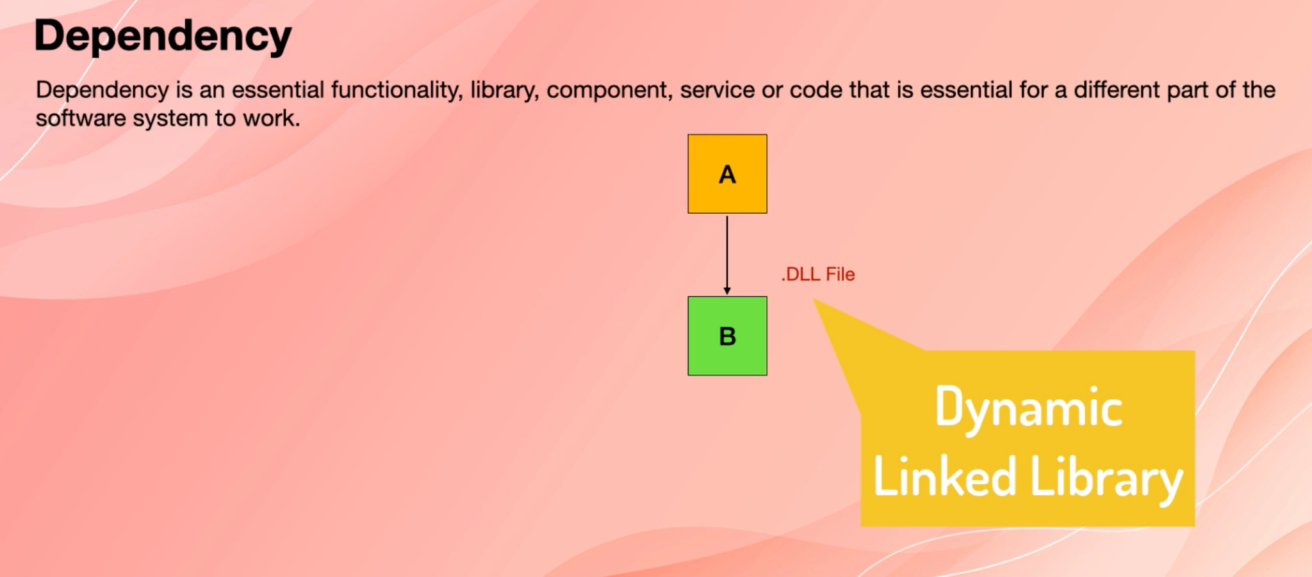

If B was .dll file, A would have to have a code to import to B and then import its function and use them. So if you wanted to replace B with something else, then you would have to change A. So as you see, a dependency would be stronger here.

So from this, **we understand that coupling is a degree of interdependence of software modules, components or services.**

So when we say coupling, that means that how strongly two things are dependent on each other, so high coupling simply means too much dependency.

Like I said, when B is a dll, then you need to change A in order to replace the B. So that means that there is a high amount of coupling or dependency there.

**So obviously high coupling is not a good thing** .So if you get asked in the interview that what is high coupling, you will say that means there is too much dependency and we cannot replace or change one system without replacing or changing their dependency system as well.

And that's not a good thing, obviously. So the aim in software design is always low coupling.

Remember this phrase, a low coupling.

Types of couplings:

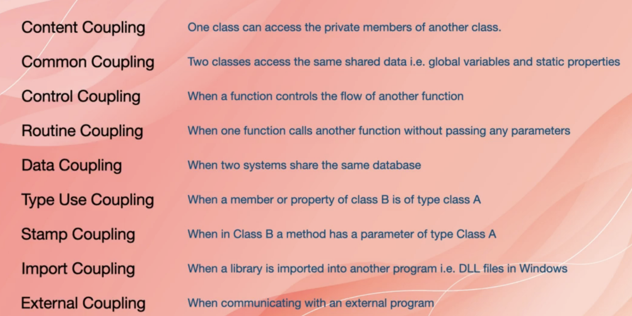

Example

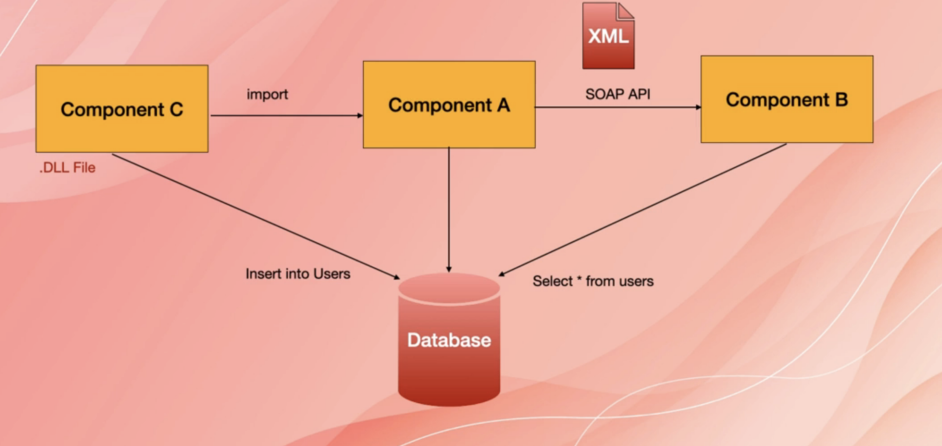

So this is one example of some of these couplings. It doesn't cover everything.

So what we see is one software system. The whole thing belongs to one software system, and there are three components of that software system. We have component A, component B and component C.

As you see, all these three components are using a shared database. So component C inserts records into a table called the users and then Components B has a command that says, I want to query that user table with select * from users.

Now, if we change the structure of the user's table because Component C needs to insert one more field or column, then component B is going to break because that column might be added or removed. And then the query is going to fail and component B is going to fail.

So as you see sharing one table or one database for that matter, between more than one component is a high coupling problem.

And another problem here is that Component C is a DLL file and Component A has imported that DLL to use it.

Now, as we said before, if component C gets replaced with something else, you need to change the code in Component A to accommodate for that.

So that is the high coupling and Component B is providing an API, but that API is a soap API.

If you don't know what soap API is, it's basically there is an XML file that defines the signature of all the methods in that API and how authentication works and data types and everything and both the dependent and dependency which means Component A and Component B have to use that example and generate classes and data types so that they can talk to each other.

Now, if we change that example, both Component A and Component B have to change their code. We have to go and modify them to accommodate for that change in the XML file.

You see it in legacy systems and restful APIs have replaced that because there is no dependency on that intermediate XML.

**2. What is Cohesion?**

Another question that is related to software engineering and also is related to microservices is what is cohesion and do we want high cohesion or low cohesion?

**So cohesion is a degree to which the elements of a module, a software or code are related or how they are directed towards performing a single task, how well they work together to achieve a goal.**

**So that means that high cohesion is good** because that means that the elements or the parts of a system are better directed towards a single task.

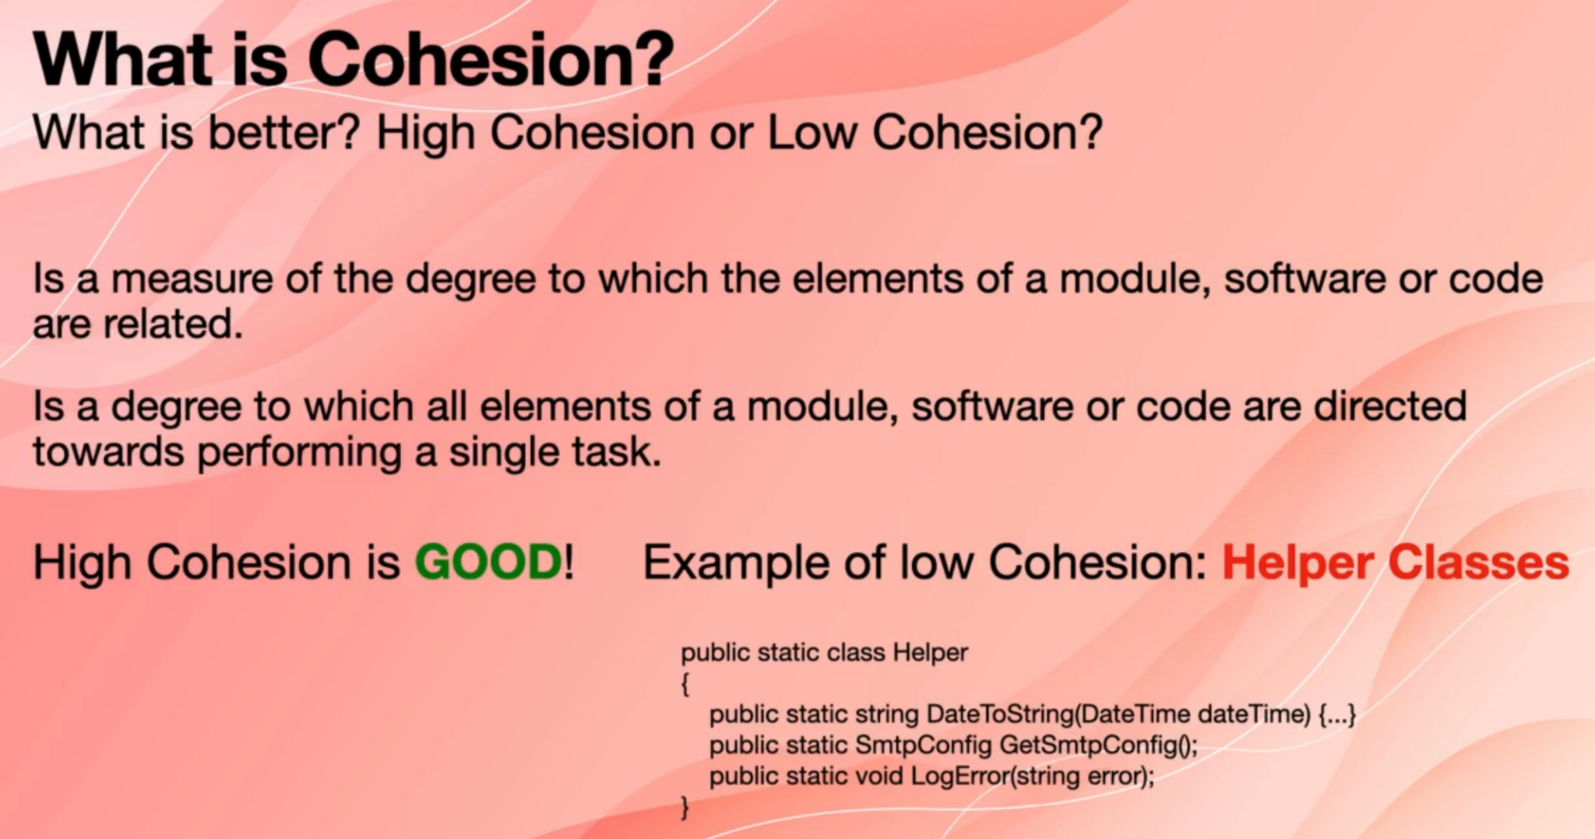

An example of low cohesion is helper classes that are supported in many languages, such as Java and C Sharp.

Let's look at this hypothetical example.

So here, I have a helper class that has some methods. The one method is date to string, it converts a date to a string or a text. The second one is a SMTP config, which is a class type, and the method name is get as SMTP config. It probably reads a config file and then returns an object of SMTP config. And the third one is log error. It logs an error message to a file or something.

So as you see, one class has three methods, and those methods are not related.

One method for converting data showing another one is for logging and error.

And as you see, they are not really related. So there is a low amount of cohesion in that helper class. It would be better to have three different concrete classes with different methods. One would be about conversion of types together.One would be about logging and the other one would be about reading config files.

And then there wouldn't even be a static and the less you use the static classes in your code that's the better solution. You could use something like dependency injection to inject the concrete classes to the consuming class.

Low amount of coupling is also good. We don't want low cohesion and we don't want high coupling.

**3. What is microservices?**

What is a microservice or what are microservices or what is a microservices architecture?

So we talk about microservices normally as opposed to a monolith or monolithic applications.So microservices is an architectural style.

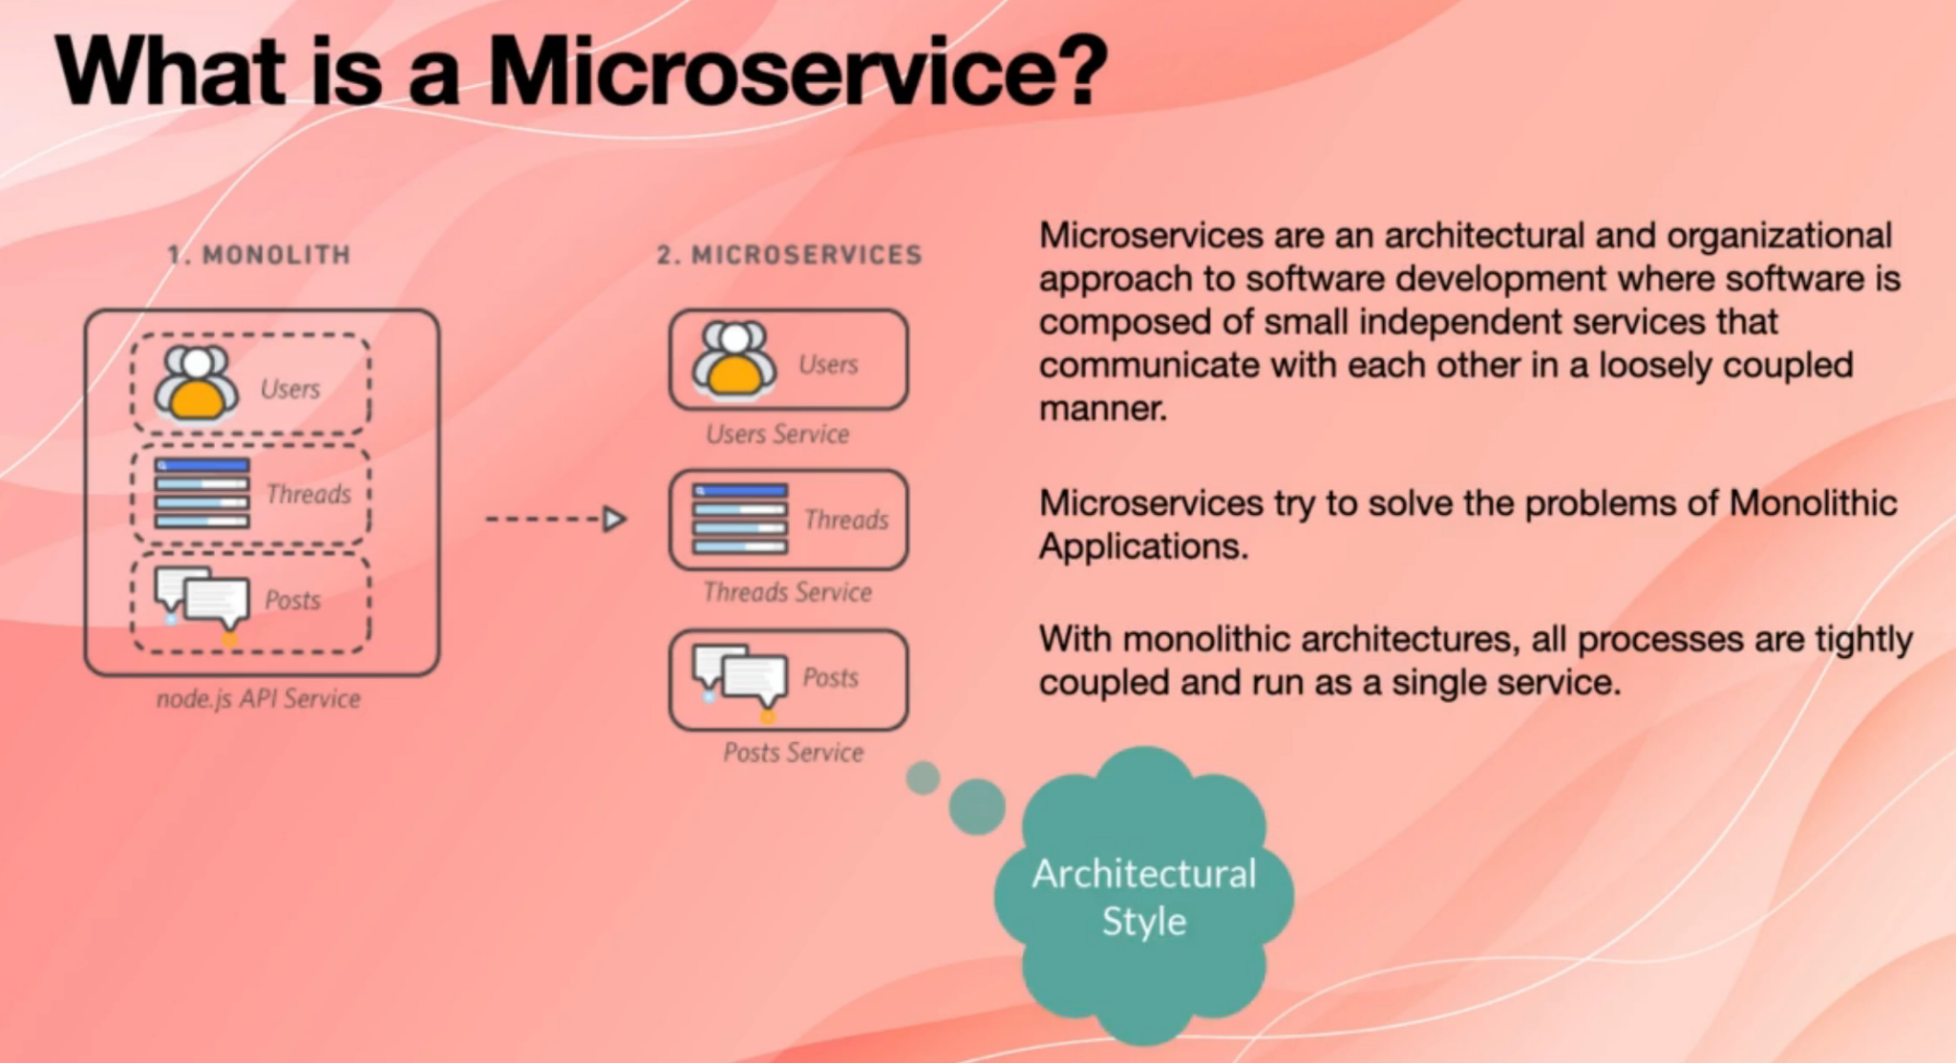

When you get asked about what microservices are, you have to say microservices are an architectural style or approach, and this approach or architectural style was introduced to address most of the problems of monolithic or monolithic applications.

**In monolithic architecture all processes are tightly coupled and run as a single service.** So different processes are part of the same code base. They share a memory and they may share a database, and they access and different classes access each

other. For example, they might access a single global variable, or they might have static properties that they can access. So they are tightly coupled and also their cohesion is low normally because you have everything dumped into that one huge code base and there is not enough organisation. And even **if you start writing a monolithic application when it grows, then you may just lose the track of keeping everything organised and it turns into a soup of different types of services and code.** So that is the problem with monolithic applications..

**In microservices** we try to organise things a bit better, and **what we do is that we turn every component or every process into an individual and completely independent service that runs and executes separately. And it has its own memory and it has its own database. They just communicate with each other through a network.**

If you want to give a proper answer to this question, you can say **microservices are an architectural and organisational approach to software development, where software is composed of small, independent services that communicate with each other in a loosely coupled manner.** So two things in here, as you see this description, says that microservices are architectural and organisational approach, and what we learn from this is that **microservices architecture also affect the way an organisation works because you will have to form teams around each service and that affects how your organisation works**, and we will go through this in later questions.

And also, if you go on the internet and Google Microservices, you might see that microservices communicate through APIs. I haven't mentioned it in this way.

That is because APIs are only one way of communication between microservices.

There are different ways, so it's better to say that they communicate through a network or through the internet in that loosely coupled manner.

**4. What are the benefits and drawbacks of monolith application?**

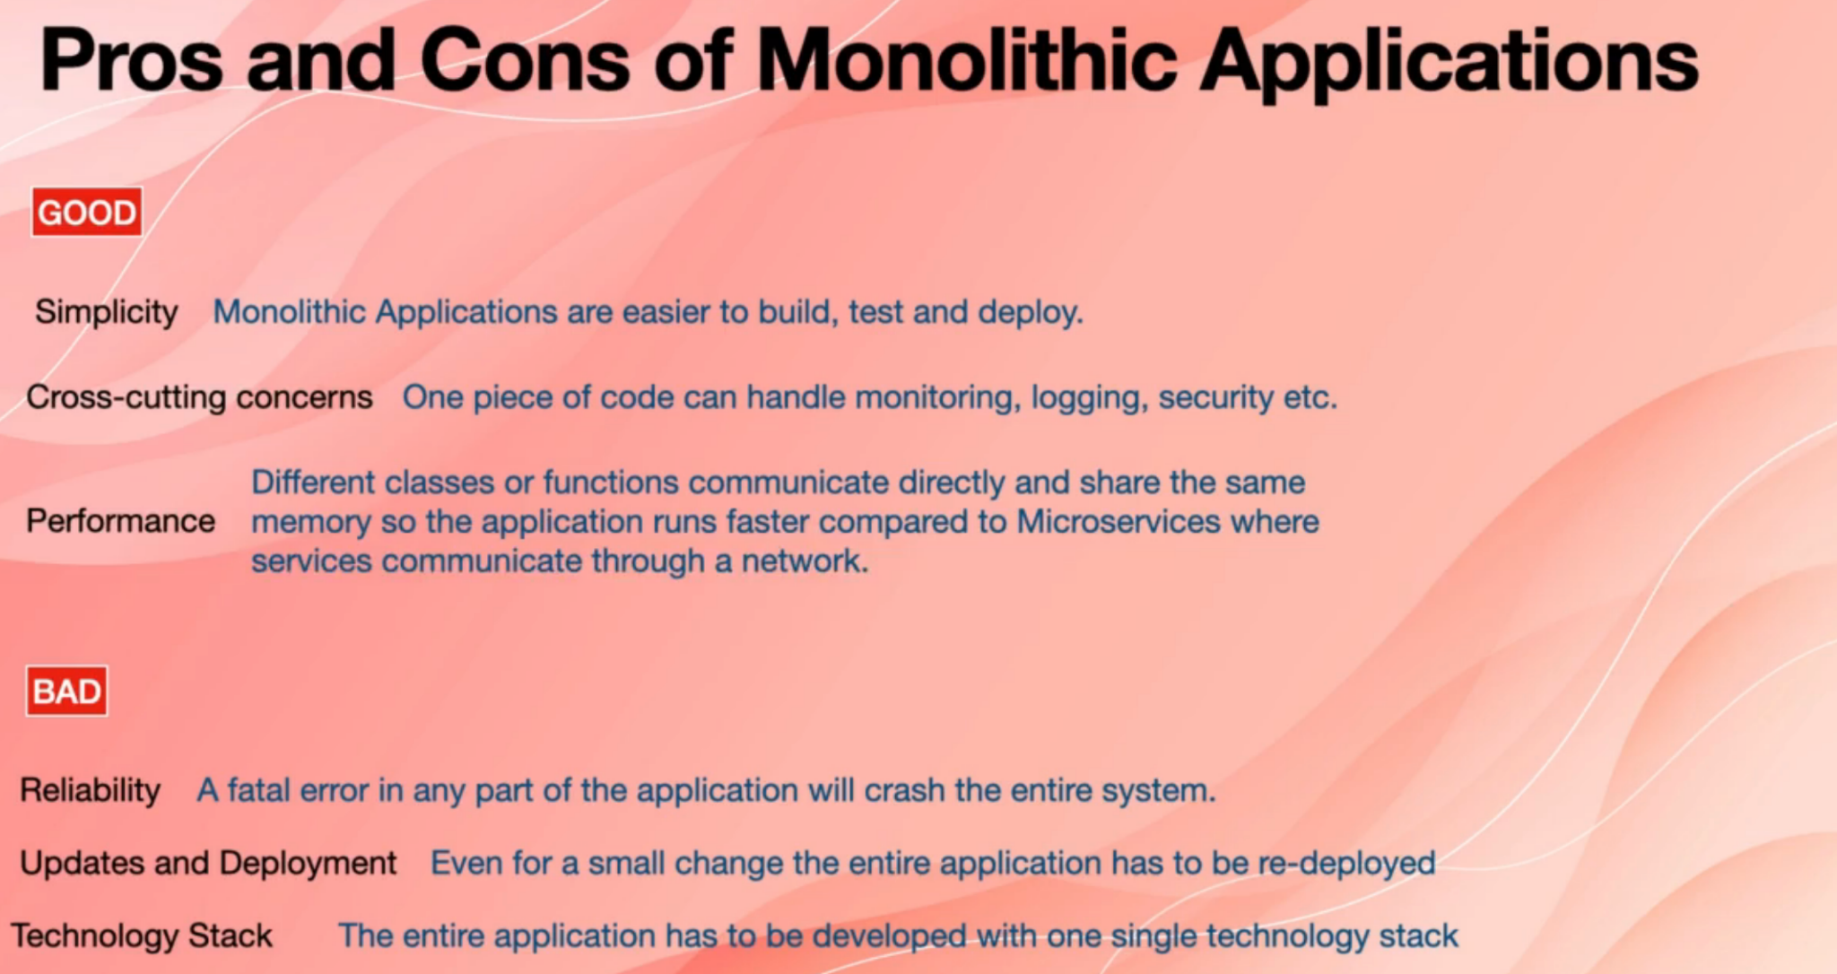

So what are the pros and cons of monolithic applications or what are the benefits and drawbacks of monolithic application?

You may also get this question, as do we always want to use microservices architecture.

The short answer is NO, because there are benefits for monolithic applications.

So to understand when we may use monolithic applications or monolithic architecture, we need to understand what is good about that.

A monolithic architecture or monolithic application has the benefit of simplicity.

Those types of applications are easy to build, test and deploy. Because you write everything in one application, there is probably one Github repository. When you test, you test one piece of code and when you deploy, you deploy everything at once.

It has cross-cutting concerns that means that you probably have only a few classes to check for security, logging and monitoring authentication, and you can use that across the entire application.Performance is normally better compared to that of microservices because again, everything is in one code base. Different processes and different parts of the application share the same memory. They can access each other's variables and data in memory much, much faster compared to when they are physically separated and they have to communicate through a network via, say, APIs.

But what is bad about monolithic applications or what are the downsides of microservices?

One of them is reliability, if there is a fatal error anywhere in the application, it's going to crash the entire system. Whereas in microservices, we design them in a way that if one microservices crashes, the entire system doesn't crash and it can somehow continue working until that one dead microservices can recover. Updates and deployments are also a problem because even for a very small change anywhere in the application, you have to redeploy the entire application. Also technology stack is a problem because the entire application has to be built with one single technology stack, for example, with Java or .NET or Node.js.

If you are in a position in a tech company that you need to hire developers, you know how hard it is now to hire developers if you just want to limit yourself to one technology stack. It's going to be very hard and very expensive to build a team. So microservices architecture allows us to build different teams that use different technology stacks

and build different microservices based on different technologies stacks, for example, of some microservices might use Node.js, some may use Python, some may use

.NET.

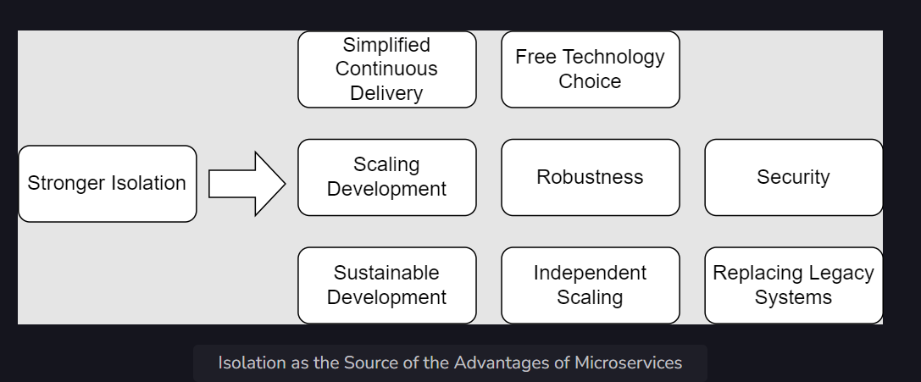

**5. What are alternatives to monolithic applications?**

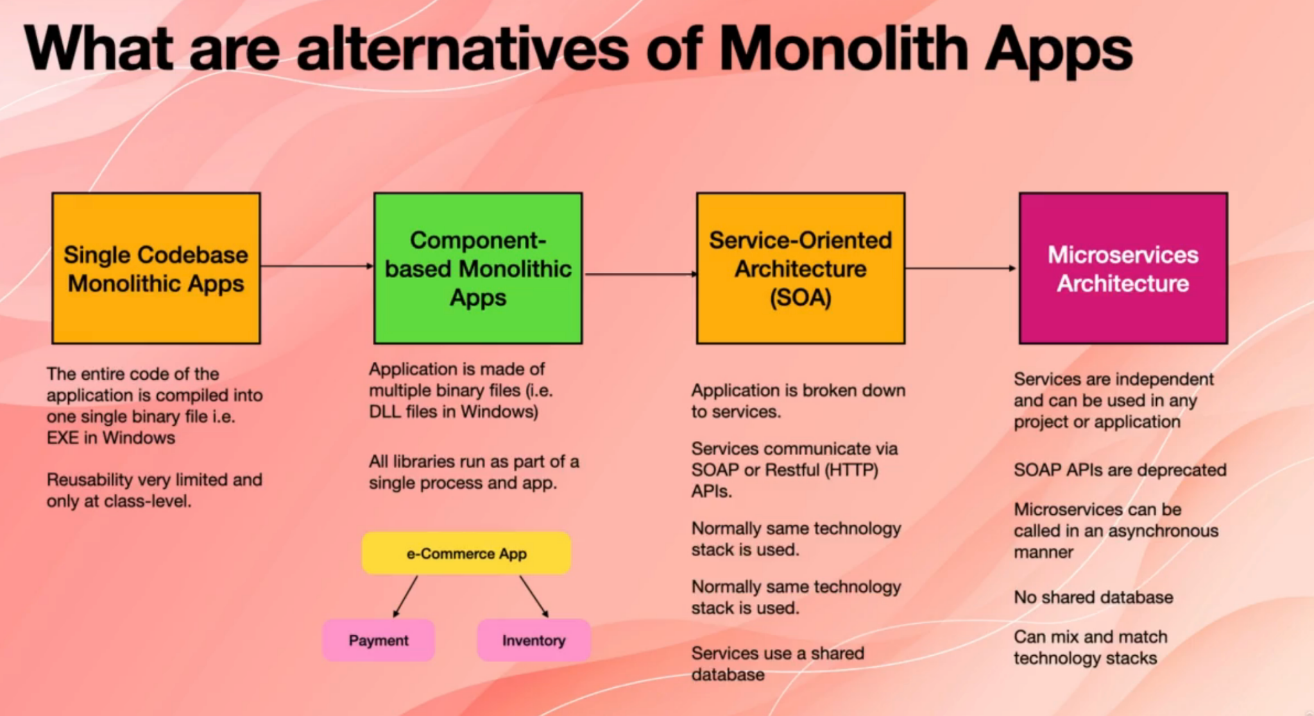

**6. What are the benefits of microservices architecture?**

So what are the benefits of using microservices architecture when we use microservices architecture?

Because **every microservices is like a mini application and it is completely autonomous and independent, we can deploy them independently.** Thus if we need to make a change in part of the system, we only make that change in the relevant microservices and then we only deploy that microservices. We don't need to deploy the entire system.

Microservices also **can be scaled out independently.** When we say scale out, it means that we will have more instances of a given service. For example, say you have a system made of payments, microservices and then product microservices and then shopping cart microservices. So when users come to this website, all of them will need to pull their products from the database and see them. But only a percentage of those people will add some products to their shopping cart, and only a few people will actually go to payment and buy the product. So if we get, for example, one million users a week who come to the website and they visit their products, we need to scale out the microservices that are for displaying their products, for pulling the products from the database and providing them to their website. But we don't need to scale out the payments because only a small percentage of people probably finish the checkout and go on the page.

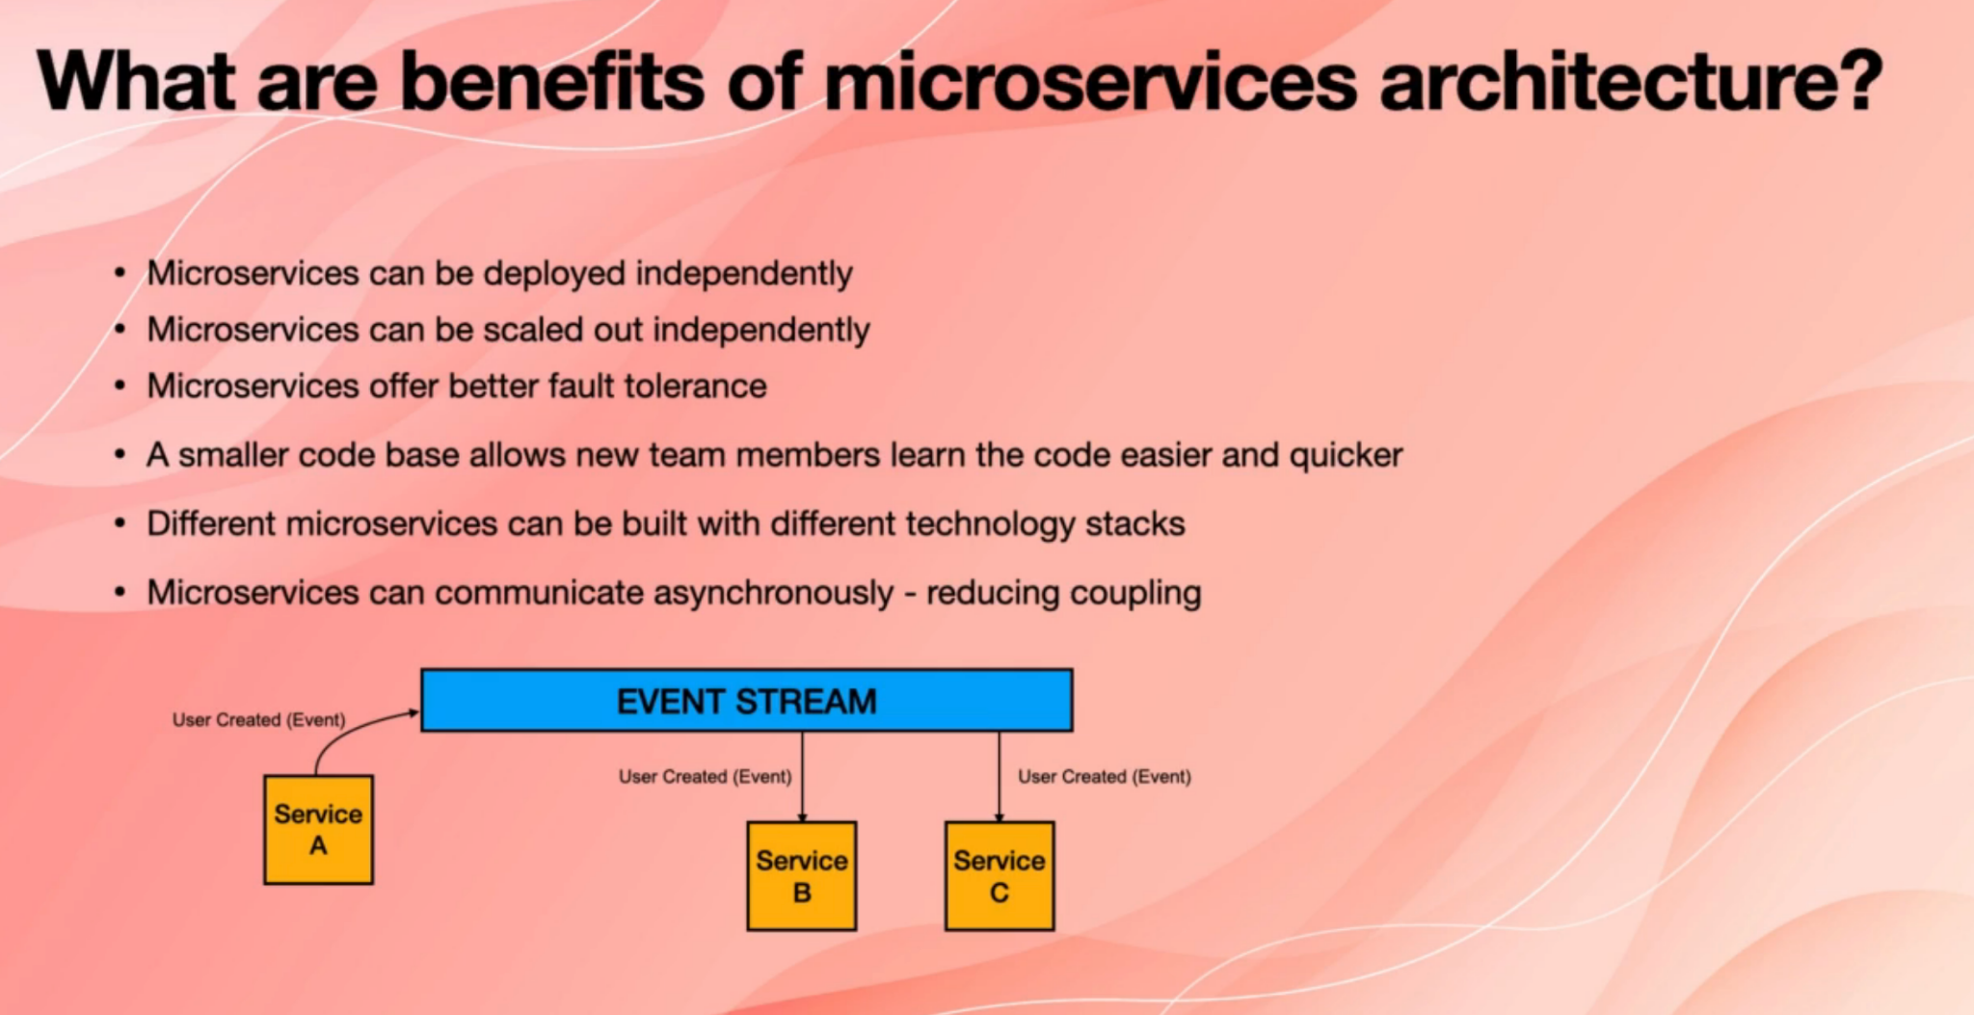

Microservices also **offer better fault tolerance**, and that is again due to the fact that every microservices is independent there is a concept called blast radius that you will see later.

So when we manage the blast radius properly, if a microservices fails, the other microservices will still manage to do work.

Maybe not ideally, but then they will still be able to do their job to some extent, and then the entire system won't crash. And because every microservices is small compared to a large monolithic application, and because normally one team looks after one or a handful of microservices when a new person joins the team, it's easier for them to understand the code and get the hang of it.

Also different microservices can be built with different technology stacks. We talked about this one microservices can be locked into another. Microservices might be built with Python, and that gives you flexibility in choosing developers and creating teams.

Another benefit is that microservices **can communicate asynchronously**. When we say microservices communicate asynchronously, it means that they don't call each other's API

directly. There is no point to point API call. So, for example, we have service A which needs to communicate with Service B and C or B C. If Service A wanted to make a call directly to Service B, then service A would be dependent on Service B, there would be a coupling or dependency there. So to remove this situation, normally we have something like an event streaming system in place.For example, a Kafka is one of them, or you can have a message by something like RabbitMQ.

So in case in an interview, you'll get asked, "What do you mean by that?

You can have an example. So service A to avoid making a direct API call to service answered B C publishes an event to the event stream.

For example, if Service A is responsible for signing up new users, it just

publishes an event which is imagined like a piece of JSON documents with some properties to the event. The Streams and Service A doesn't care who is going to receive this event.

Just say, Hey, this event happened now. Anybody who is interested in that service, for example, Service B and Service C, they subscribe to their event stream and they pull this stream from the event stream.

**7. What are the drawbacks of microservices?**

We mentioned the benefits of microservices, let's also talk about drawbacks of microservices. So microservices based systems are more complex to design and build because you will need to design more components, you will have to make sure that their boundaries are well designed. The way they communicate is efficient.

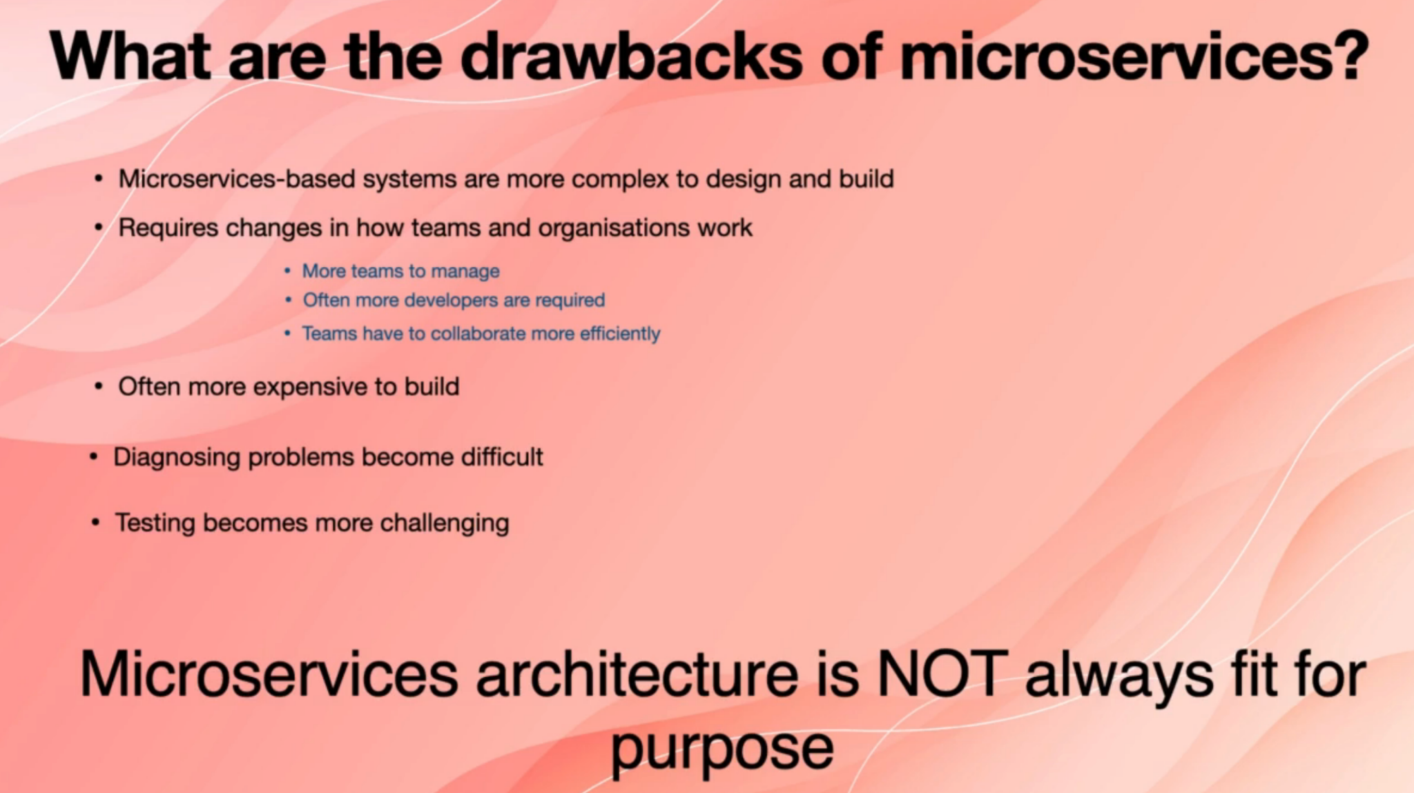

And also, you need to understand how you are going to monitor this system when it works. And also, you need to make changes in how teams are formed, how teams work, and also how the entire organisation works. Because as we said before, every microservices is maintained and managed by one team or every few microservices

are owned by one team, and therefore the way you form your teams will be different.

So you will end up having more teams normally, and you will obviously need to manage more teams because you have more teams.

Obviously, you will need more people because every team member has to be specialised in a couple of microservices and then teams will have to be very efficient in communication because you have to make sure that the teams adhere to the reference architecture and if they want to deploy, the other teams also know what's going on. So they need to be in sync.

And often microservices based applications and systems are more expensive to build because you are obviously dealing with more people, more complex CI/CD and also some components that you may need in a microservices based application.

One example is the event of streaming that we talked about in the previous lecture.

They don't exist and they are not needed in a monolithic application so that extra infrastructure will incur more costs.

A big downside of microservices is that diagnosing and debugging problems becomes more difficult, especially if you have a production problem where there is no source code, it's a lot harder to pinpoint the root cause of problems when you use microservices, because in a large application, you can, for example,

get their copy of databases, run it locally, traced that code in microservices.

You don't know which service is causing the problem, or maybe some merchant services together are causing the problem. So it's harder to pinpoint the root cause of production problems.

And likewise, testing becomes more challenging because when you are building a system, for example, from scratch, some services may be reduced, some may not be ready. And also, if you want to report bugs and chase the bugs, you will need to deal with more teams. So the bottom line is that microservices architecture isn't always fit for purpose. It's not always the ideal solution.

It's not one size fits all solution.

You have to compare the pros and cons or benefits and drawbacks.

And then based on that, decide if this architectural style suits your application, your project and your company.

**8. How do microservices relate to business?**

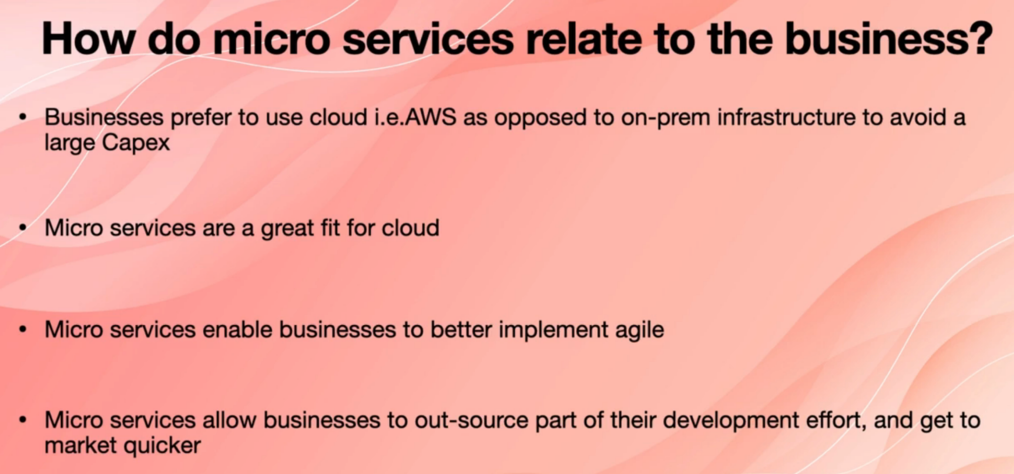

**9. Name some design patterns and tools used in developing microservices.**

Sometimes in interview sessions, the interviewer may ask you to name some patterns or tools that we use when we develop microservices, and normally the purpose of that question is to basically break the ice and start questions around things that you know, rather than things that you may not know.

These are just examples that I'm providing to you. If throughout the course you come up with patterns and names of tools that you can remember easier by

all means remember them and use them.

So one of the things you can mention is event streaming. We talked about the event streaming in the previous lecture and the one before, and we said that one example is Apache Kafka. Message brokers are similar to event streams. They are not the same thing, but they are similar. We will see them in the future lectures. One example is the Apache Active MQ.

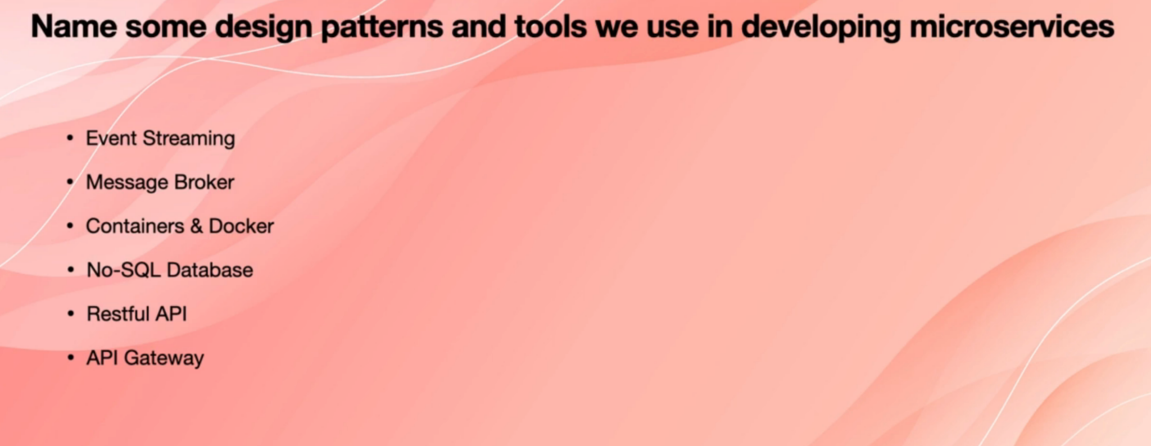

Containers and docker are important. Containerization refers to when we package the binary files and everything that a microservice requires into a container and deploy it to a docker or to something like k8s.

No SQL databases are common in microservices, and we use them normally to store the events that we pull from, and have a copy of those events.And that helps with reducing the blast radius.

And also, obviously restful APIs are very common and useful. If you want to query and other microservices connect to it, get some data directly. You can use restful APIs.And as I said before, now, if you want to use APIs, we use restful APIs.

Soap APIs are not common anymore.

And the last one is API Gateway, which is a very important part.

And that is used when you want to provide access to a given micro service to outside systems or people.

**10. What are major components of microservices architecture?**

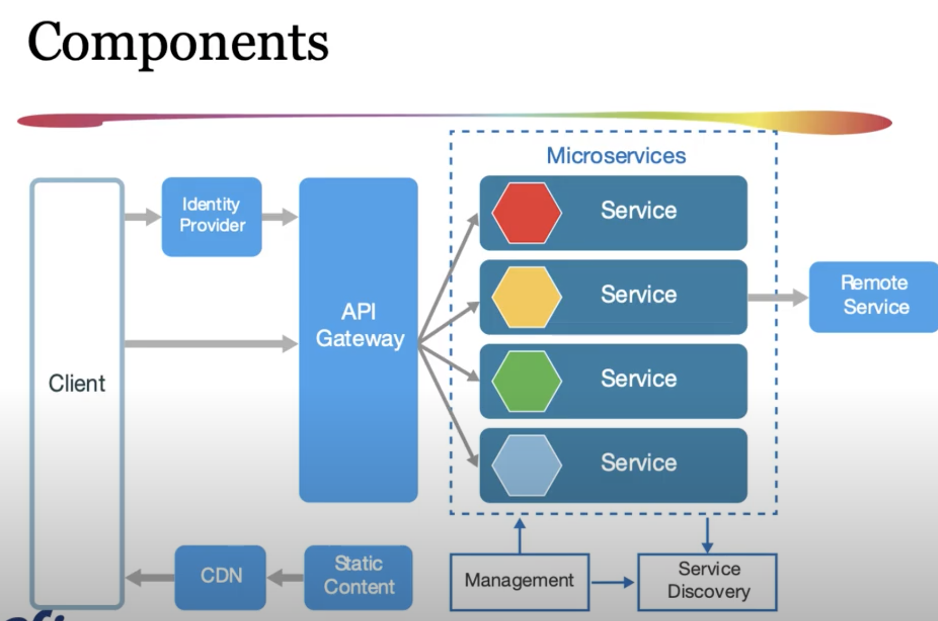

1. Microservices

The main component of microservices architecture is the self-contained services. They can be any language and function separate from one another, making them ideal for implementation through various software teams. There is also the service mesh. It's responsible for the communication between microservices via a messaging layer.

2. Containers

The containers are a package of software that functions independently. Containers work to isolate each service in the same environment. In order to create microservices, a virtual machine can serve as a container and simulate the functionaries of a standard physical computer. Containers provide efficiency because they only rely on specific dependencies and the underlying code within the service. Containers also provide resource-efficient means to package services and give developers various deployment alternatives. Additionally, container orchestration tools like Kubernetes provide automating scalability and container management.

3. Service Mesh

The service mesh offers a layer of infrastructure that provides additional security and makes for more predictable behaviours in terms of communication. The service mesh also uses a **sidecar pattern** and utilises sidecar proxies to provide dynamic messaging. This setup allows the developer to forego having to use code when creating portions of the application.

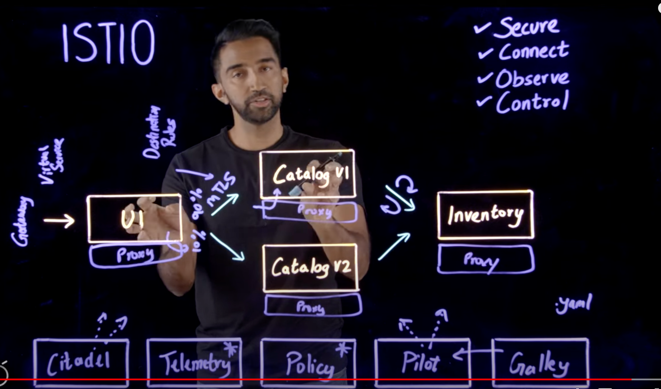

4. Service Discovery

Service discovery is a mechanism that allows application and microservices to locate each other on the network. The components of service discovery involves service registry, service registrar. The registry contains a dictionary of service vs its address on the network, the registrar is responsible for adding/ removing services from the registry, checking which services are alive on the network and updating their statuses to ensure smooth inter service communication. If you use k8s then this is inbuilt and you don’t need to take care it.

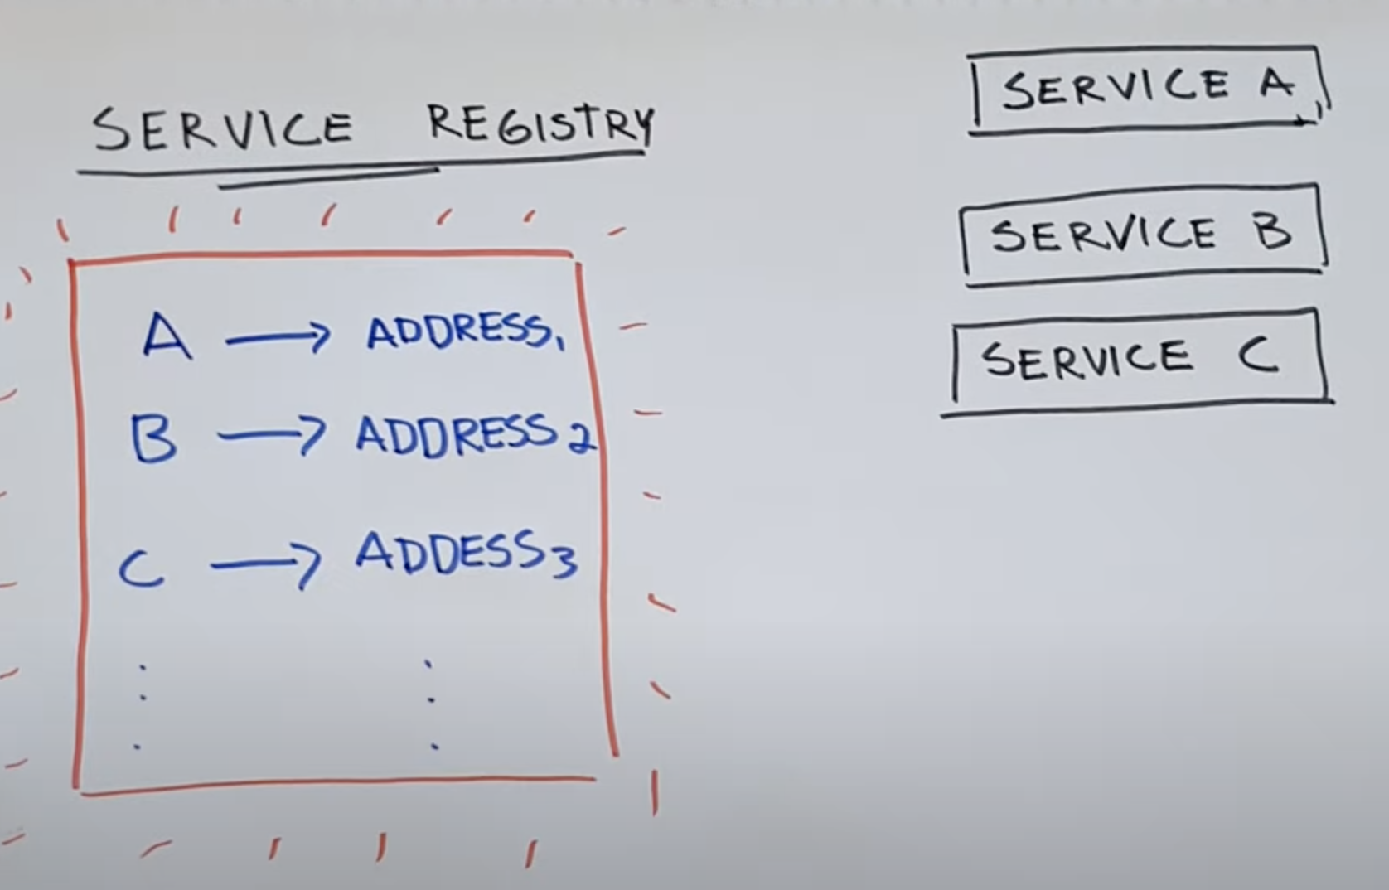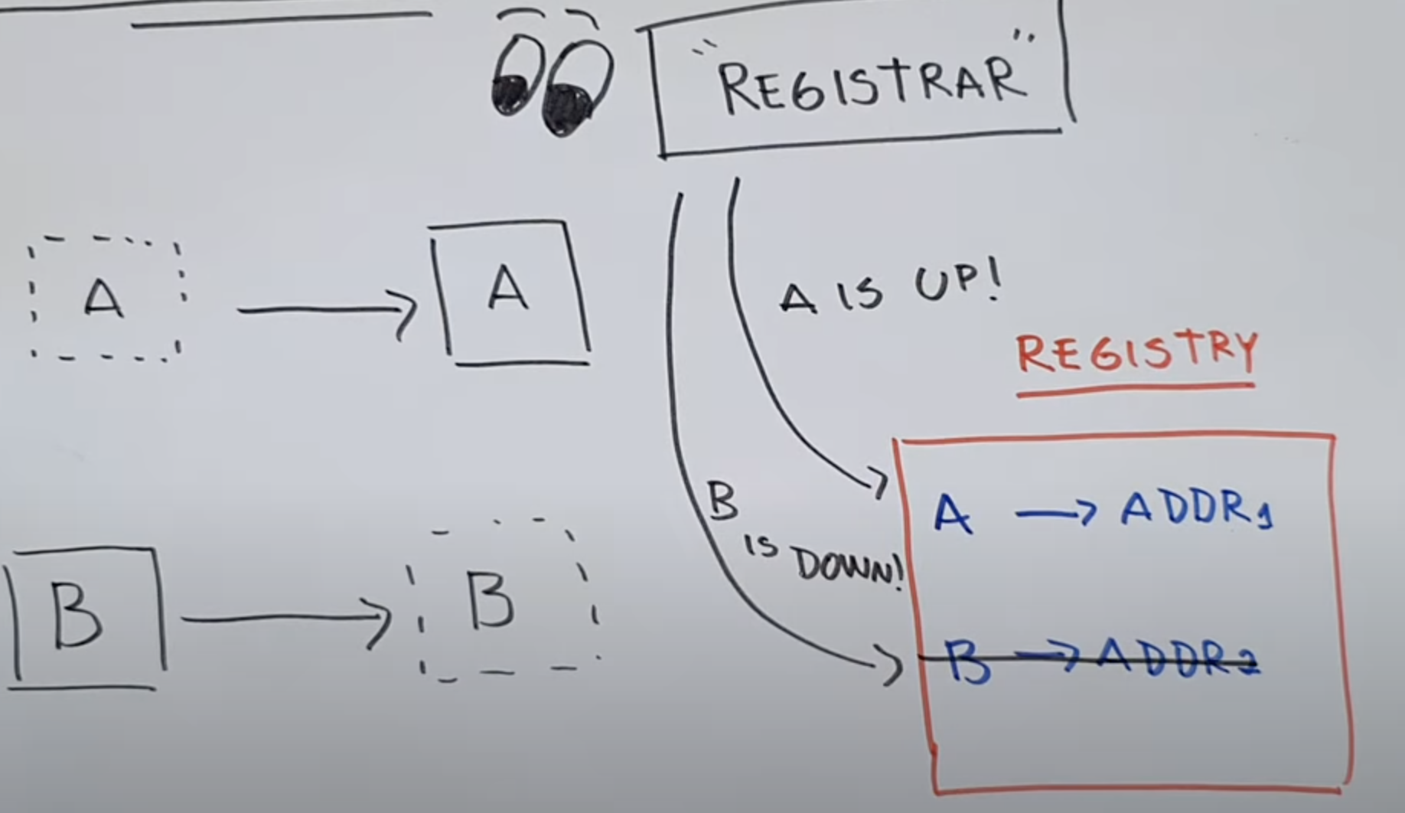

5. API Gateway

The API gateway is an essential part of communication in the complex distributed microservices architecture, it can handle administrative tasks, ensure the microservices load is lightweight, and perform load balancing actions when necessary. The API gateway also allows for faster communications between clients and microservices. This setup differs from SOA, or service-oriented architecture.

11. **What are blast radius and resilliancy in microservices?**

So basically, the concept of blast radius refers to how badly the entire system will be affected if one microservices crashes or becomes unavailable. In monolithic applications obviously, the blast radius is 100 percent. If parts of the application encounter a fatal error, for example, you would divide a number to zero if you don't do any error handling and your entire application will crash. If the database becomes unavailable, either because it crashes or because there is a network misconfiguration or it gets overloaded. For any of those reasons, the entire application is going to stop working.

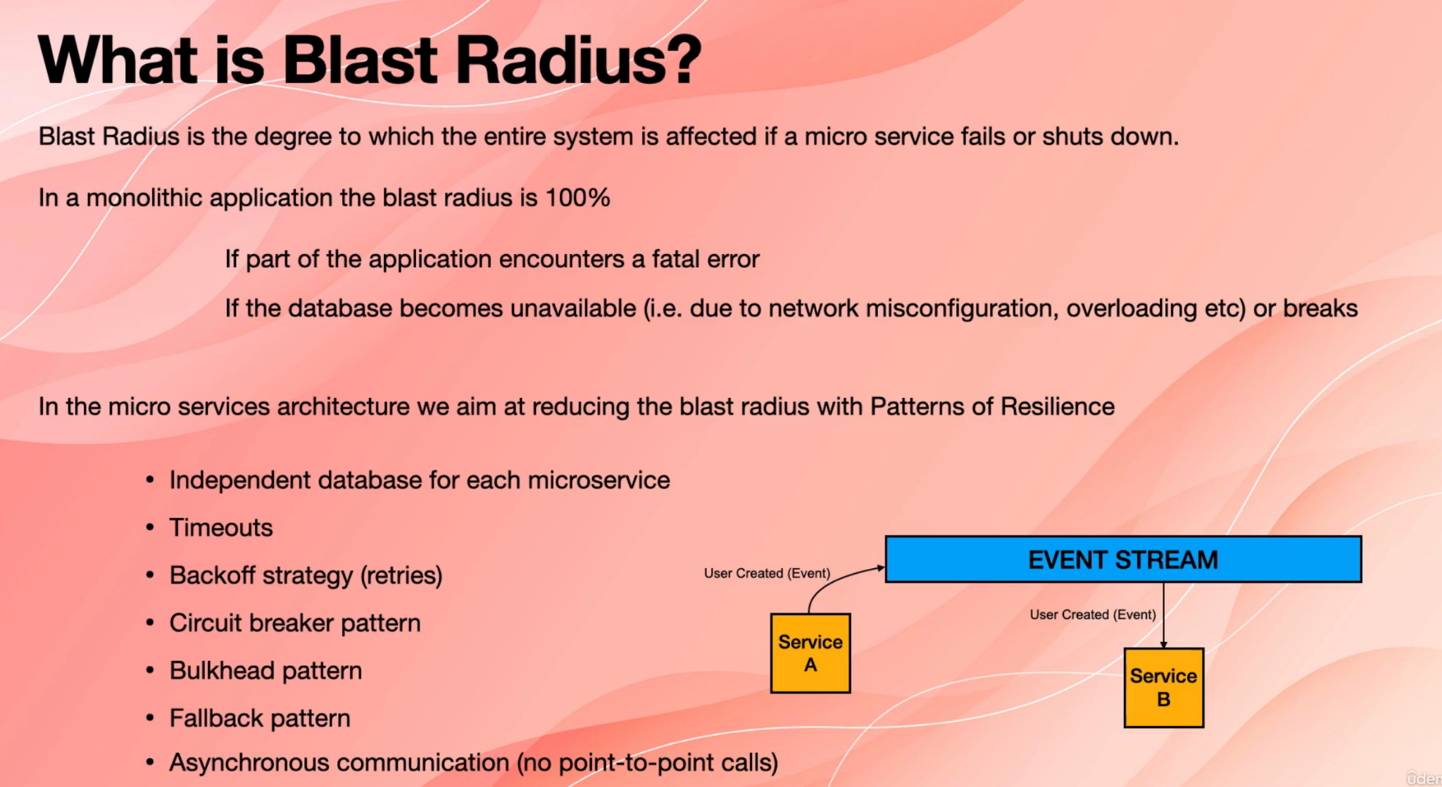

In the microservices architecture where we aim at reducing the blast radius with some patterns that are normally called patterns of resilience.Some of these patterns include,

**1. Independent database for each microservices.**

So I think in one of the early topics I mentioned that we don't share databases across multiple microservices. Each microservices must have its own database and must have all the information that it needs to function, and that helps with reducing the blast radius.

**2. Timeouts.**

If you make a point to point API call, you need to apply timeouts and you don't wait

forever for that other microservices to respond if you get timeout and then you have to handle it gracefully.

**3. back off strategy**

It is a kind of retries where you make a call to an API, if it doesn't respond, you wait, for example, for two seconds. If then you try again. If it doesn't respond, you wait this time for four seconds and then you wait for eight seconds until you give up. We will see these in more detail later.

**4. circuit breaker pattern**, is one of the other partners.

We will look at this one in the next lecture   
**5. bulkhead pattern.**

Remember the name. We will see this in detail.

**6. Fall back pattern**

If you cannot handle a request, you just hand the request over to another microservices that can handle the request, but not in an ideal situation.

So sometimes we will have backup microservices that can do a few things just to keep the system alive, but they are not meant to have their full functionality.

**7. asynchronous communication,** is preferred because it helps with resiliency and reducing the blast radius.If you remember in the previous lecture, we had mentioned that if there are two services service A and Service B, if we call the service B directly from Service A, if Service B becomes unavailable, then Service A is going to break because obviously you make an API call the other end. It doesn't respond in the network and you get a fatal error. Asynchronous communication will fix this problem by basically having an intermediate level that mediates between the two services and microservices A will raise an event. Microservices B subscribes to the event stream and gets it now.

**12. What is the circuit breaker pattern?**

Circuit breaker pattern applies to API calls or point to point calls and not asynchronous calls via events streaming services.

So In circuit breaker pattern we set a threshold for how many times the API call to a given microservices can fail.For example, we can set it to a number such as three and then if the API calls to that, given microservices fails more than that three times the number of threshold, then we reject any further API calls to that microservices.

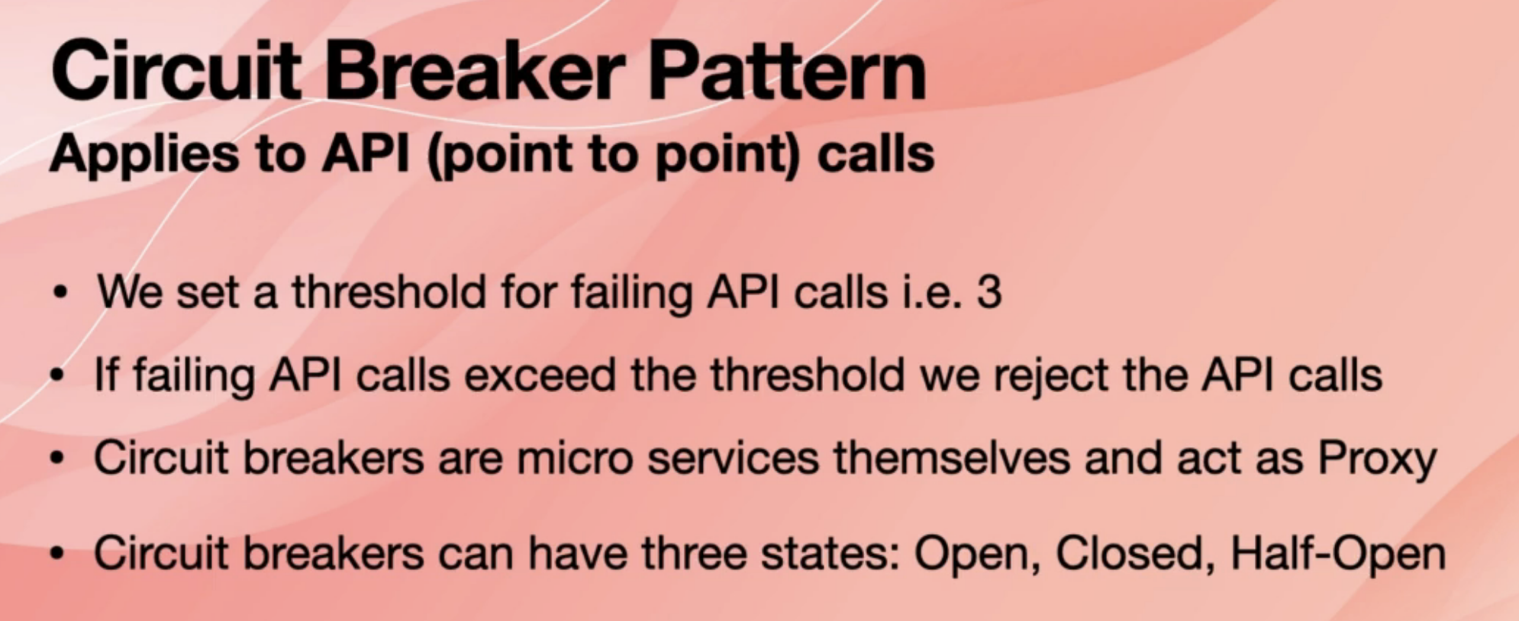

And to do that, we create a microservices that is basically called the circuit breaker microservices, and we put it in front of the target microservices, and that acts as a proxy.

It can have three states open closed and the half open. It's a bit misleading. Closed is the one that we always want. It's a good one. Open means that the circuit is open and we cannot pass the API calls to the target. Half open means that sometimes we send the request to microservices, sometimes we reject them and we do that to keep the microservices running, but close to that threshold. In theory, that is how it works.

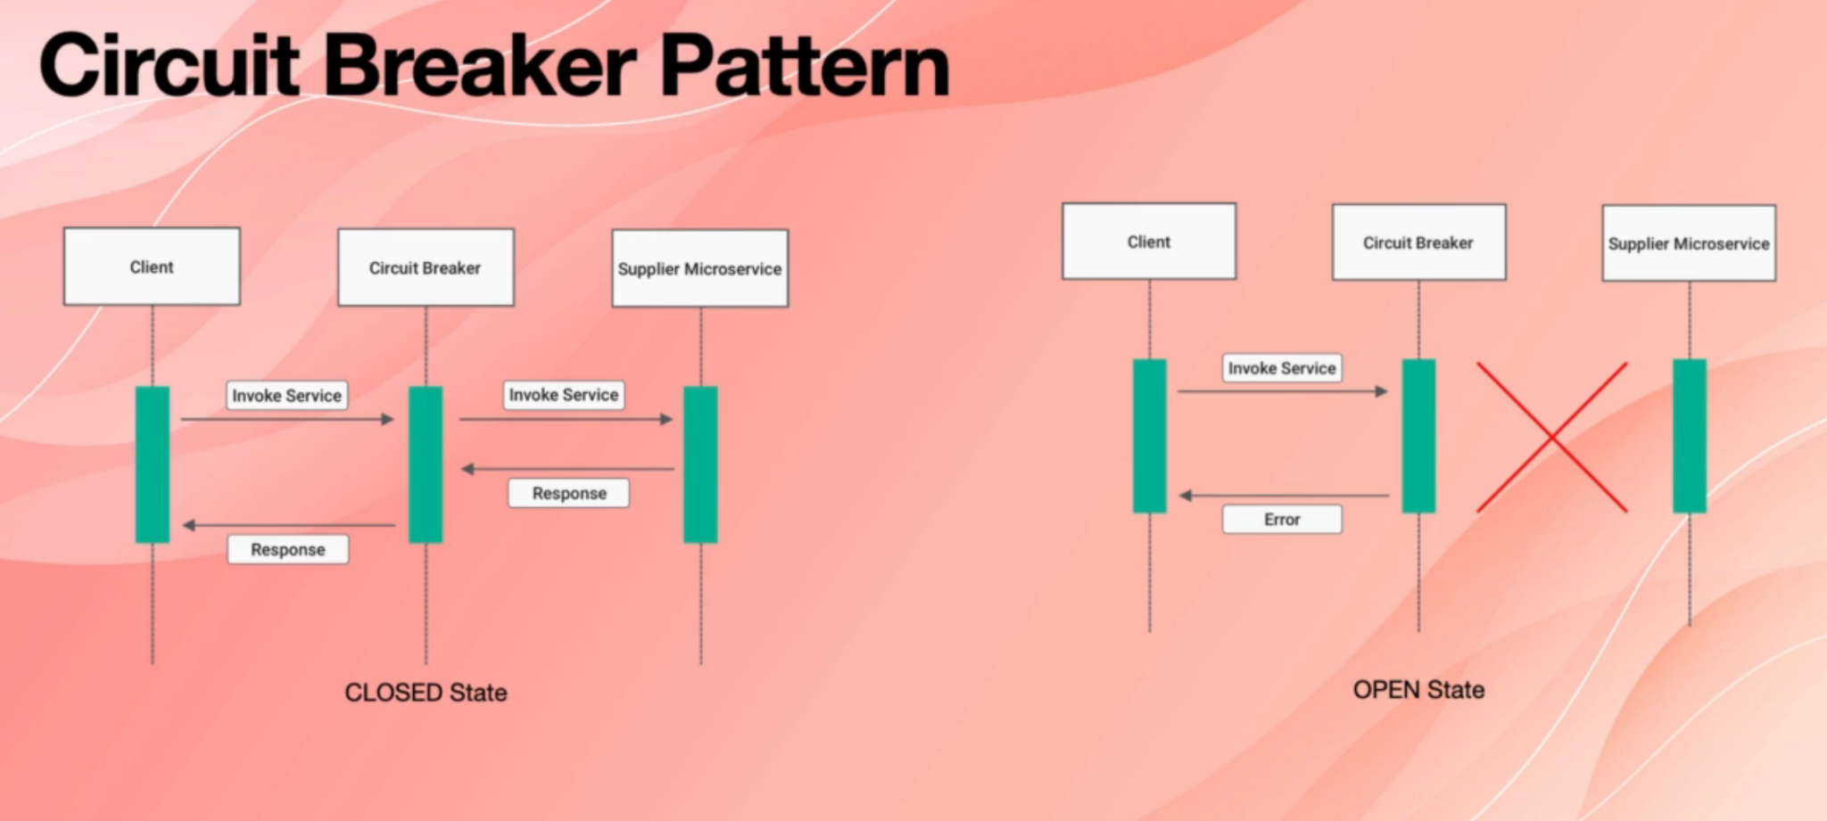

On the left side, you have a client microservices that needs to make an API call to the supplier, microservices on the right side.We put the circuit breaker in between two and when client wants to make a call to supply microservices,it has to go through a circuit breaker microservice.

Circuit breaker passes the request to supplier and then supplier, returns the value to a circuit breaker and then circuit breaker passes it back to clients. so it acts as a proxy. And in this state, we call it closed state.

The opposite is the open state when the circuit is open, so client makes a call to a circuit breaker circuit breaker decides that supplier is not able to respond.

For example, it might be broken, it might be suffering from overloading, and it needs time to scale out in that case. Circuit Breaker returns an error to the client, and client has to handle that error gracefully and wait again.

For example, we talked about the back office strategy its client has to wait, for example, for two seconds and try again. If it fails again, then wait for four seconds and try again.

The state in between is half open, which is something between closed and open.

And that is when Circuit Breaker, just say, rejects half of the requests and this passes the other half to supplier microservices, or at least half of the requests can be handled, but then supplier microservices won't be overloaded.

So this is the theory in reality, because if you want to have one circuit breaker paired microservices, you are basically going to double the number of microservices you are dealing with and also having one centralised circuit breaker service is not a good idea because we are going to have one single point of failure.

What we can do is that sometimes microservices can have circuit breakers built into them. If you are a .NET developer, I think as of that net core three point one, this capability was added to web APIs. You can check your own state and say my CPU usage is very high or my downstream microservices are returning error, so I'm not really going to accept more APIs and then you can reject the API calls.

So the best situation would be when you mix and match two as you would have a circuit breaker for key microservices that are not supposed to get overloaded by any means, for example, say, payment service.

**13. Name some of the ways or architectural styles for building microservices?**

One of the very simple ways of deploying microservices is that you put one microservices on one virtual server, and this is a good way for breaking down large on premises, monolithic systems into smaller, manageable services and migrate them to the cloud.

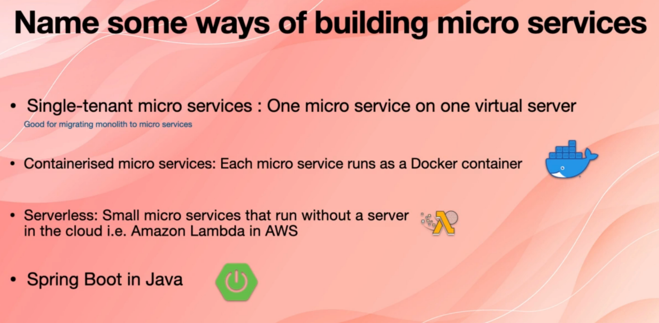

You can also containerised your microservices using docker and deploy them. Normally, you would need some kind of orchestrator for that. For example, you may need Google's Kubernetes.

There is also a technology called serverless microservices. In this technology there are no servers or there is no containerization. You create a very small micro service using a language such as Python or Java or even dot net. And then you deploy them to your cloud provider, for example, to Amazon Web Services, and then your cloud provider runs that code for you in their own infrastructure, and you will need to maintain any infrastructure for that.

There is also Spring boot in Java, which is a good way of implementing and deploying microservices. The good thing about the spring boot is that if you don't use any cloud technologies, perhaps because you work in a large organization that is still has so many systems on premises in their own datacenter, you can use a spring boot to build and deploy microservices. And then if you want to move them to the cloud later, you can move it to cloud. And that's a good benefit. Obviously, you can only use that if you use Java.

**14. What is the difference between Event and Message?**

The concept that you need to know and understand clearly in order to be successful in interviews and also to be able to design and implement microservices based applications is what an event is, what a message is and what's the difference between events and messages.

So in order to understand this, clearly, let's talk about them in the context of object oriented programming.

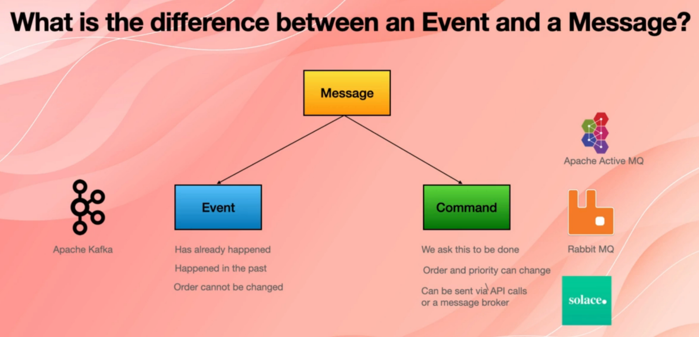

So there is a base or superclass called a message, and it's got two subclasses. One of them is an event, and one of them is a command and they are different.

When you hear a message in the context of microservices, we are normally talking about commands. And they are used interchangeably.

An event is something that has already happened. It happened in the past and therefore event order cannot be changed. If you change the order of events that have already happened, it's as if you are trying to change history. For example, it's as if you say World War One happened after World War Two. It just doesn't make sense.

Commands, however, haven't happened yet. We want them to happen and therefore order and priority of messages can be changed and they can be sent to other microservices in two ways. Either you may have a point to point API call, for example, at Post API, call to another microservices, or you deliver your message to a message broker and other microservices subscribe to that message broadcast and receive the command.

Events are handled via and by event streaming platforms such as Apache Kafka, which is very common amongst Java developers.

In terms of message brokers, we have Apache Active MQ, which is again popular amongst Java developers. We have RabbitMQ, which is very popular amongst the developers and we also have something that is taking off and is quite new and is called solace.

So to see this in an example, let's have this example and see how messages and events work. Imagine that we have three microservices.

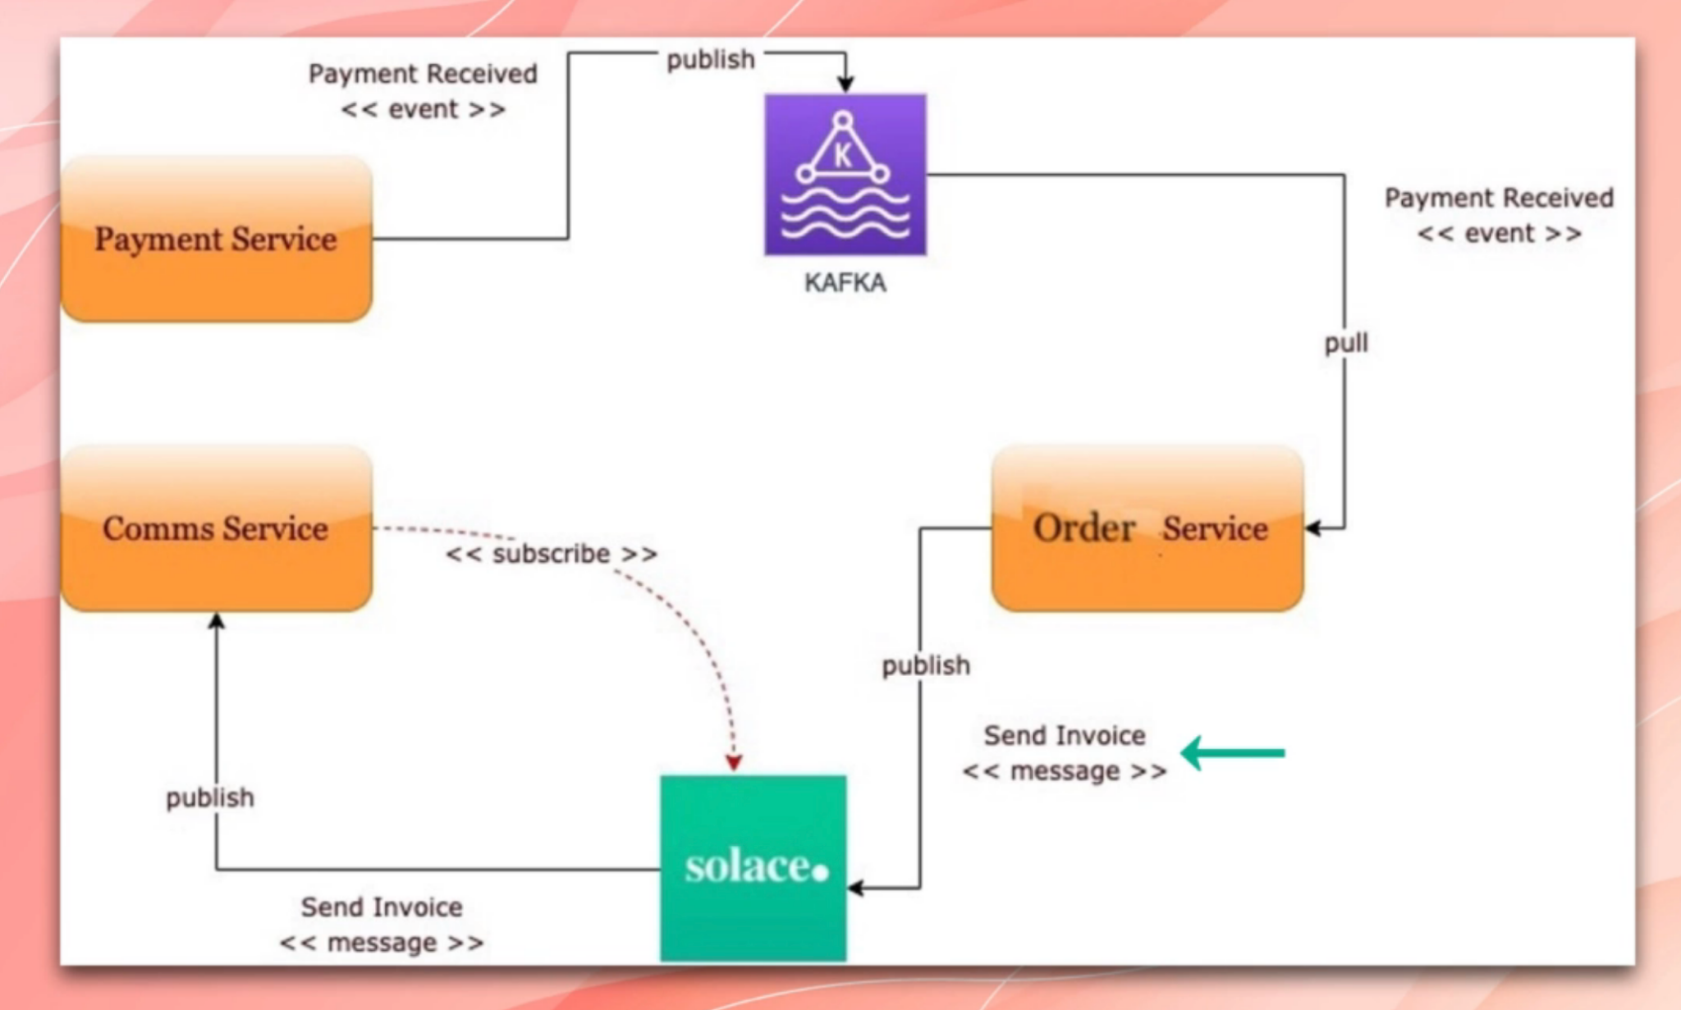

One of them is payment service. One of them is communication service or comms service, and one of them is order service. So when the user pays by, say, a credit card, we raise an event to Kafka, to Apache Kafka that is the event streaming platform. Payment received is an event it has already happened and then order service subscribes to that event

and receives that event. And then the order service wants to send an invoice to the customer because it has processed the orders and now wants to send an email to the customer and say, hey, this is your invoice.

For that, it has to send a message to the communication service. So sending the invoice has not happened yet. We want that to happen. So we send a message to solace in this example.

It can be a rabbit MQ or active MQ. It doesn't matter. And then the communications service also subscribes to that child in solace or, say, rabbit MQ and receives that message and then sends the invoice to the customer. And as you see it, that is the difference between a message and an event.

**15. What is a distributed transaction?**

What is a distributed transaction? Knowing and understanding distributed transactions is extremely important, both for passing the interviews and also for building microservices properly.

So what is a distributed transaction in microservices based architecture?

We know that each microservices has its own database and there is no shared database.

And because there is no shared database, we cannot use the traditional transaction also referred to as ACID transactions.

And instead, we need to handle the transaction across multiple microservices, and we have to make sure that the transaction is atomic.For example, have an order, the order is in order service database and its related payment is in the payment database and everything is in a reliable state and managing transactions across multiple services is called distributed transaction. It is referred sometimes to as eventual consistency because, as we said, eventually we want everything to be consistent and atomic.

So if we look at an example in a monolithic application, we normally have a system and the system has a database.

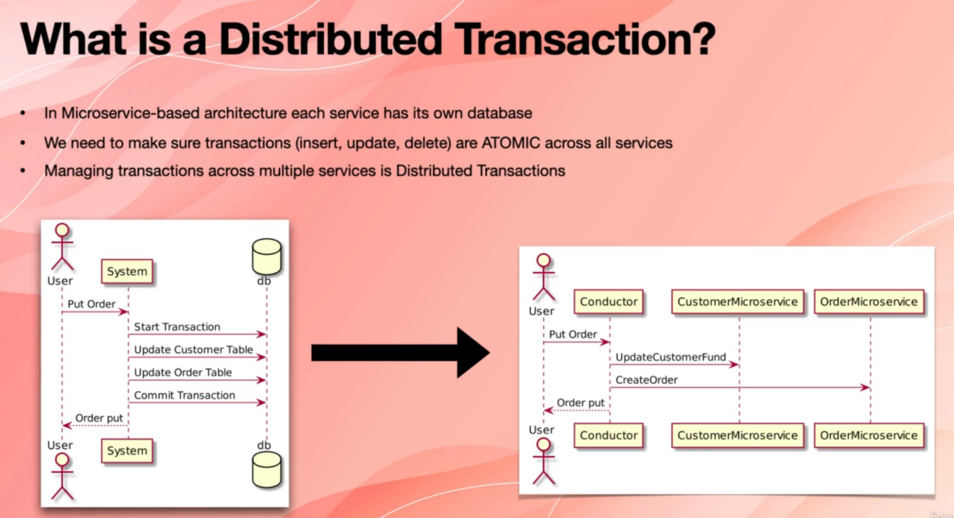

And now the user puts an order. You start a transaction, for example, in sequence. I bet you have a command called Begin Transaction. You update the customer table and then you update the order table and then you commit the transaction. For example, there is a sequence where you say commit a transaction and then the database goes to the reliable state and the system returns, OK to use it.

Now we want to break this down to microservices. You may have two microservices.

One of them is custom customer microservices, and one of them is order microservices.

So in this type of system, what we need to do is that we need to send a command to customer microservices and say, create the customer or update customer fund, for example.

So in this example, we want to update the customer's fund. So we send a message to customer service and then they need to send a message to all their microservices

and say, create order. Now we want to make sure that if order is not created successfully, the fund is not deducted from customer's balance or fund is deducted only if Create Order has successfully updated their or order microservices.

So the question is that how do we do this now?

We have two databases to update and we need to make sure that they are in a reliable state at the end of their transaction.

There are a few ways of handling distributed transaction, and two of them are the main ones.

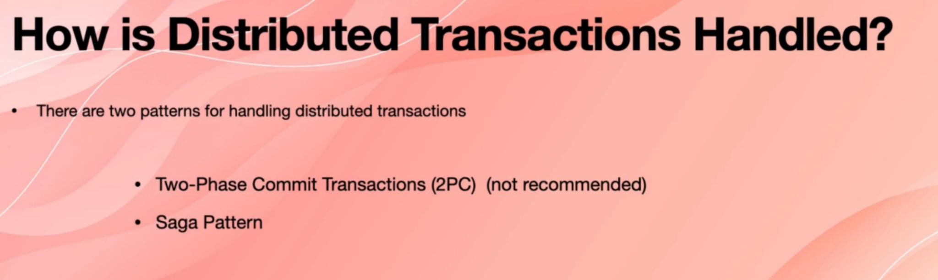

So one of them is called two phase commit transactions. When you read documents on the internet, you will see the 2PC term.

And we also have a saga pattern in the next two lectures, we will go through the details of these two patterns.

**16. What is a 2-Phase commit or 2PC pattern?**

Two phase commit pattern is widely used in distributed database systems. Sometimes it's useful in microservices only when there are only few microservices involved in building

the system.   
It has two phases that's why it's called a two phase commit pattern.

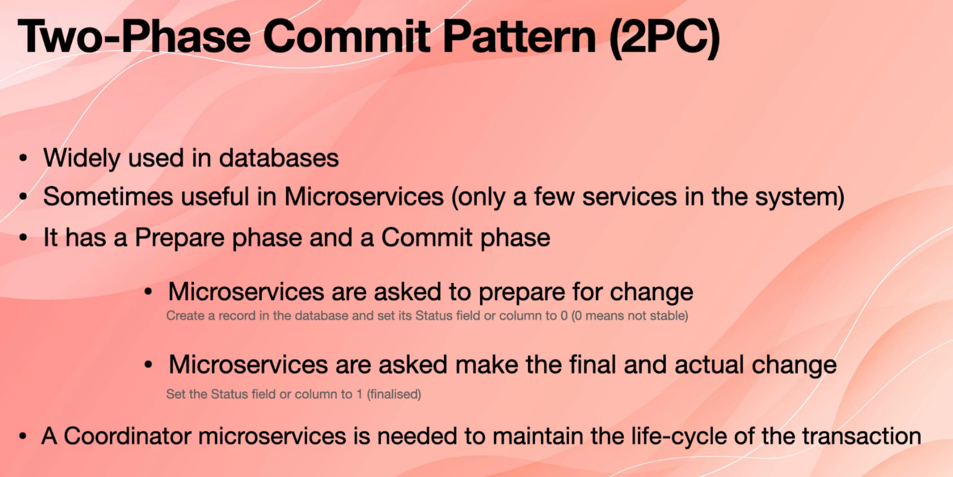

It has one phase that is called prépare, and then it has a phase that is called commit.

So to start a transaction, microservices are asked to prepare for a change, and that is called the prepare phase, which, for example, in this phase we create a record in the database with some values in it that a record has a property or a column called something

like status, and we set it to zero or false, which means that this column should not be read.

That is like a temporary row in the database, or it's a temporary document in no sql database,

And then we make our update and then microservices are asked to make the final and actual change, which is the commit phase. And in this phase, after making all the actual updates we set, the value of that status field or a column into one or true, which means that the record is stable and it can be used normally.

Because there are multiple microservices in the system there is a coordinator microservices that is needed in order to maintain the lifecycle of the entire transaction. And in the previous lecture, we saw a coordinator microservices and we can see it in this diagram. This is a successful Two-Face comet, which means that all the microservices successfully committed their transactions

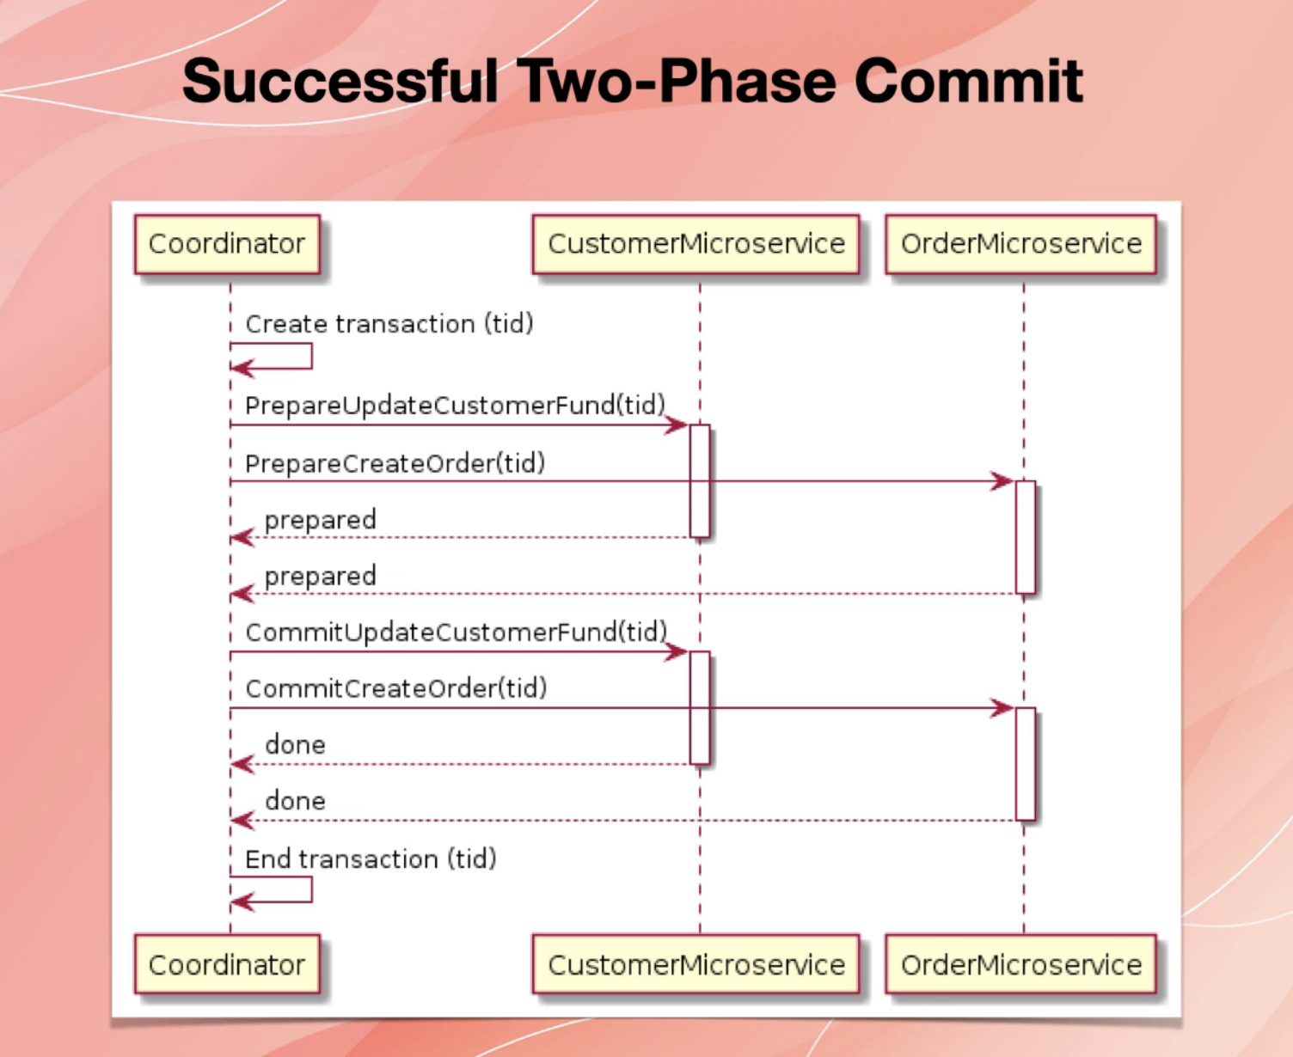.

So as you see, we start the transaction or we create a transaction, which gives us a transaction ID. We asked the customer micro to prepare for update customer fund change, and then we passed their transaction ID to it. And also, we asked the order microservices to prepare for creating an order. And we passed that transaction ID to it. Both customer microservices and order and microservices written OK to coordinator and they say, we

are prepared. And then we make changes. And then we say commit Update for customer fund. And then we say to customer microservices that comet the updating customer fund with a transaction ID. And we do the similar thing by making a call to order microservice and say, commit create update. Again, you pass the same transaction ID and they do that successfully and they return. OK. And then we say transaction is closed at the end successfully. So as you see it, that is the coordinator microservices that is asking customer micro service and or their microservices to prepare and to commit.

Now let's look at if failed to face commit. Following diagram is self explanatory.

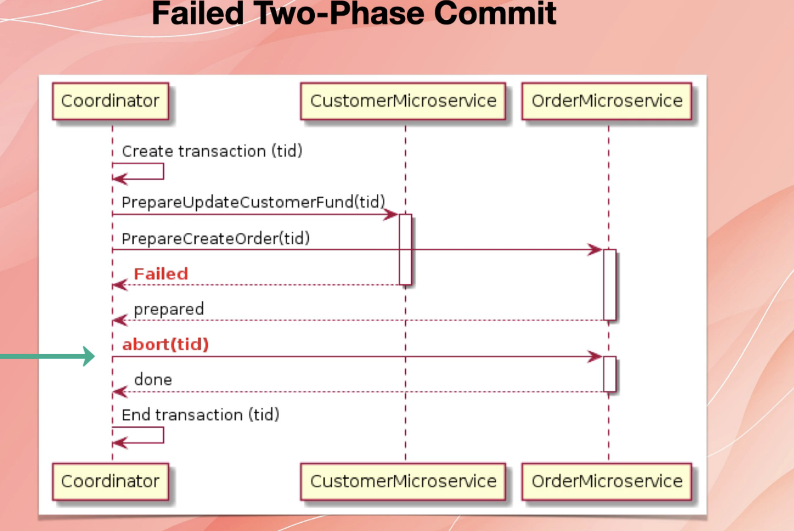

**17. What is the Saga pattern in the context of distributed transactions?**

Saga Pattern is an asynchronous way of managing distributed transactions. We say asynchronous because in two phase commit pattern, we have to wait for the other microservices to send us acknowledgement and then we determine the final state of the transaction however in Saga pattern, as we will see soon, every microservice is responsible for managing its own transaction, and then there is no waiting for the microservices to finish the transaction. So in that sense, the Saga pattern is asynchronous and it's up to every single micro service to handle their own transaction.

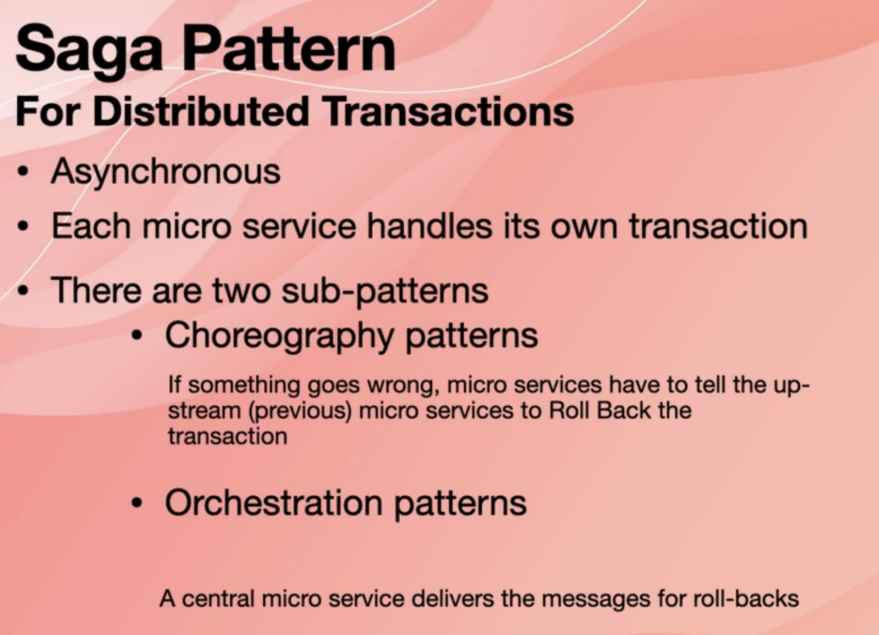

There are two sub patterns that we will see.

One of them is the choreography pattern and in the choreography pattern every micro service manages its own transaction. How about if something goes wrong? The microservices that have a failed operation have to notify the upstream or previous microservices of that failure, and then it's up to those upstream microservices to handle the roll back.

The second pattern is orchestration patterns.

In this case, there is a central microservices that manages the messages between microservices.

So these are two patterns: choreography and orchestration patterns **are not only for managing distributed transactions.** In fact, choreography and orchestration patterns are mainly for managing and implementing the business workflows.

For example, if you go to an E commerce system and place an order for, for example, say, a T-shirt or the microservices that work in the background to make that workflow to happen and finished, they have to work in either choreography pattern or orchestration pattern, or sometimes a hybrid of those two.

Part of that managing the workflow is managing their distributed transaction, and that is why we talk about choreography, pattern and orchestration here.

And at the beginning of this topic, I said Saga pattern in the context of distributed transactions. We will learn more about choreography and orchestration pattern.

For now, we just talked about them in the context of distributed transactions.

**18. What is the Choreography pattern?**

Let’s deep dive into the choreography pattern. We do this in the context of managing distributed transactions. In this example, we have order micro service and we have customer microservice, so order microservice creates an order and when it does create an order, it manages the transaction in the traditional way within the database.

And once it's done, it raises an event called order created normally between these two microservices, there will be an event streaming platform such as Apache Kafka

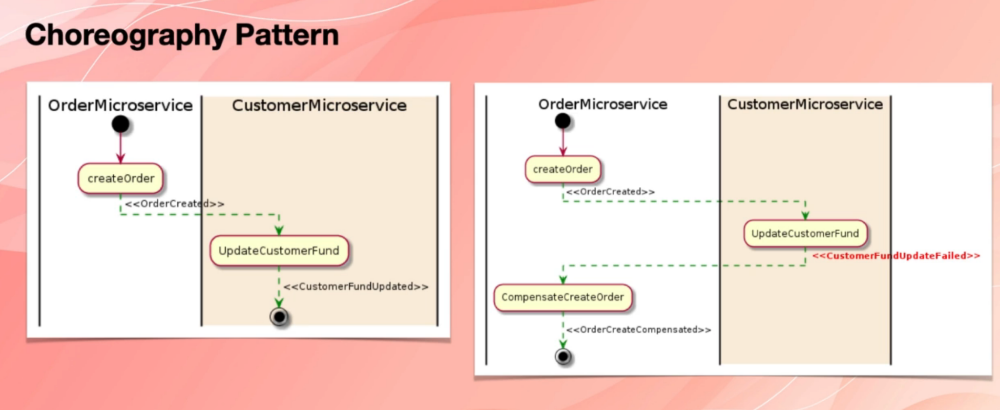

.

We have removed that detail just to simplify things and make them more understandable.

So once the order created event is raised, customer service is subscribed to that event, and receives that order created event and then goes and tries to create a new transaction in its own database, update the fund or balance of the customer, and then finishes the operation.

Now, if something goes wrong, this is what will happen. So order microservice creates the order. It raises the order created event and customer microservice receives that events and tries to update the funds. But then something goes wrong. For example, the customer doesn't have enough balance. The credit card doesn't work for any reason. The transaction cannot be committed successfully. In that case, customer service has to notify upstream stream service, which in this case is the order microservice about the failure and then order microservice has to compensate for that problem either removes the record from the database or does something that neutralizes whatever change it had made before.

So as you see in choreograph your pattern, there is no orchestrator in between these two macro services. They have to communicate correctly somehow, and the logic of managing the transaction is scattered across all the engaged the microservices.

**19. What is orchestration pattern?**

So in this topic, we want to quickly deep dive into orchestration pattern and however again we do this in the context of managing distributed transactions.

In orchestration pattern, there is a service, a centralised micro service that we call as orchestrator. Orchestrator knows how our workflow has to be executed. And also it knows that if anywhere in the system something goes wrong, which microservices have to

go and compensate for the failed transaction. For example, in this example, order service will create an order.

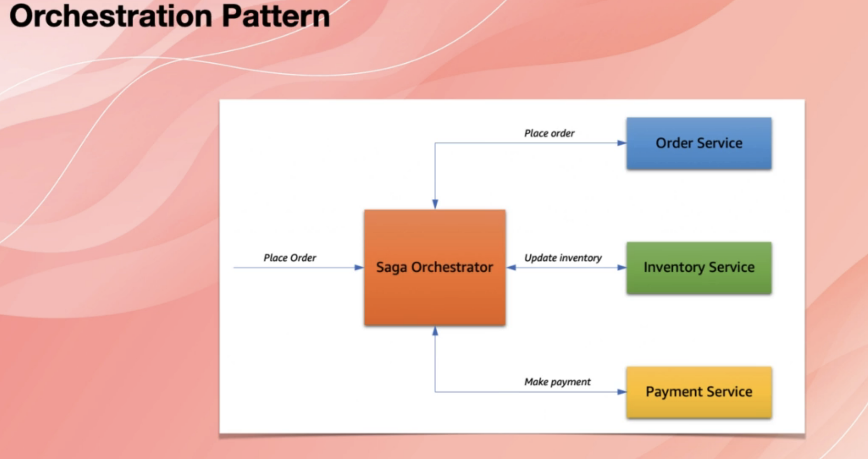

It will raise an event such as order created and then saga orchestrated or just orchestrated will receive that event. The orchestrator knows that, and now inventory has to reduce the number of available items in the inventory. It sends a message to inventory service and says deduct this item and then inventory service does that. If something goes wrong, inventory service raises an event which is something like inventory update failed.

And this time, it's not the order service that receives this event. It's the orchestrator macro service that receives this event and orchestrator knows that which microservices have to go and compensate for the failed transaction, for example, up to here or their service has

to cancel the order. Now, if order service managed to create the order and inventory service managed to update the inventory, but then payment failed payment service would raise an event such as payment failed and then orchestrated and with service will catch that event.

And then it would send two messages to inventory service and to order service and would tell them that this transaction has failed.

Do you have to roll back so orchestrator microservices and other macro services engaged in orchestration pattern use event to streaming platforms such as Apache Kafka?

And sometimes we use a message broker as well to send messages. It depends how you handle the roll back events. If you want to trade all of them as events, then Kafka is enough.

Otherwise, if you want to say when I get the event of transaction failure, I want to send a command or a message to the other microservices and tell them that they have to roll back, you will need a message broker as well.

It depends how you want to design your system, but in general that's orchestrated microservices orchestrates and Marshalls all the communication between those microservices that are related to committing or rolling back a transaction.

**20. What are differences between monolith, microservice and SOA?**

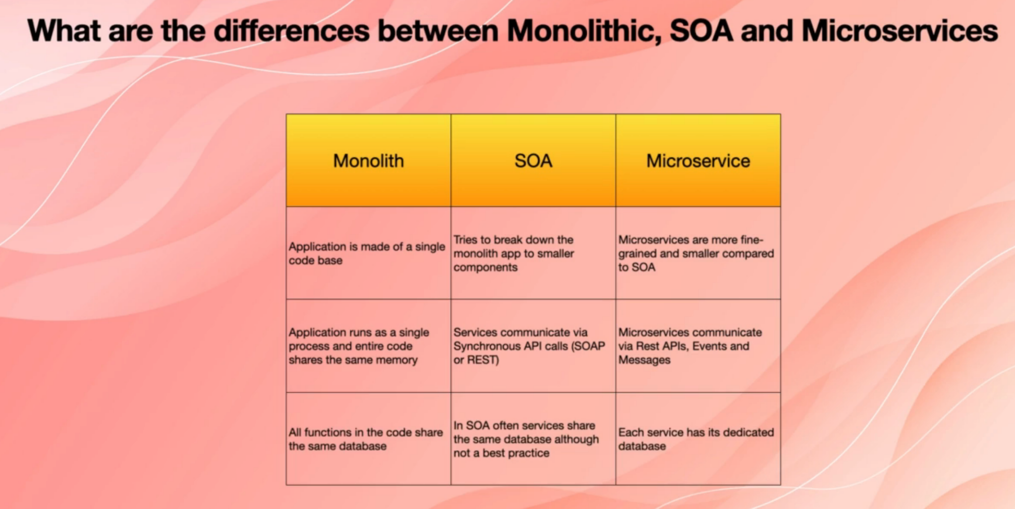

**21. What is DDD?**Microservices are the most scalable way of developing software. But you need a good design that lets developer teams work autonomously and deploy without stepping on each other’s toes.

Domain-Driven Development allows us to plan a microservice architecture by decomposing the larger system into self-contained units, understanding the responsibilities of each, and identifying their relationships.

As the name suggests DDD focuses on designing micro services architecture based on business capabilities. Domain-Driven Design (DDD) is a software design method wherein developers construct models to understand the business requirements of a domain.

How well one can solve a problem is determined by one’s capacity to understand the domain. Developers need to collaborate with domain experts to guarantee that the code is aligned with business rules and client needs. Developers and domain experts use a ubiquitous language to share knowledge, document, plan, and code.

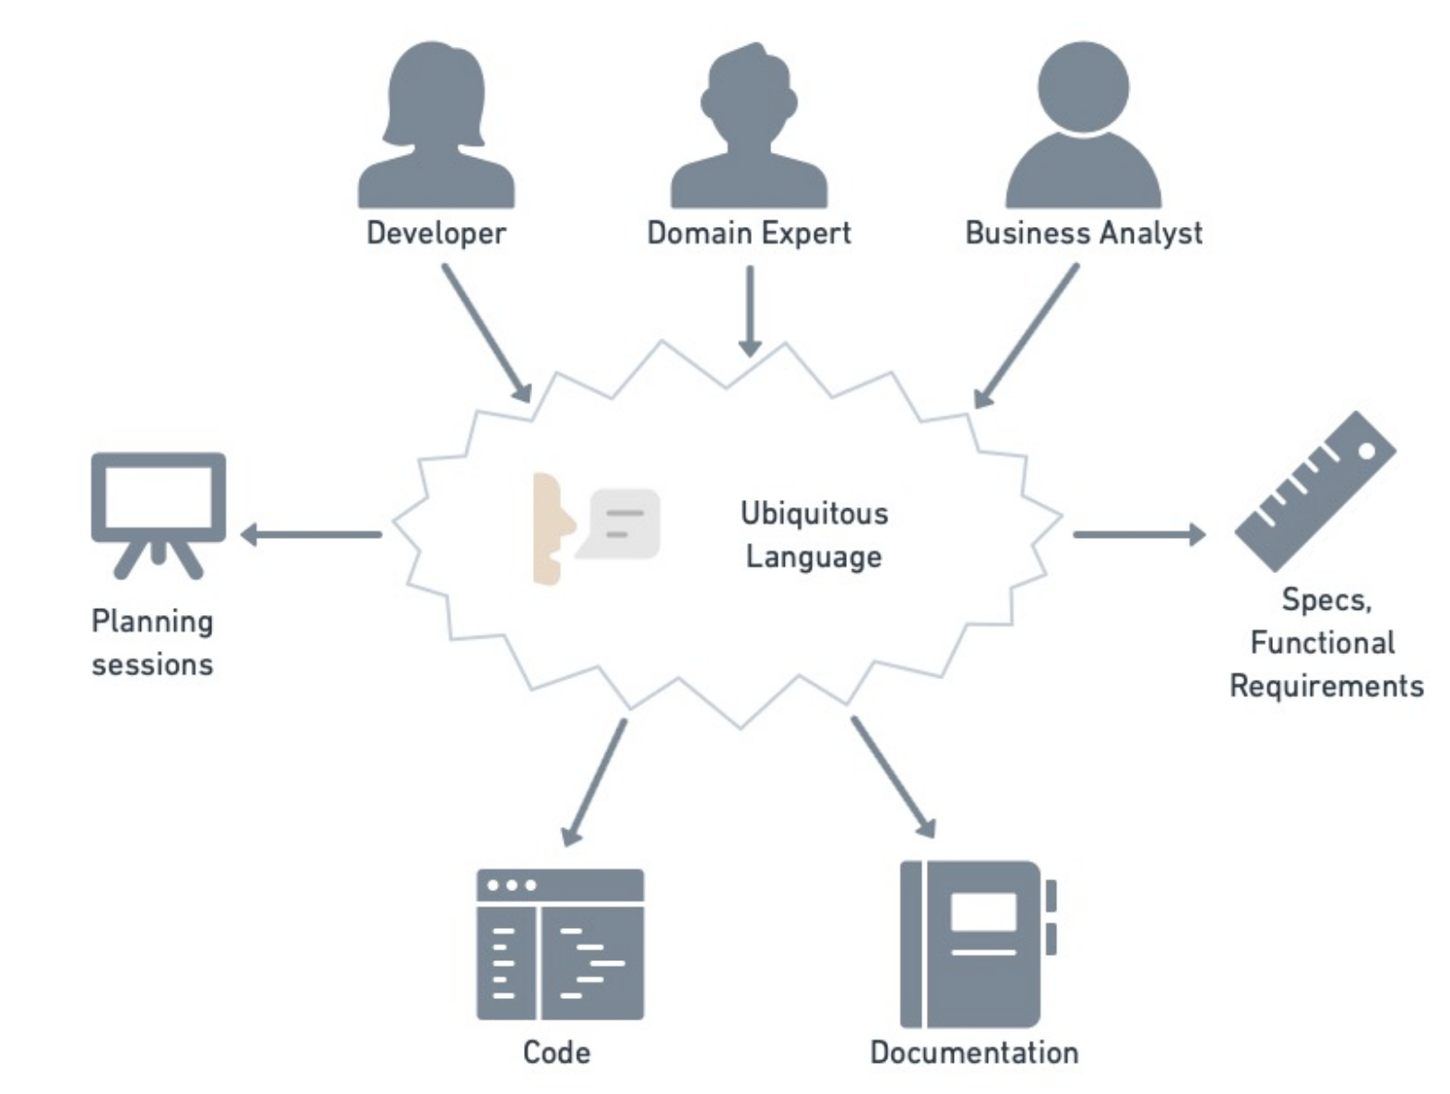

The two most important DDD concepts for microservice architecture are: ***bounded contexts and context maps***.

**Bounded Context (BC)**

The setting in which a word appears determines its meaning. Depending on the context, “book” may refer to a written piece of work, or it may mean “to reserve a room”. A bounded context (BC) is the space in which a term has a definite and unambiguous meaning.

*Before DDD* it was common practice to attempt to find a model that spanned the complete domain. The problem is that the larger the domain, the more difficult it is to find a consistent and unified model. DDD’s solution is to identify BCs so that the domain can be broken down into manageable subdomains.  
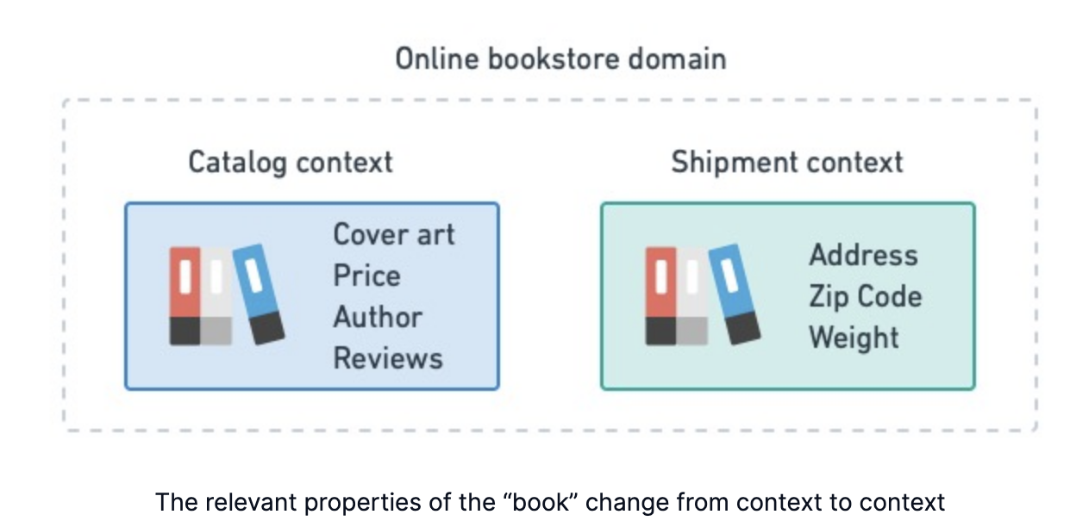

In software, we need to be exact. That is why defining BCs is critical: it gives us a precise vocabulary, called ubiquitous language, that can be used in conversations between developers and domain experts.

More info: https://www.youtube.com/watch?v=xjx4Zkh0NDU

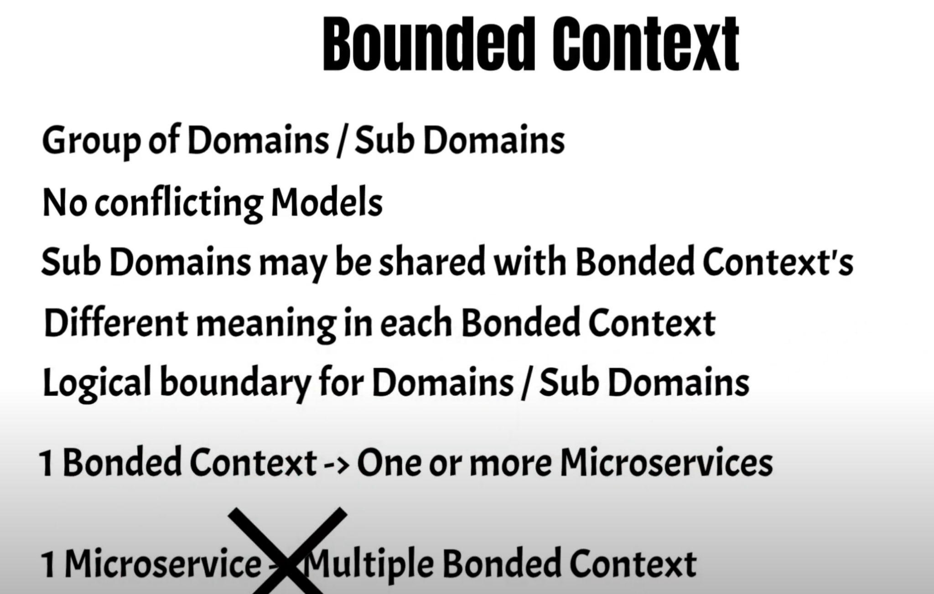

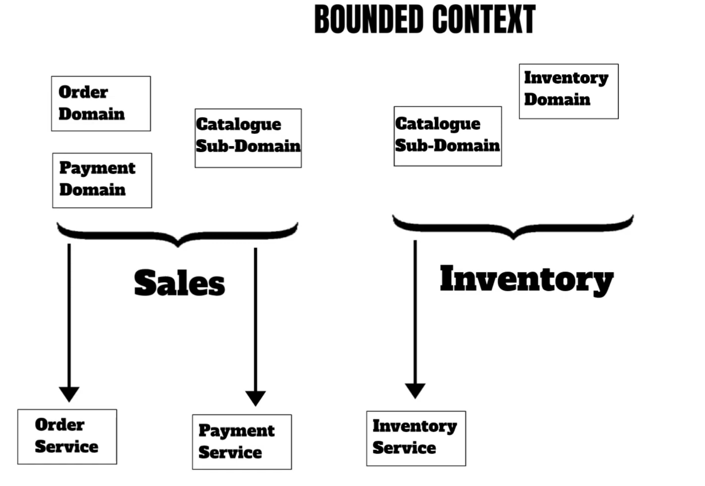

**Context Map**

The presence of a BC expects the need for communication channels. For instance, if we’re working in an e-commerce domain, the salesperson should check with inventory before selling a product. And once it’s sold, it’s up to shipping to ensure delivery of the product to the correct address. In DDD, these relationships are depicted in the form of a context map.

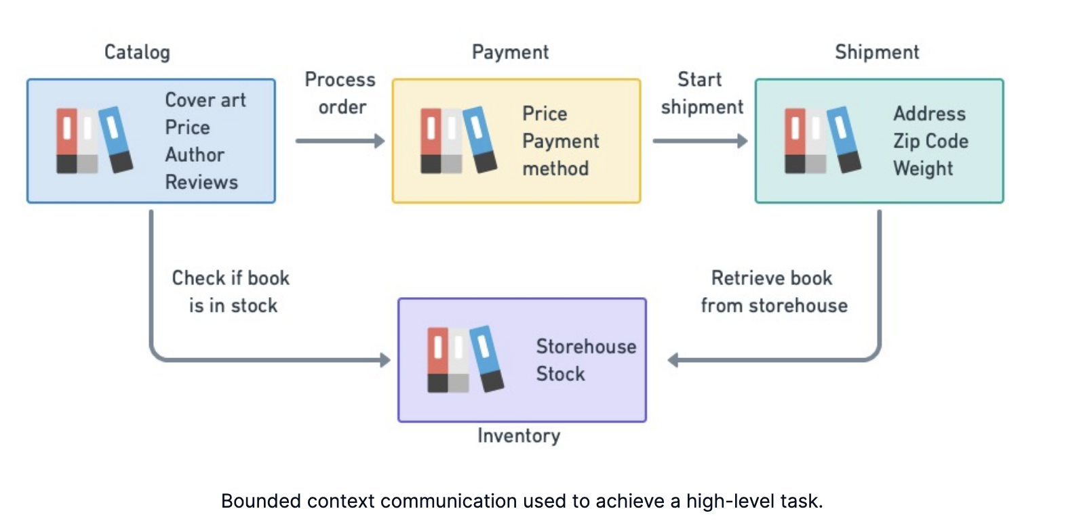

**Domain-Driven Design for microservices**

DDD takes place in two phases:

In the **strategic phase** we identify the BCs and map them out in a context map.

In the **tactical phase** we model each BC according to the business rules of the subdomain.

**Strategic phase**

During this phase, we invite developers, domain experts, product owners, and business analysts to brainstorm, share knowledge and make an initial plan. With the aid of a facilitator, this can take the form of an Event Storming workshop session, where we build models and identify business requirements starting from significant events in the domain.

In strategic DDD, we take a high-level, top-to-bottom approach to design. We begin by analysing the domain in order to determine its business rules. From this, we derive a list of BCs.The boundaries act as natural barriers, protecting the models inside. As a result, every BC represents an opportunity to implement at least one microservice.

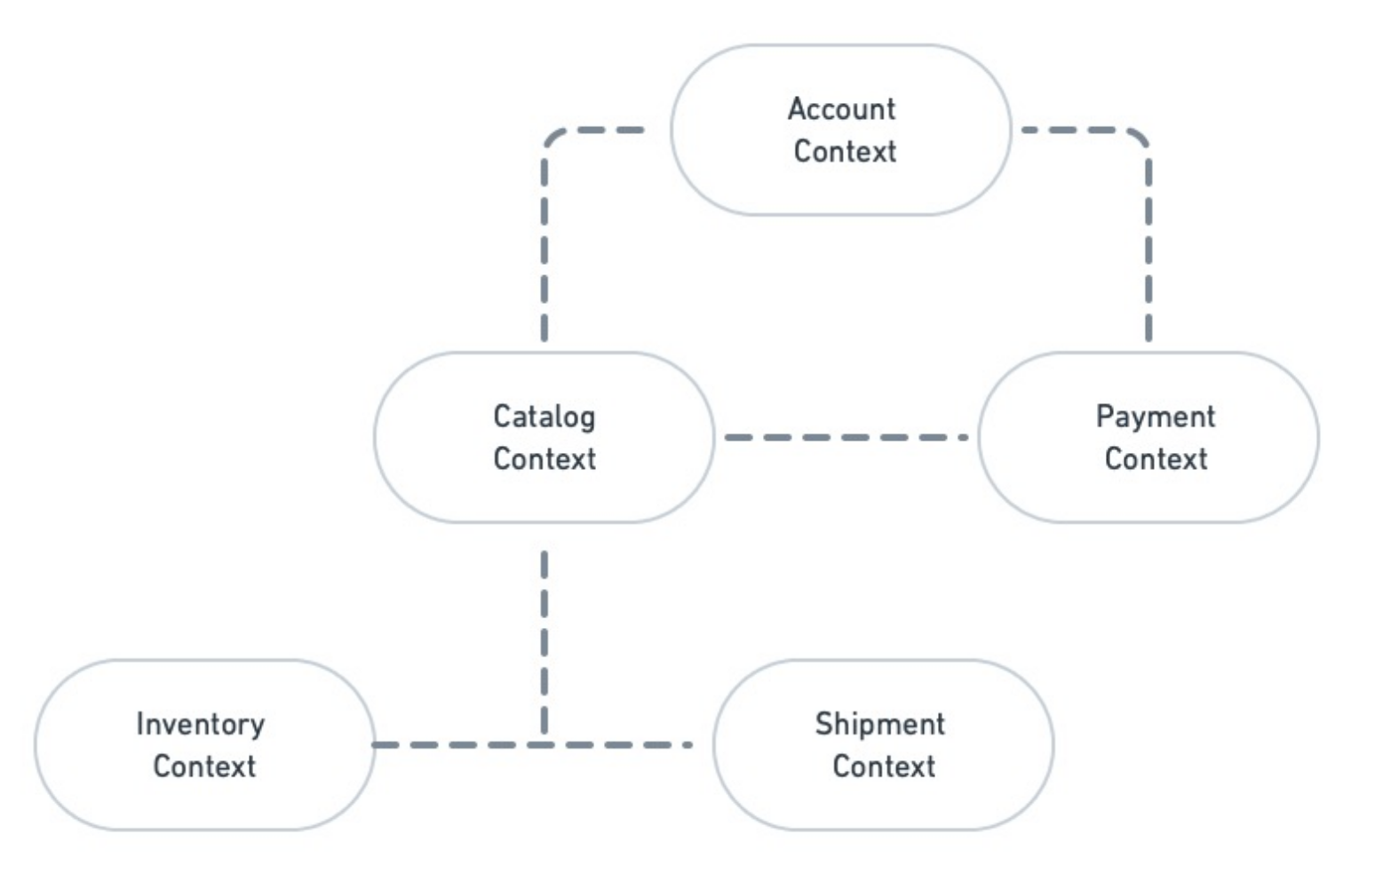

**Types of relationships**

Next, we must decide how BCs will communicate. There are four types of relationships:

**Open Host Service (OHS)**: the service provider defines an open protocol for others to consume. This is an open-ended relationship, as it is up to the consumers to conform to the protocol.

**Published Language (PL):** this relationship uses a well-known language such as XML, JSON, GraphQL, or any other fit for the domain. This type of relationship can be combined with OHS.

**Anticorruption Layer (ACL):** this is a defensive mechanism for service consumers. The anti-corruption layer is an abstraction and translation wrapping layer implemented in front of a downstream service. When something changes upstream, the consumer service only needs to update the ACL.

**Separate ways:** this happens when integration between two services is found, upon further analysis, to be of little value. This is the opposite of a relationship — it means that the BCs have no connection and do not need to interact.

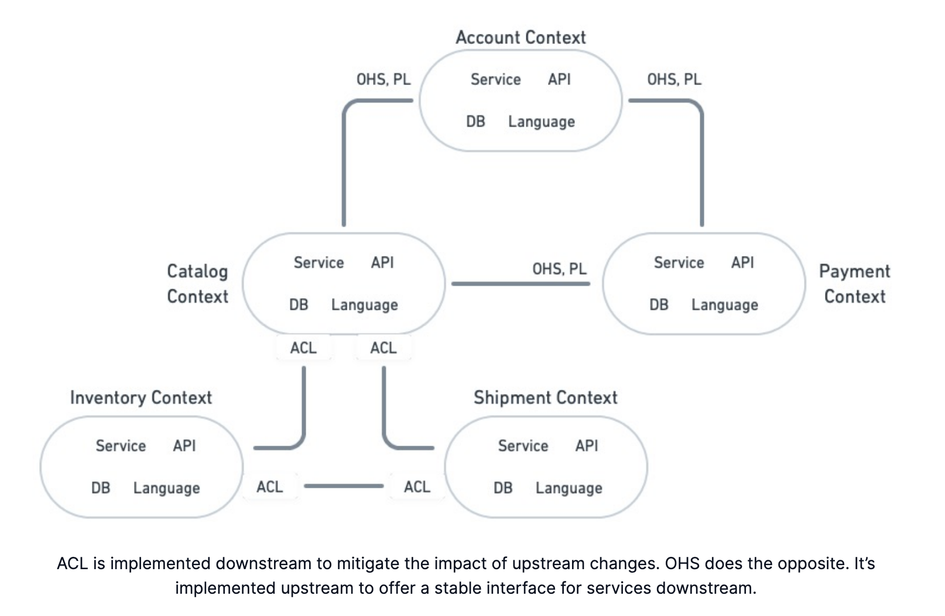

Tactical phase

In the previous stage, we identified BCs and mapped their relationships. In this stage, which requires developers well-versed in DDD theory, we’ll zoom in on each context to construct a detailed model.

The models created with DDD are technology-agnostic — they do not say anything about the stack underneath. We focus, instead, on modeling the subdomain. The main building block of our models are:

**Entities**: entities are objects with an identity that persists over time. Entities must have a unique identifier (for example, the account number for a customer). While entity identifiers may be shared among context boundaries, the entities themselves don’t need to be identical across every BC. Each context is allowed to have a private version of a given entity.

**Value objects**: value objects are immutable values without identity. They represent the primitives of your model, such as dates, times, coordinates, or currencies.

**Aggregates**: aggregates create relationships between entities and value objects. They represent a group of objects that can be treated as a single unit and are always in a consistent state. For example, customers place orders and own books, so the entities customer, order, and book can be treated as an aggregate. Aggregates must always be referenced by a main entity, called the root entity.

**Domain service**s: these are stateless services that implement a piece of business logic or functionality. A domain service can span multiple entities.

**Domain events**: essential for microservice design, domain events notify other services when something happens. For instance, when a customer buys a book, a payment is rejected, or that a user has logged in. Microservices can simultaneously produce and consume events from the network.

**Repositories**: repositories are persistent containers for aggregates, typically taking the form of a database.

**Factories**: factories are responsible for creating new aggregates.

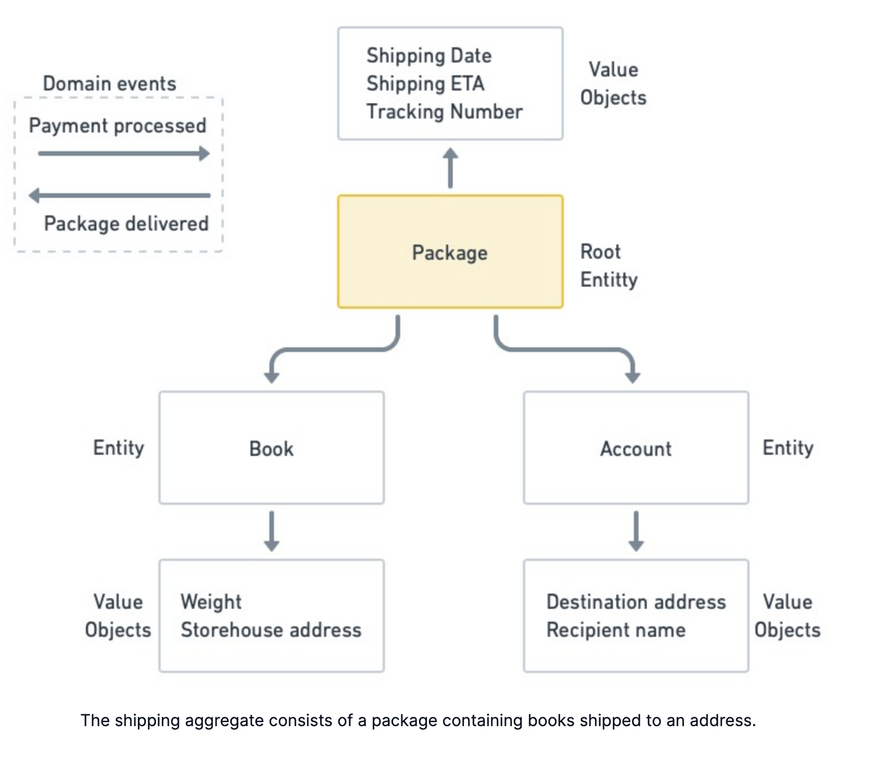

**22. Explain how independent microservices communicate with each other?**

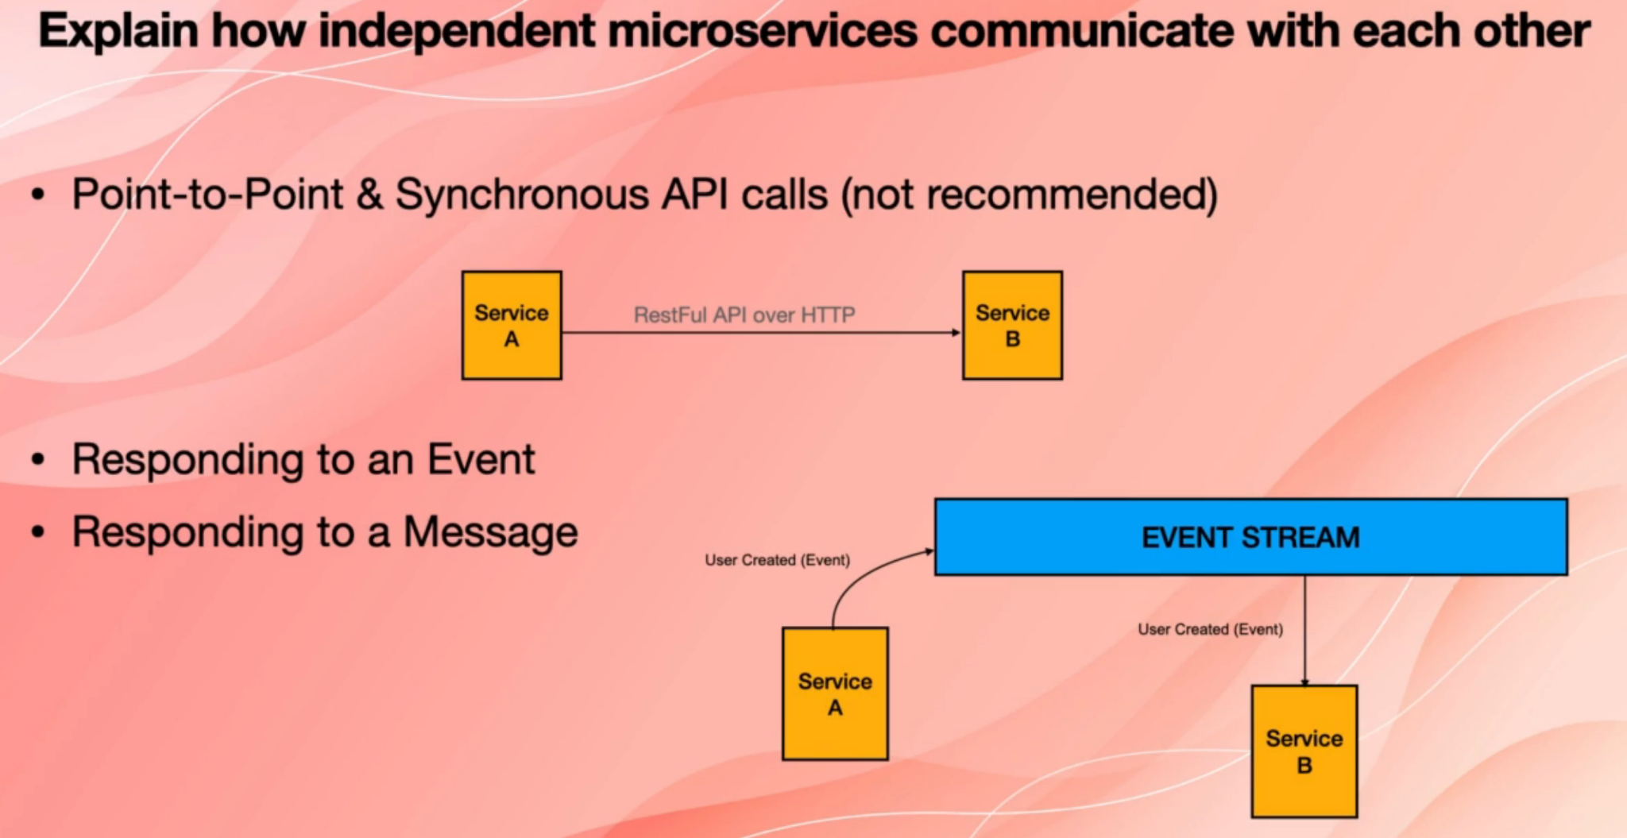

**23. Explain CDC.**

CDC stands for consumer defined contract.

When we say consumer, we are not talking about a person that purchases something, we are talking about the consumer of a service or the consumer of an API.

CDC is a kind of test that we have to create to make sure that constant changes that we make on microservices over time will not break the dependence microservices. Because if you have two microservices and one uses the API of the other one, if you change the signature of the API or the structure of the values that API returns, you are going to break the calling microservices.

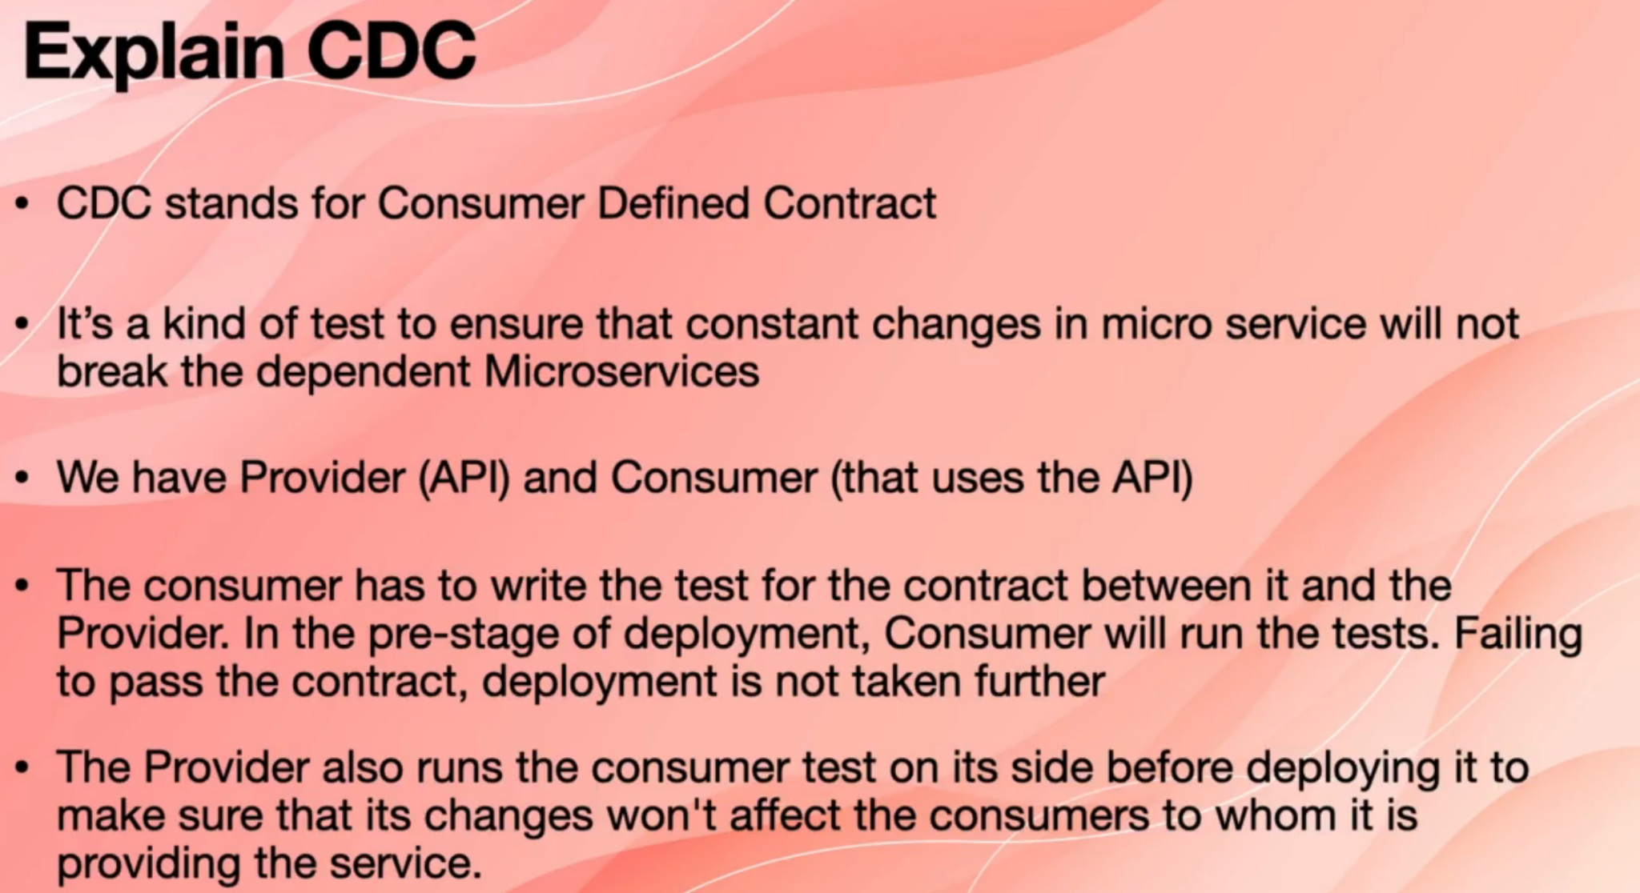

So in order to counteract that, we have a provider, which is the service that provides the API and we have a consumer that uses the API and the consumer has to write the test for that contract or the class, for example, that is between the consumer and the provider. And then in the pre stage of deployment, for example, in pre production environment or in our testing

environment, the consumer will run that test. If the test fails, then we know that the contract is not suitable and then we don't deploy. Also, the provider has to run the same test and again before we deploy to production in the pre-deployment production to make sure that their change is not going to break any of the underlain and downstream consumers.

**24. What are client certificates?**

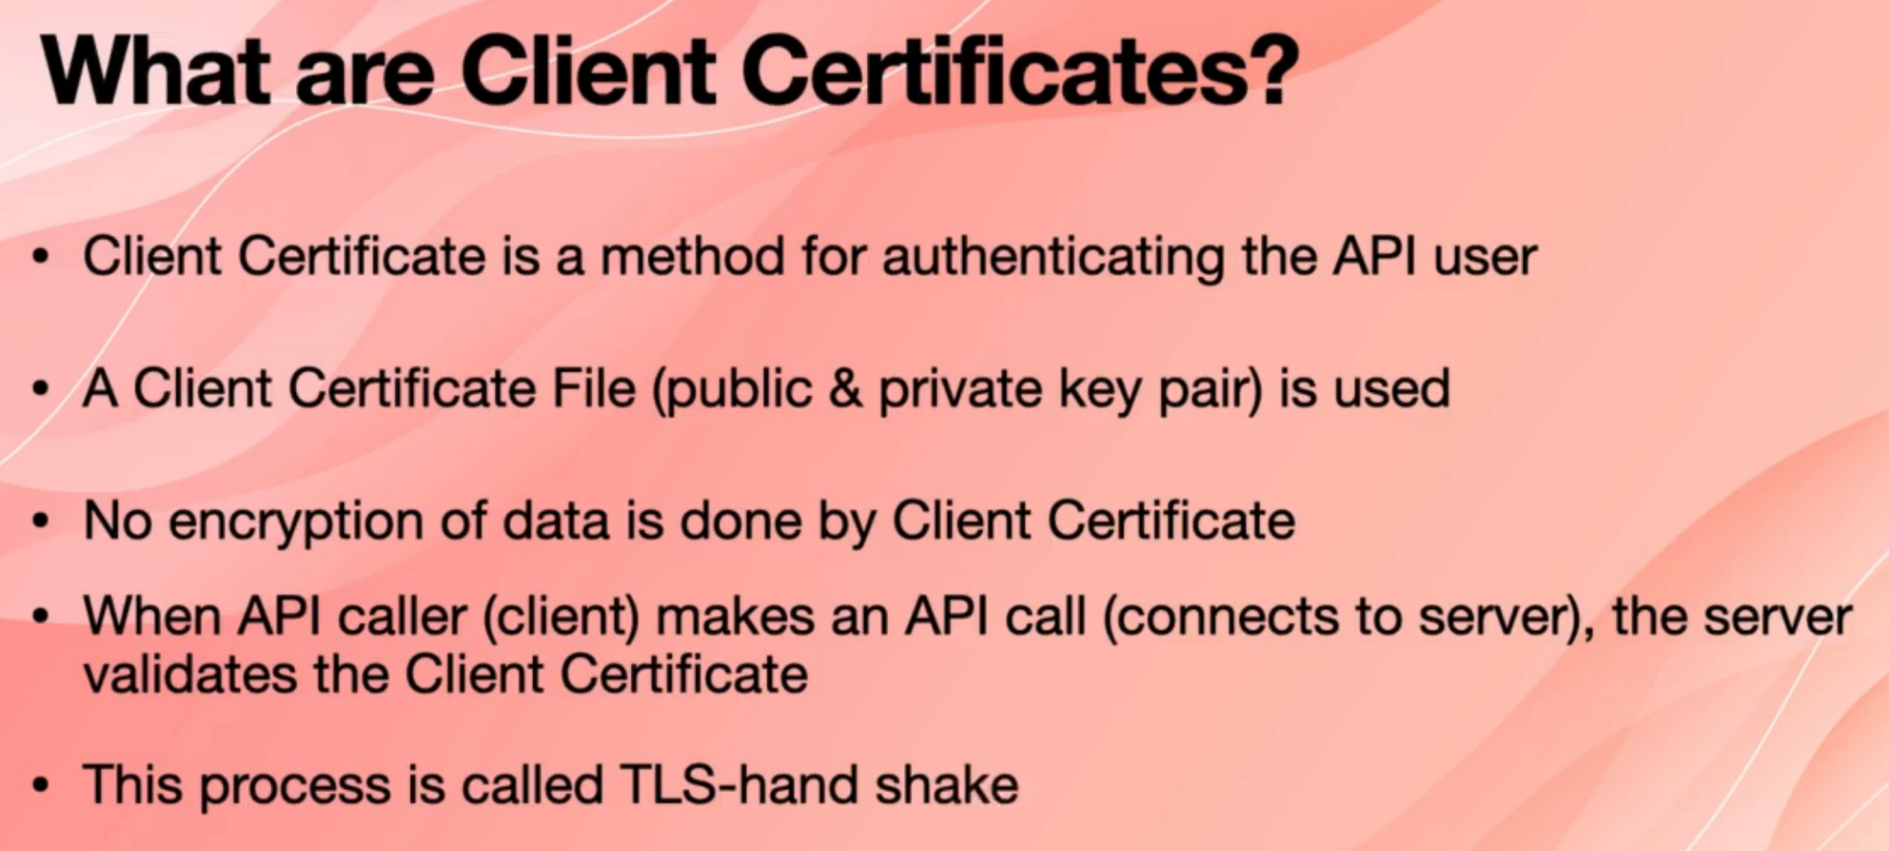

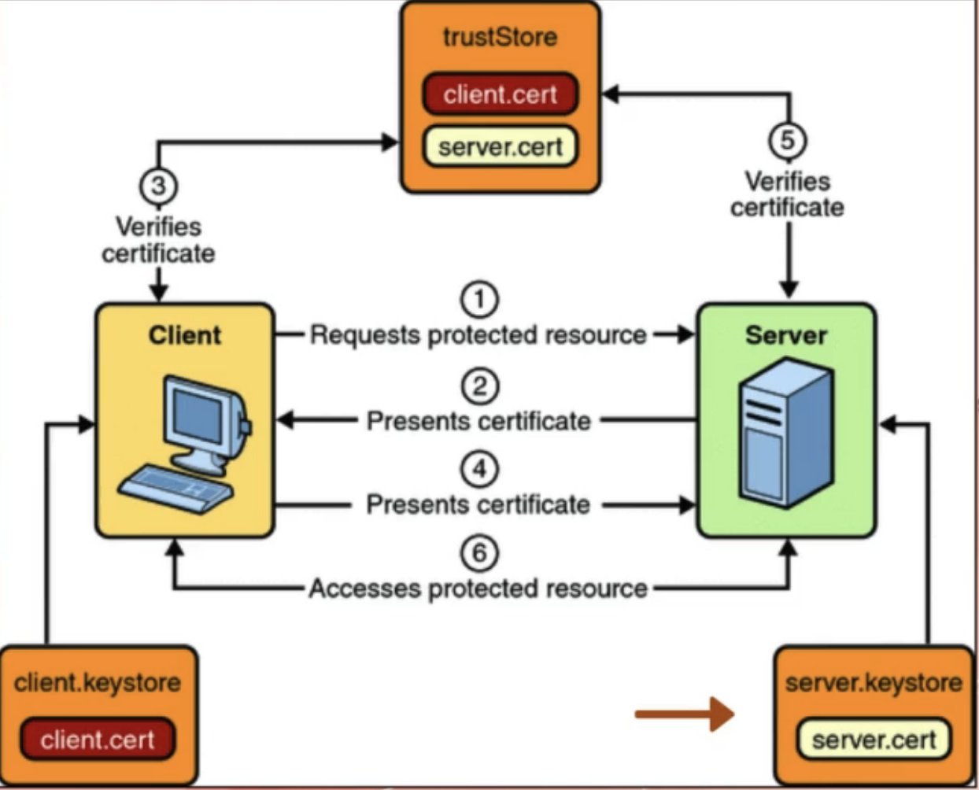

**25. What is semantic monitoring?**

What is semantic monitoring, so monitoring microservices is crucial because the entire system is broken down to the small, independent applications called microservices, and we have to make sure all those microservices work as expected so that the entire system also works. So to make sure that we have a good view and observability on the entire system.

There are two ways of monitoring the system.

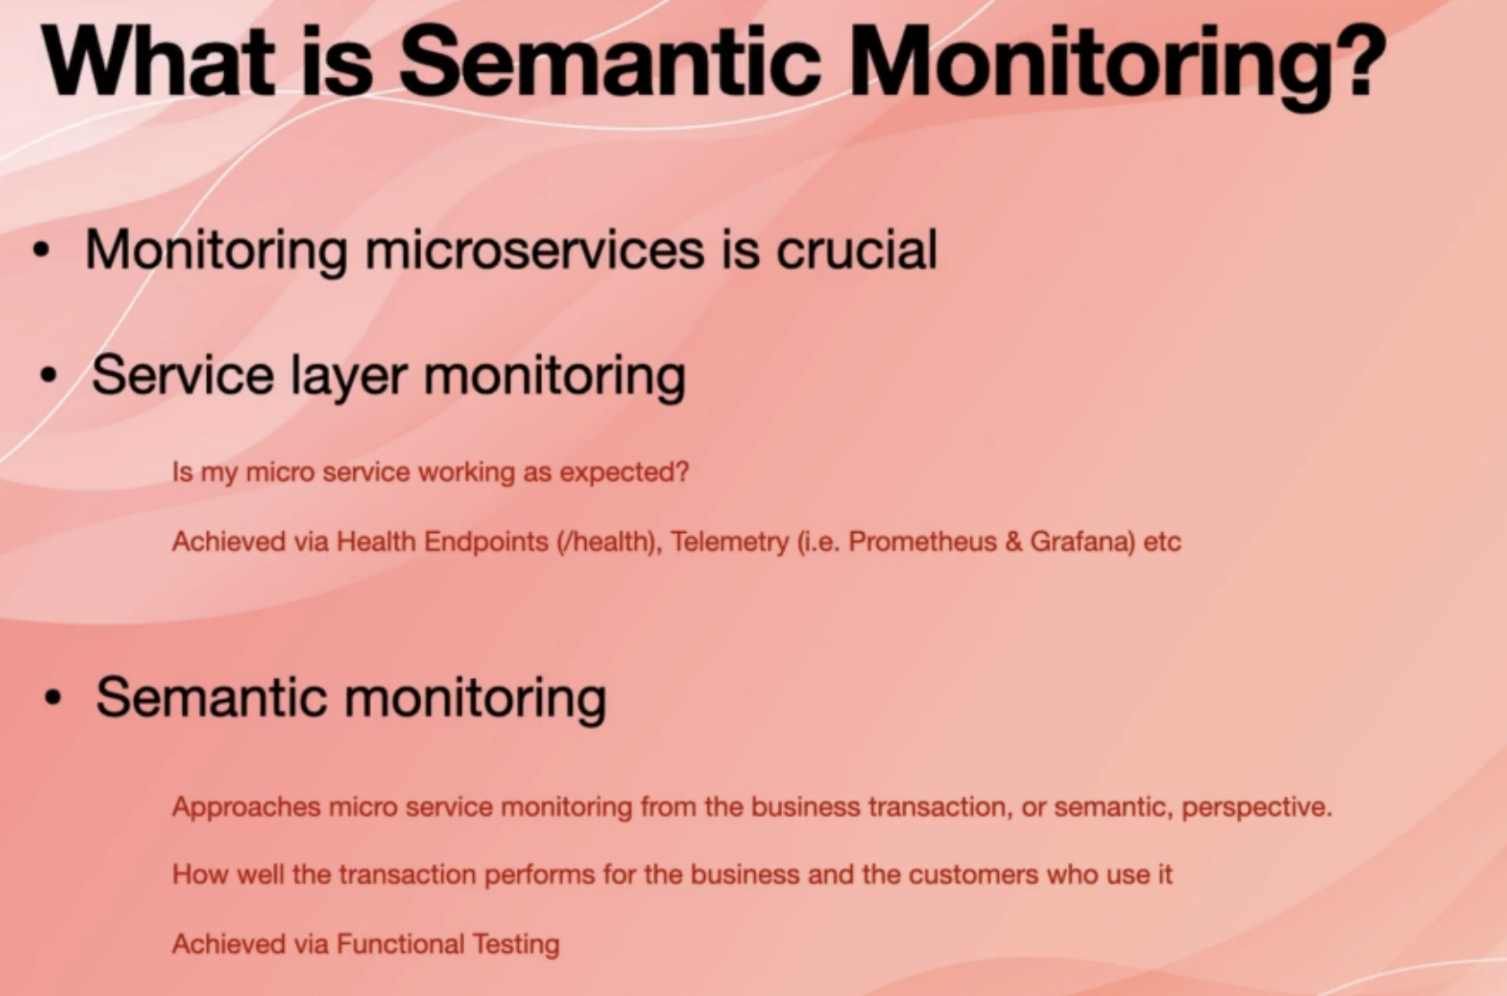

One of them is the service layer monitoring, and the other one is called semantic monitoring in service layer monitoring. Basically, we want to know if a given micro service is working as expected. Normally, this is achieved by your health endpoints.

Another way of doing the service layer monitoring is using telemetry, also known as collecting time series data, which can be achieved via systems such as Prometheus, which is a time series database and graphana, which is a visualization tool.

Semantic monitoring is basically approaching the problem from business perspective.

That is an entire system working as expected, not just one given micro service.

Is a business transaction working as expected.

For example, if I am a user or go to a website without knowing that what is behind this website, how many microservices are working together if I go the place on the order?

Does my order go through and is it fast enough? All that is called semantic monitoring and this is achieved via functional testing. So that's the difference. Service layer is more fine grained and it's done at the wrong time. Semantic monitoring is done via functional testing.

**26. What is idempotence?**

A function / api / operation is idempotent if it produces a single output even if it is called multiple times. An example is update api which will update resource in the same way even if you call it 100 times. Another example is post api which is NOT idempotent cause if you call it 2 times with same data it will create 2 resources.

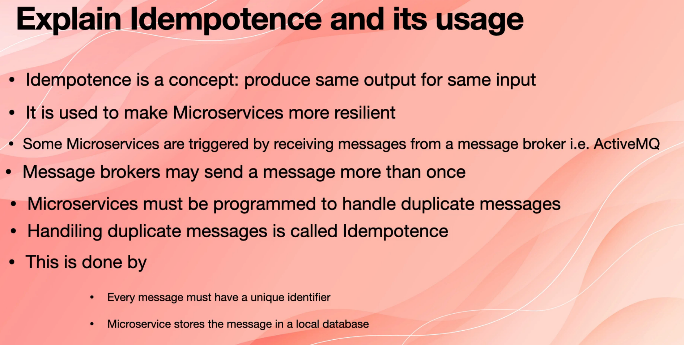

**27. Types of testing in microservices?**

This is not an exhaustive list, but some important testing.

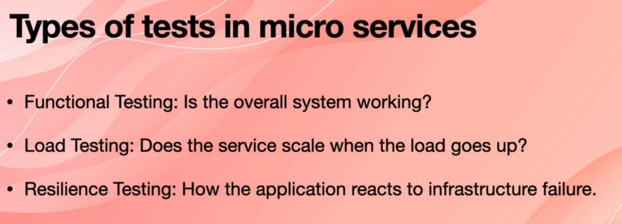

28. What is Mike Cohan’s testing pyramid?

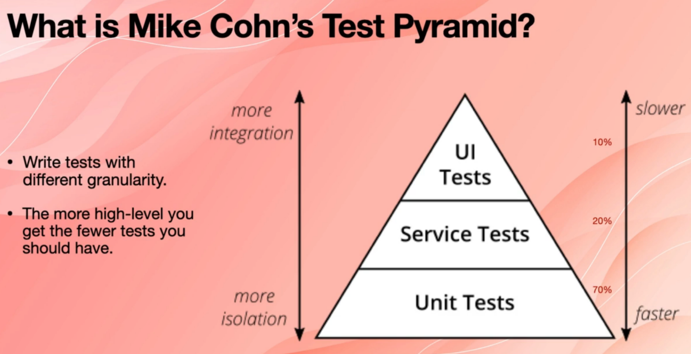

**29. What is a container?**

Container is a bundling and packaging of an application, for example, microservices and all its dependencies as a package that allows it to be deployed easily and consistently regardless of the environment.

So a developer can write a microservices and then create a Docker container that packages the application and everything that application needs to run, then deploy it to any other environment as it is, for example, a software that only runs on a Linux machine and uses MySQL using containers that can be deployed to a Windows server without having to install My SQL on that server. (Run once run any where)

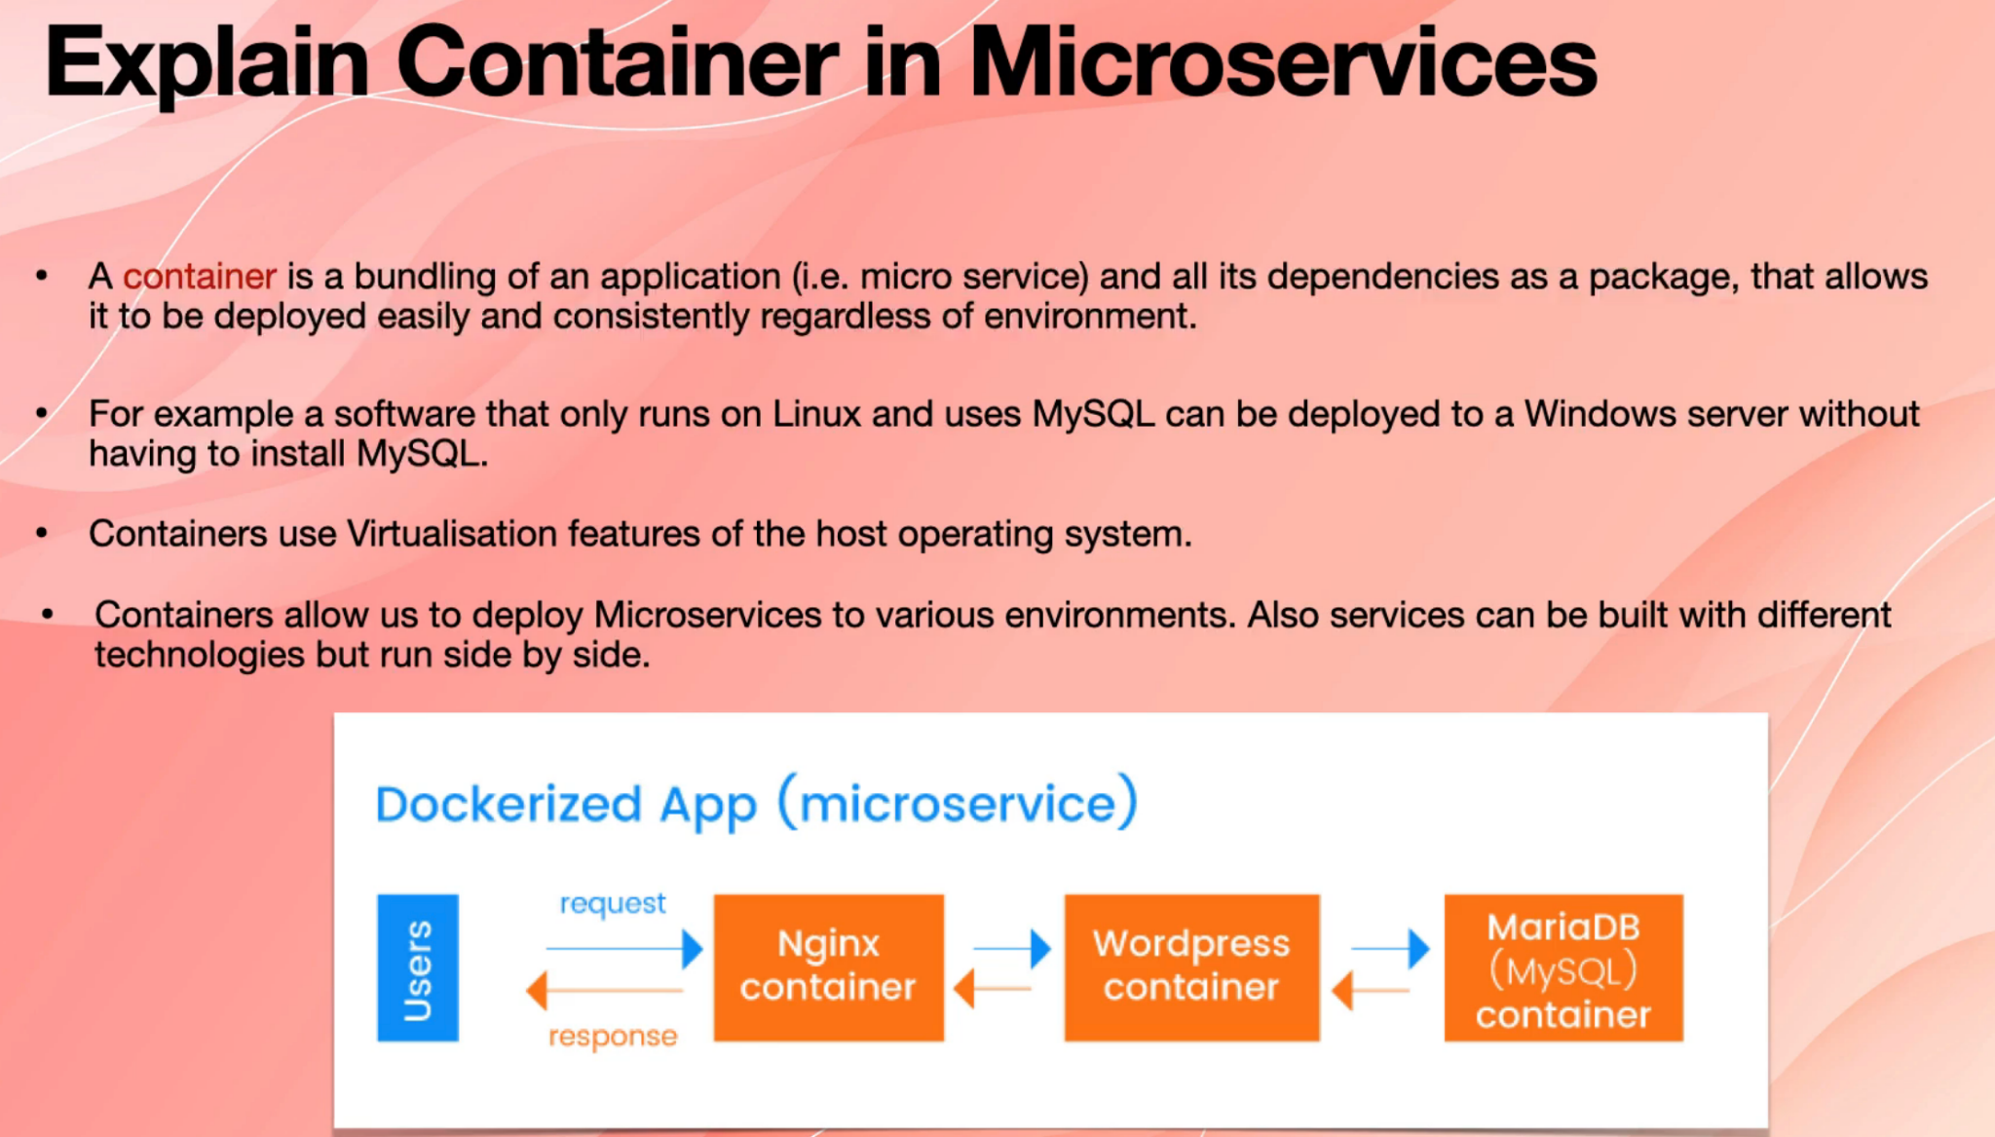

Containers use the virtualisation feature of the host operating system. So if you want to run containers on an operating system, that operating system must support virtualization.

For example, Windows 10 Home Edition doesn't support the virtualization feature, but the Windows Server and Windows 10 Pro. They do support virtualization feature, and you need this virtualization feature because you want to run an application that is built for a specific operating system in other operating systems as well.

Containers also allow us to deploy microservices to different environments just because, as I said, virtualization allows us to do it. Also, services can be built with different technologies, but to run side by side.

So again, one benefit of having containers is that because they are isolated, but they also have everything they need. You can build one microservices, for example, with .NET and other microservices to be Java and other microservices with Python.But then you build a container for each of those microservices and deploy them to the same machine without

having to install Java SDK or nets wrong time or python on that server.

So this is an example of a docerized app when we say Dockerized app, it's basically a containerised app. So in here, a user on the left side wants to access a WordPress, for example, website, and the WordPress uses MySQL. In this operating system imagine it is just like Windows we need a web server. We need WordPress, and we need My SQL.

So instead of installing WordPress on that operating system and installing my SQL on that operating system, what we do is that we deploy a container that includes NGINX . If you don't know what NGINX is, it's something like Apache or is something like I see in windows.

It just basically handles the web requests. So we deploy NGINX. We configure it to talk to the container of WordPress. And also we create a network between WordPress container and MySQL or maria db container. And then they talk to each other. They only talk to each other via their interfaces.

**30. What is the main role of docker in microservices?**

So we said that a container is basically a bundle and a package of an application or microservices with every other dependency that has to be shipped with that microservices.

So that package is called a **Docker image.** So one of the roles of docker here is creating that image or creating a darker image, which is packages, the application and all its dependencies to a binary file called the docker image.

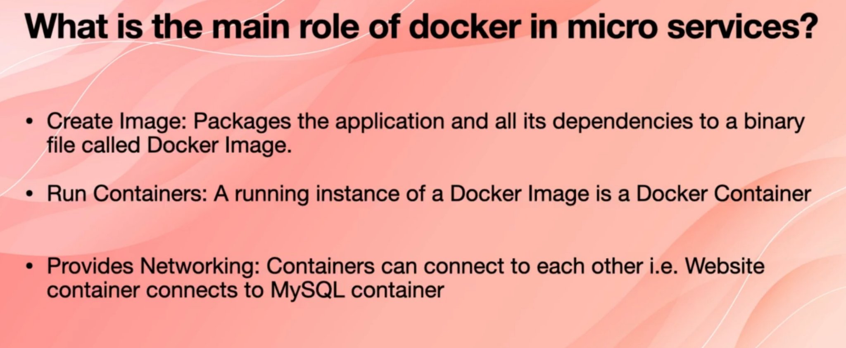

Docker also runs the containers. Running instance of a docker image is a **docker container** also provides networking so containers can connect to each other. For example, a website container can connect to a mysql container.

So there are three things that Docker does for us creating the Docker image, running the containers and providing networking between their two containers.

**31. How can you deploy a docker container?**

One way of deploying Docker containers is to deploy to machines or servers that have Docker desktop which has an application on them. This is normally just suitable for your local development, and you can run daycare on your desktop machine.

Another way is to deploy Docker containers through serverless container services, for example, in Amazon Web Services. There is a service called a AWS fargate with a farget you provided Docker image and then Amazon Web Services takes care of creating containers and creating networking and everything else.

The last way of deploying containers and this is the best way to my opinion, and the most common way of deploying containers is to deploy containers to a container orchestration service. For example, Kubernetes is one of these services.

They provide networking, monitoring, logging, access control and all the other cross-cutting concerns, and they act as a chassis for their containerised microservices.

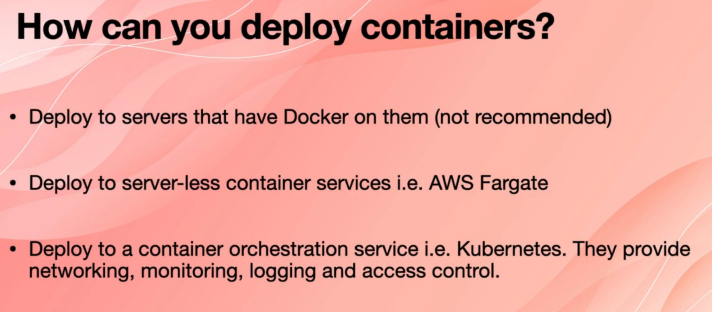

**32. What is Restful API?**

An API stands for application programming interface and it provides an abstraction of how the client should reach out to the server. Rest API in addition to this contract provides a set of rules that define how applications or devices connect and communicate with each other.

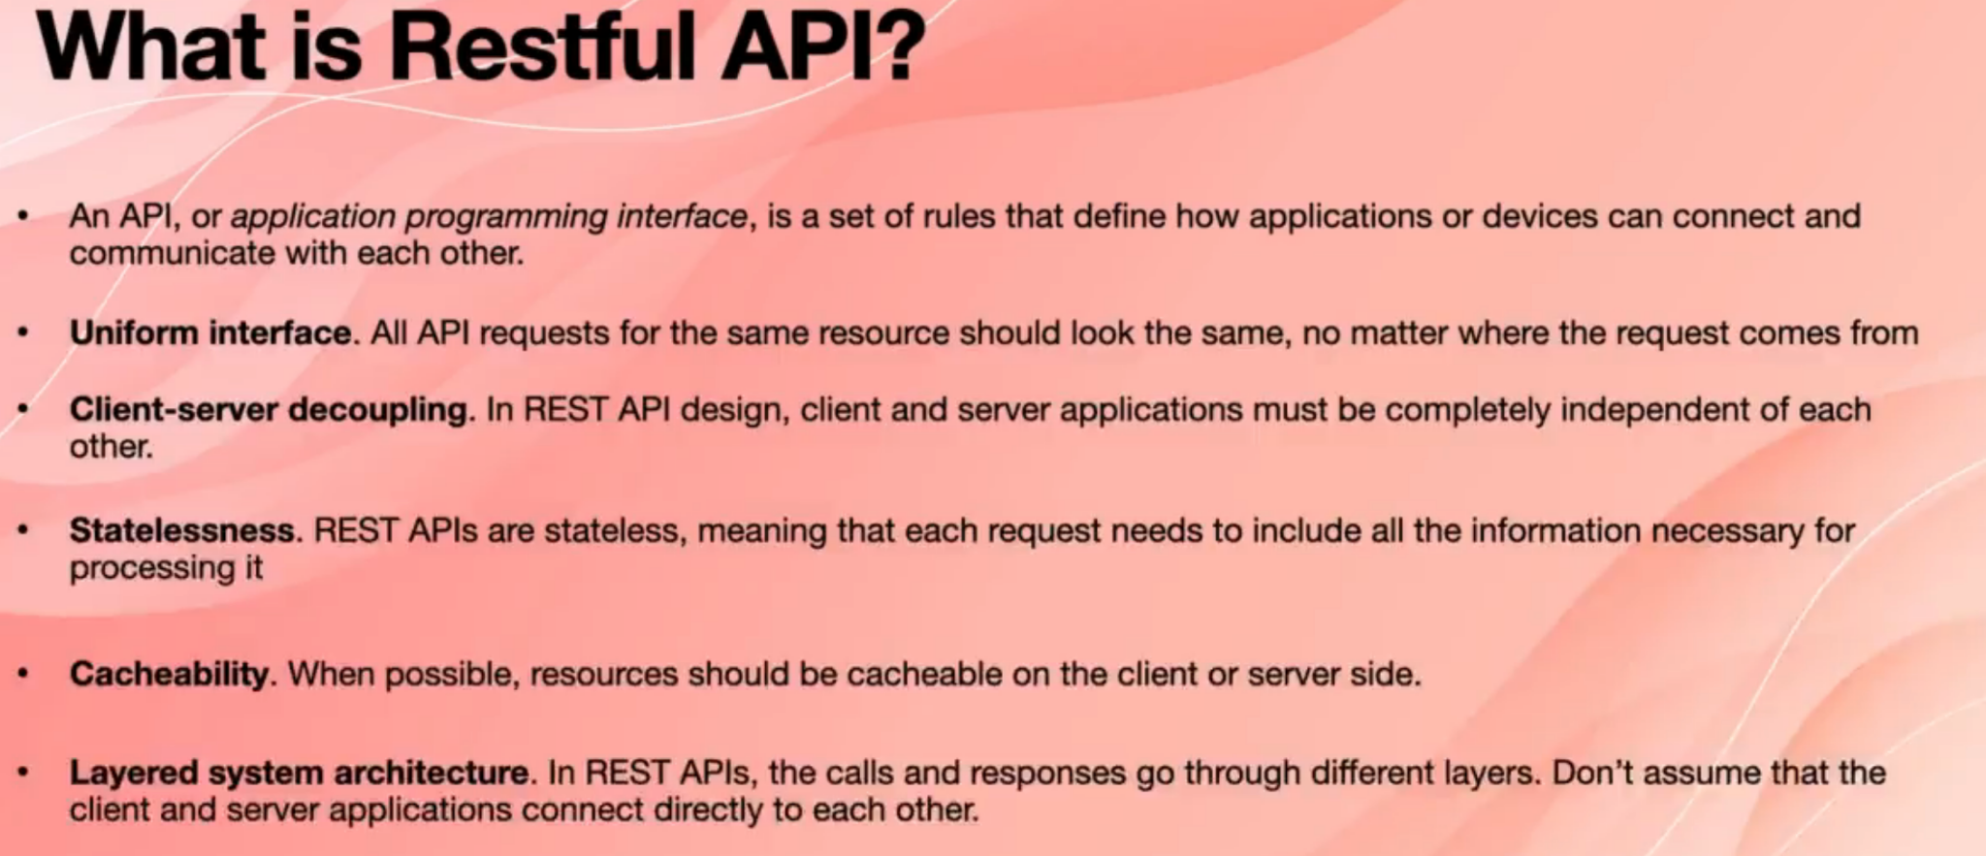

In Rest API all APIs are designed around resources. All the API requests for the same resource should look the same no matter where the request comes from, and this is called uniform interface client server decoupling. Eg to create/read/update/delete an employee use /employee, the API will differ in the verbs(Get/Post/Put/Patch) used for an operation

When you design a rest API client has said about applications and must be completely independent of each other, there should be no interconnectivity or entire dependency between them is stateless. Rest APIs are stateless, which means that every single request needs to include all the information necessary for processing it.

The rest API call has all the information that is needed for cacheability.When possible, resources should be capable on the client side or server side and layered system architecture in rest APIs they call and responses go through different layers.

Don't assume that the client and server applications connect directly to each other. Sometimes, in order to reach to the server or to the actual API, you have to go through some layers for eg. security, caching etc.

33. What are the ways to test microservice application?

Again, this is not exhaustive list.

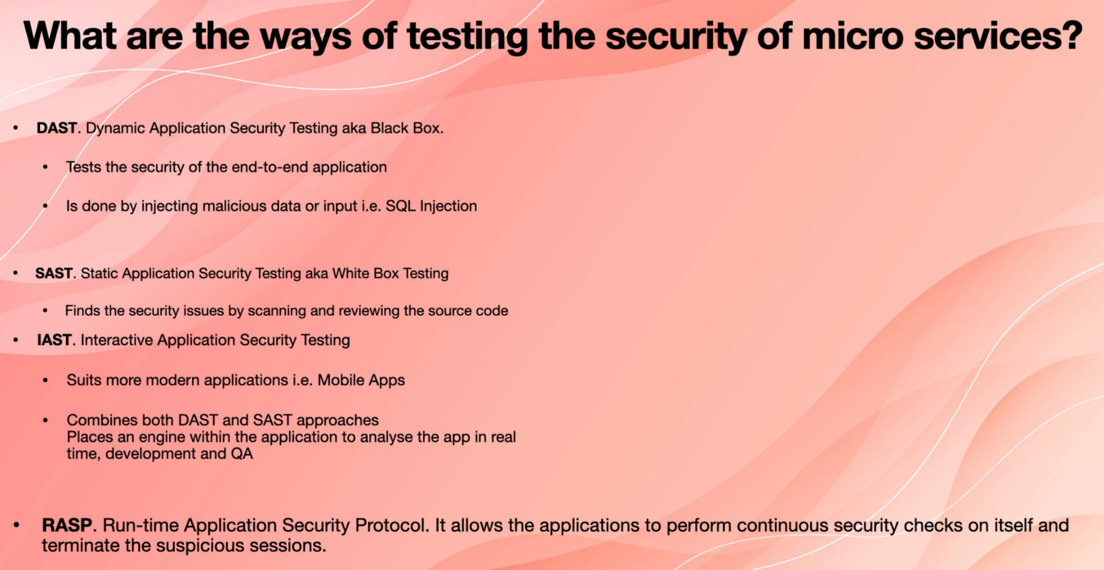

**34. Explain a scaling cube.**

Scaling Cube explains the three different ways that we can scale our application

when we say scale.We basically are talking about handling more load and more stress.

So in the scaling cube, we have an x axis, which means that you just add more resources.

For example, you add more servers. If you use Amazon Web Services, you know that there is a concept called auto scaling group, which means that as the load goes up, in other words, as the CPU and memory usage of those servers go up, if they reach a certain threshold, it adds more servers to that auto scaling group and that is part of the x axis scaling.

We also have a y axis in y axis. In this, we split the system by functions. Basically, if you think of every microservices as one function y axis allows us to scale every microservices

in a different way, y axis enables us to scale every microservices individually. So instead of scaling the entire system just because one of the microservices is coping with more load,

we are wasting resources. So by breaking down the entire system to individual functions or, in our case, to individual microservices, every micro service can scale independently.

We also have Z or z axis, which is basically a partitioning. For example, we can say handle the customer of each country by a different set of microservices. These microservices can be deployed to a region or in their country that is closer to their customer.

This is an image that explains the scaling cube.

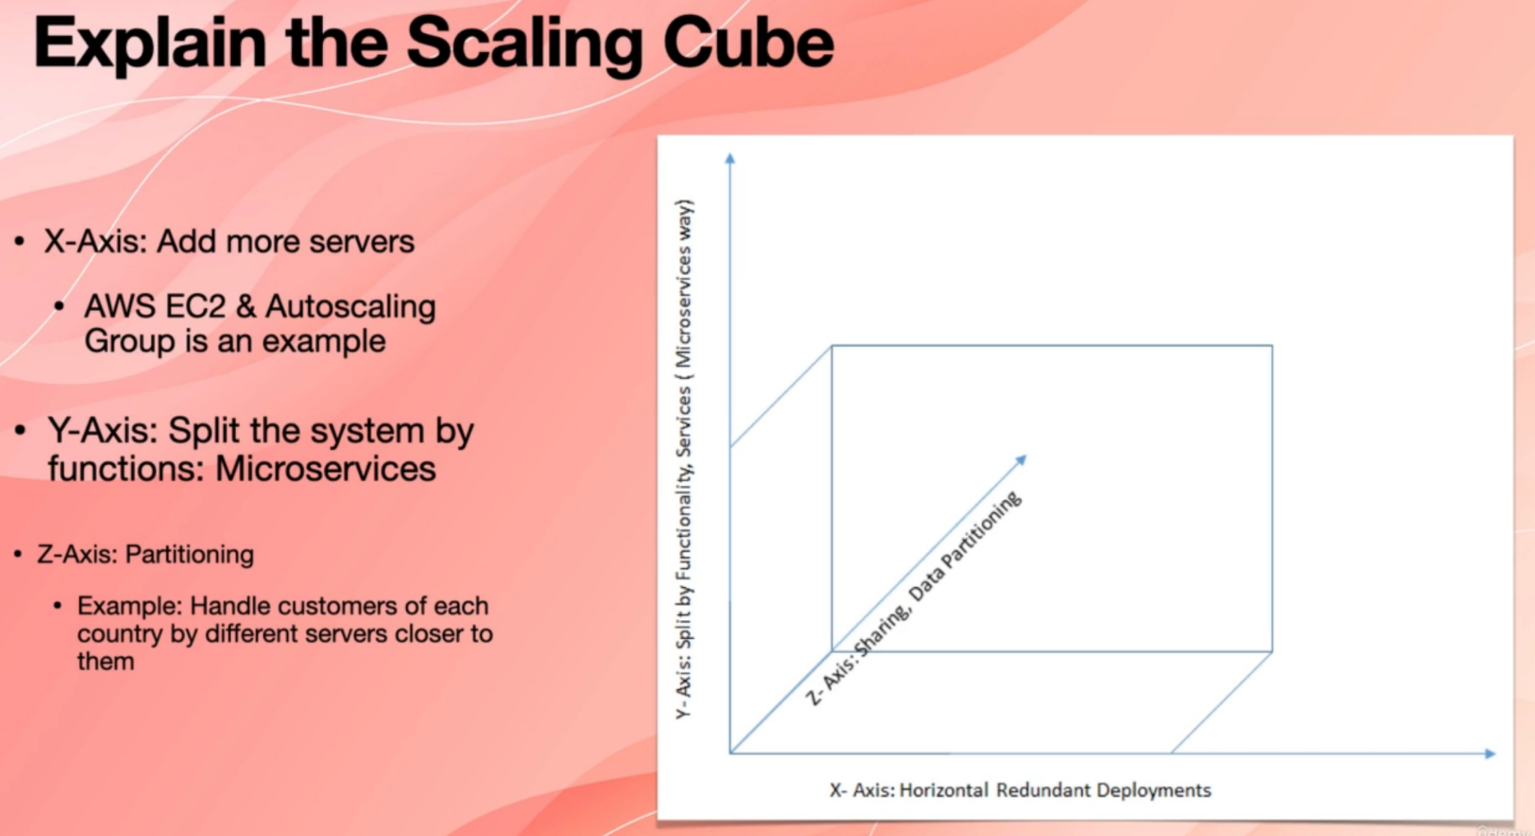

So in x axis, we are just deploying more resources, which is also equal to cloning the existing servers, for example, or adding more containers in y axis. We split the system by functions and services, which is the microservice way, and that is why understanding

scaling cube is important. And in that axis we use sharing data partitioning, sharding and those mechanisms.

**35. What is Data Offloading?**

Microservices normally run in virtual machines, for example, they are stuck at containers running in a virtual machine, or they are just applications running in a virtual machine, for example in Amazon Web Services or in Azure. And therefore, because virtual machines and containers are not stable.Microservices can appear and disappear. It may just come to life and it may get terminated because we scale out.

This means that microservices must not store any data in their local storage or in their memory data, such as state or session data, because when their container or virtual machine gets deleted, all that data also gets deleted. Instead, microservices must store all the data that they have locally, such as a state and session data in a shared database. And one of those shared databases is a Redis, which is very common.

So this is an example.

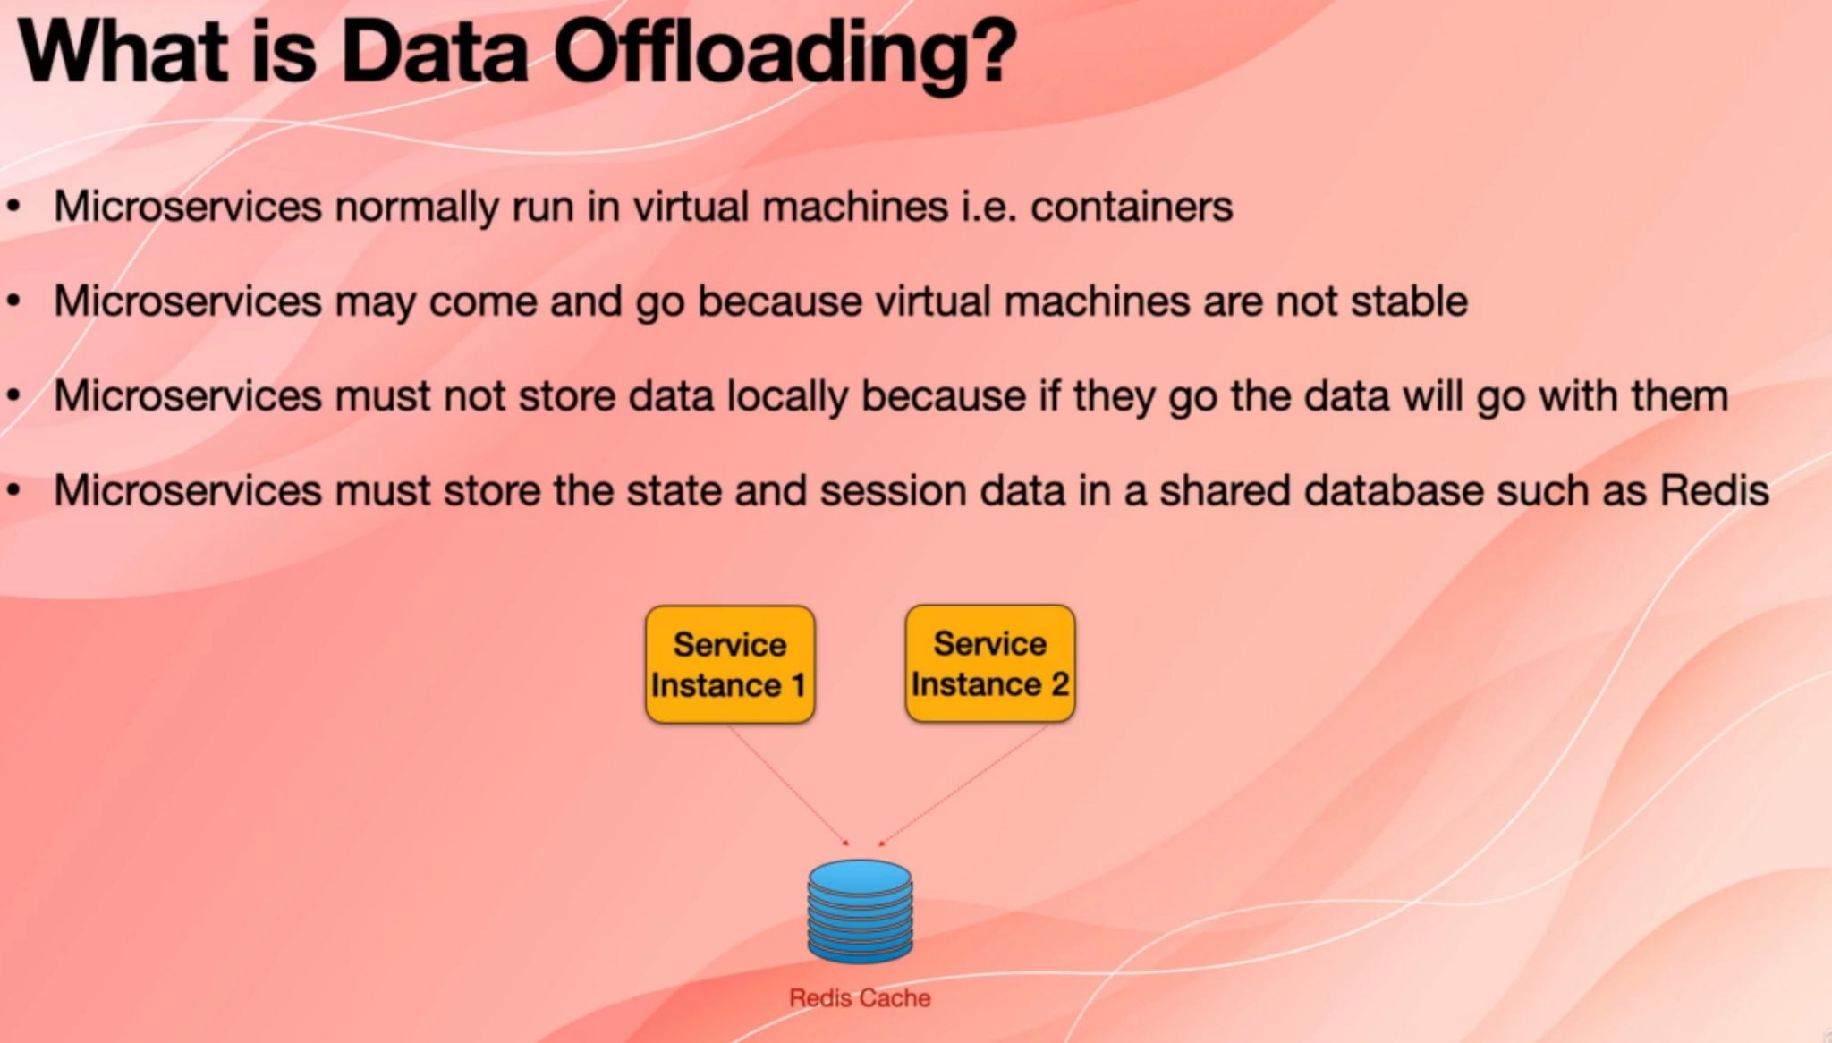

So there is one microservices, but we have two instances of that microservices service instance. One is one instance and service instance. There is another clone or a copy of that same microservices. So instead of maintaining the data and information in their own memory, they put everything in this case. Registration is available as a cloud service, or it also is available in eight years and in Azure as their managed service, you can use it.

In this case, what happens is that if service instance two just gets terminated, data is in Redis and the service instance one can still use that data.

**36. Explain CQRS pattern.**

CQRS stands for command query responsibility segregation. So we said that every micro service has its own database. Microservices do not share databases. Now the problem that it causes is that because every microservices has its own database and it doesn't have access to the database of other microservices, it is really not possible to run a SQL query

across multiple tables in multiple domains.

Now, to support this and to fix this problem, a new micro service is created that needs to run the SQL query to maintain a view of the data. It needs to execute the query so it has a table or a small database that includes data from other microservices that we need in order to run our SQL query on it now to generate that database or table, and to keep that view database up to date.

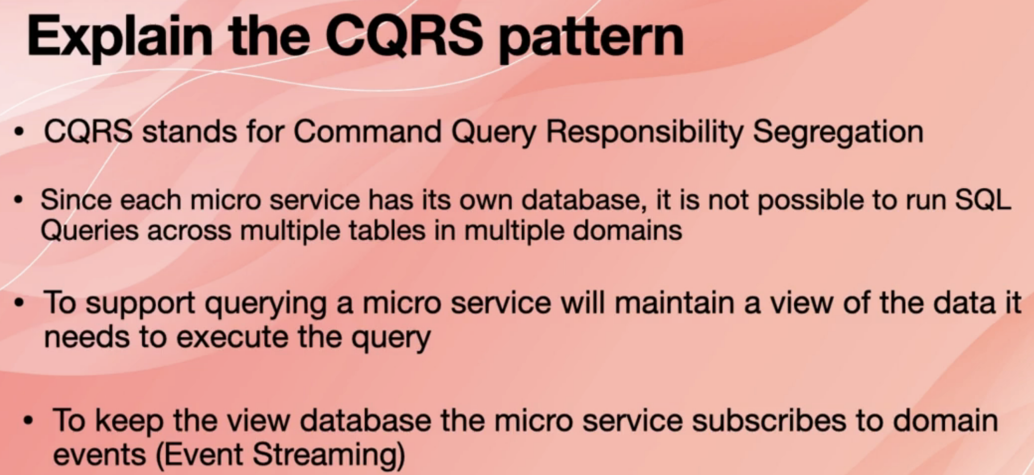

The microservices subscribes to domain events via event streaming. Now, if you want to get that information and use that to update your database, your microservices simply subscribes to those events.

So we have all the microservices, we have kitchen services, we have delivery service, we have accounting service. Now we want to have history of all the orders and what happens to them. So Order History Service subscribes to the events generated by ordering kitchen delivery and accounting microservices. And then when the events are received, it generates order history, view database and then puts their information in that database.

Now, if you want to run their queries, such as find order or find order history, the order history

service simply queries that database to quickly retrieve the data and then use it.

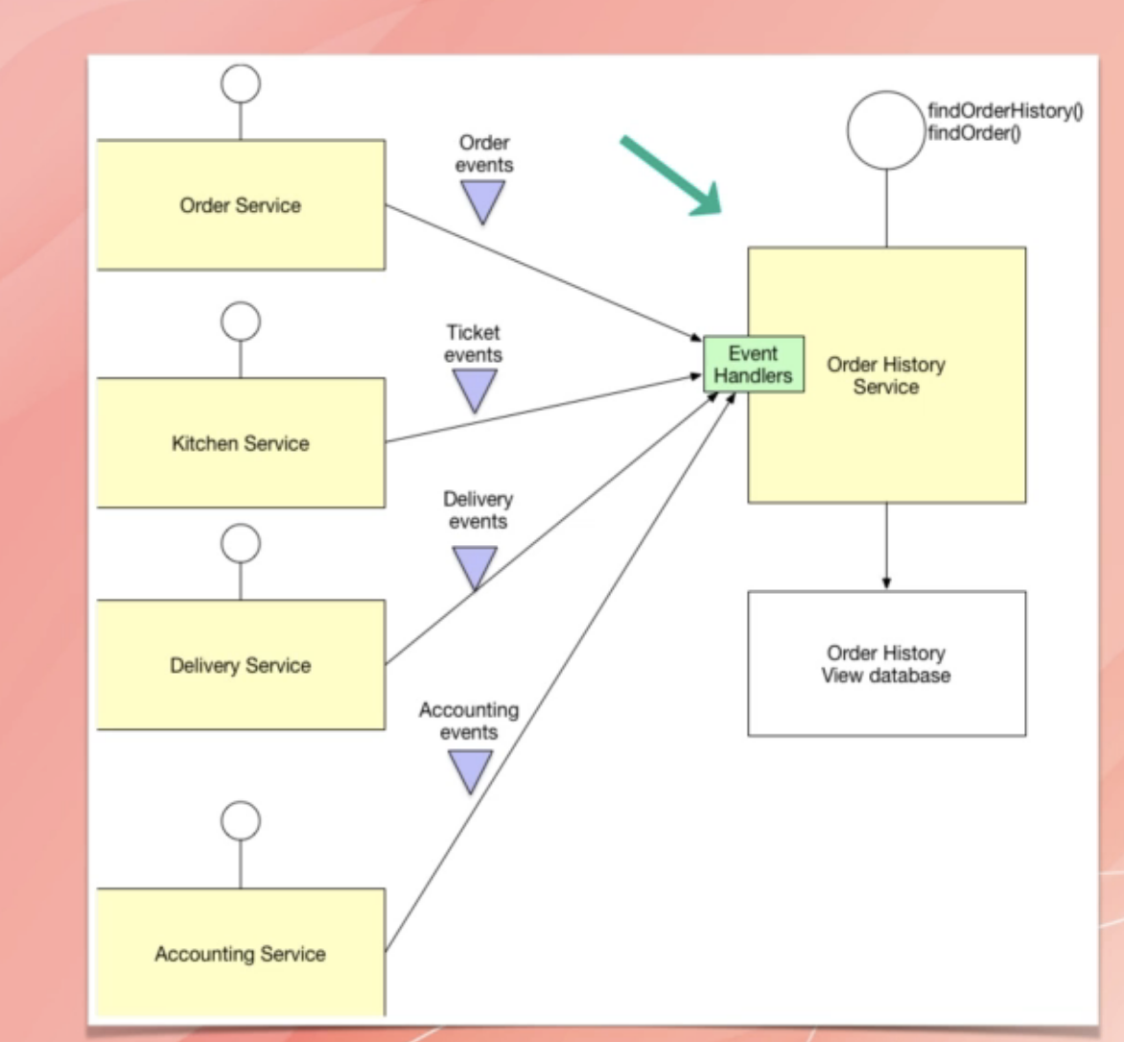

**37. Explain API gateway pattern.**

API Gateway helps their clients, for example, mobile applications connect to microservices in this diagram.

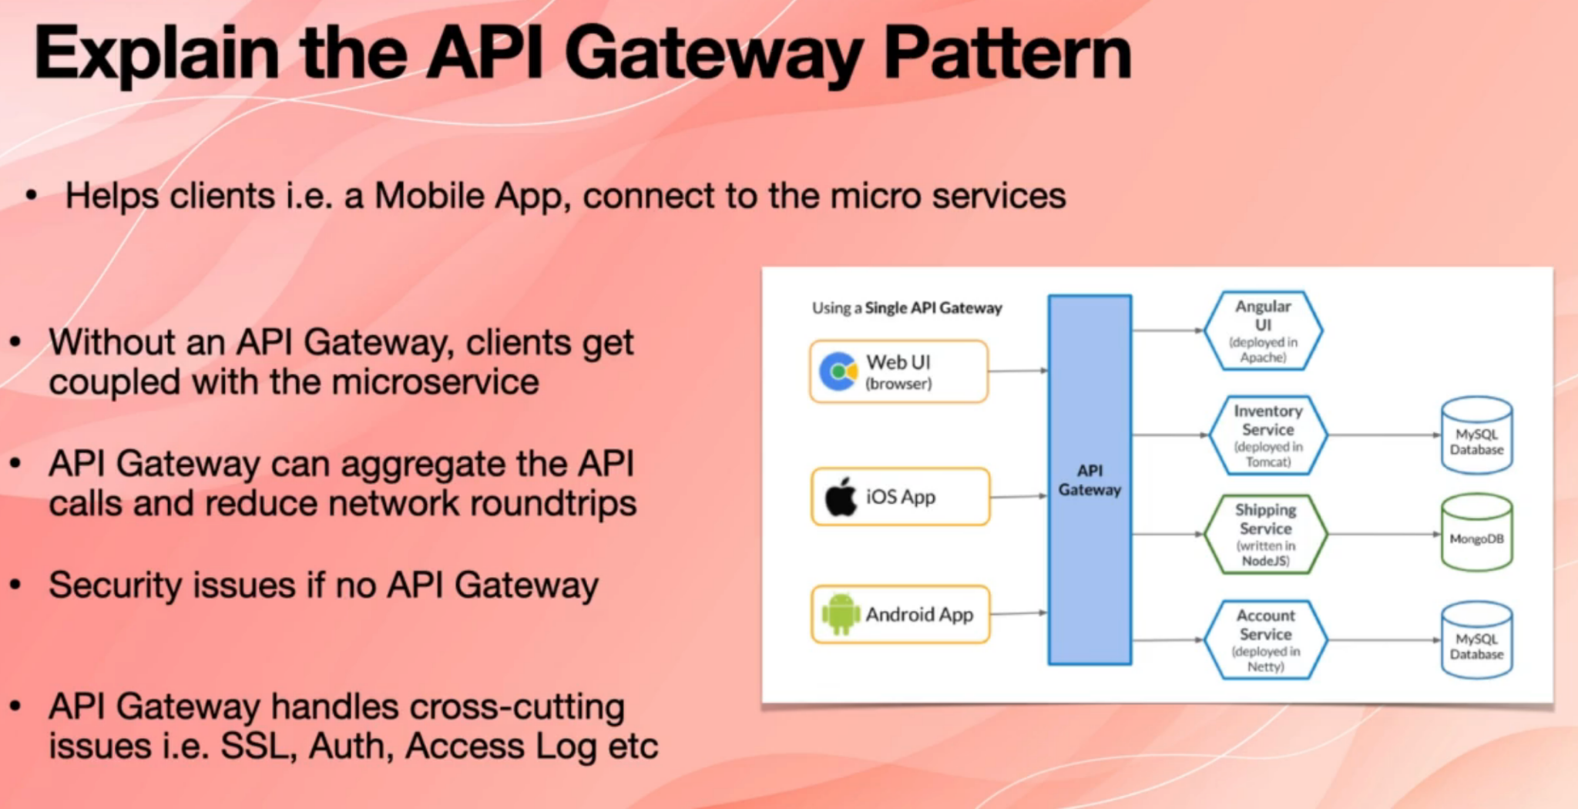

On the left side, we have the clients, for example, a web user interface that is running in their

web browser and iOS app, and an Android app. They are trying to access the microservices.

They go through API Gateway in order to access the microservices. If the API Gateway wasn't there, then the clients would get coupled with the microservices.

So if you would change any of those microservices with something else, you would have to update your UI. The client, for example, your IOS app would also break API.

Gateway also can aggregate the API calls and reduce the network roundtrip. For example, say that Android app wants to make a call to account service and a call to a shipping service and a call to inventory service to find out, for example, what happened to a shipment without

the API gateway, the Android app would have to make three API calls, but with API Gateway, we can make one API call to API Gateway and API gateways normally have this feature that they make the three calls for you, and then they combine the results and then return the result. And with this, you basically saved the traffic or the network round trips.

If we didn't have an API gateway, we would have security problems or every microservices would have to take care of security, for example, authentication. Whereas with API Gateway, you implement authentication only once at the API gateway level. Some API gateways have logic and smart for understanding the attacks for malicious API calls and that type of things as well. And then they protect the microservices.

API gateways also handle the cross-cutting issue is, for example, SSL connection authentication, access log and that type of things.

38. Explain event sourcing. [Pending]

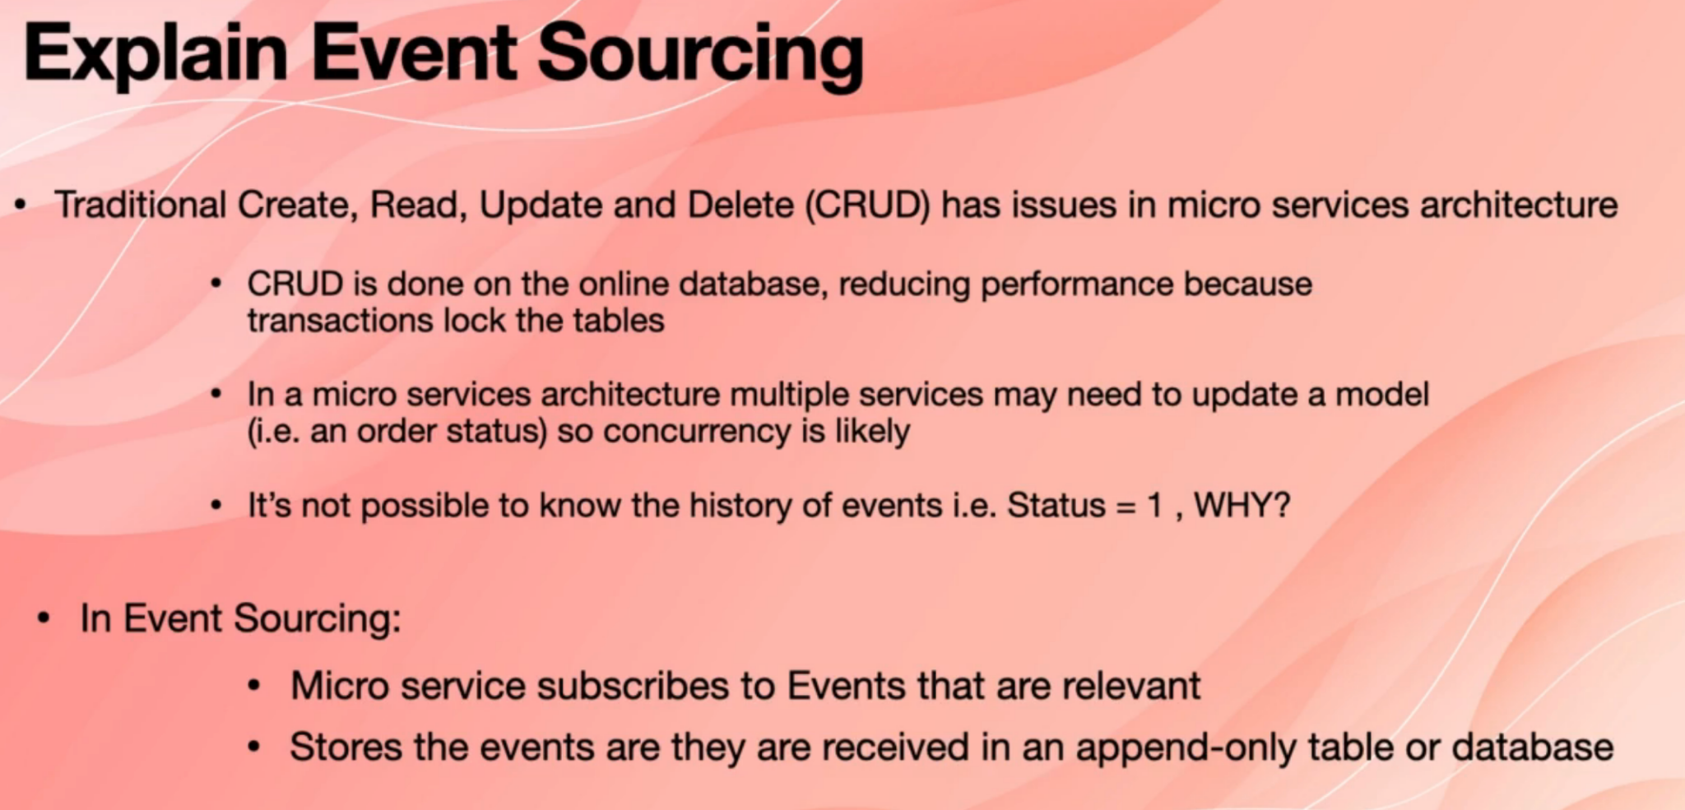

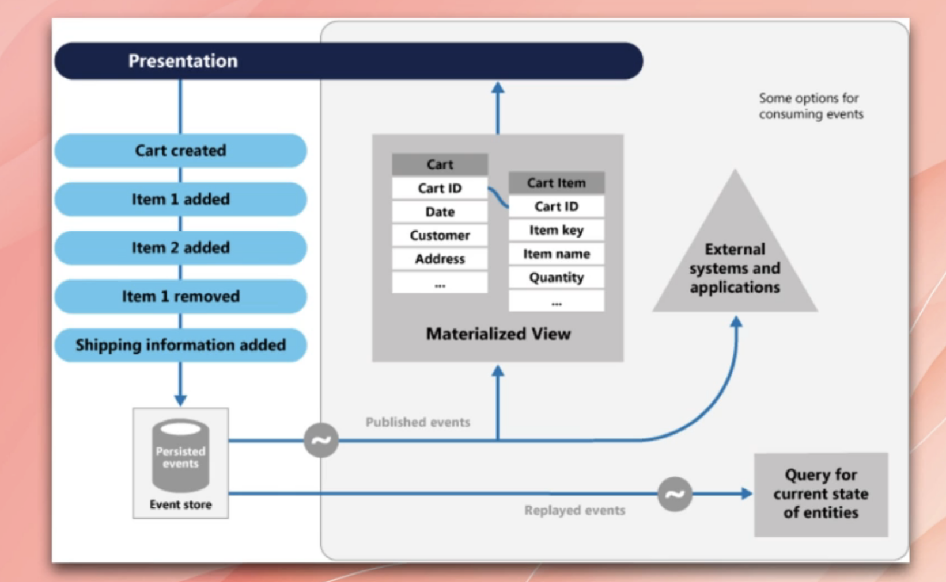

**39. Explain strangler application.** [Pending]

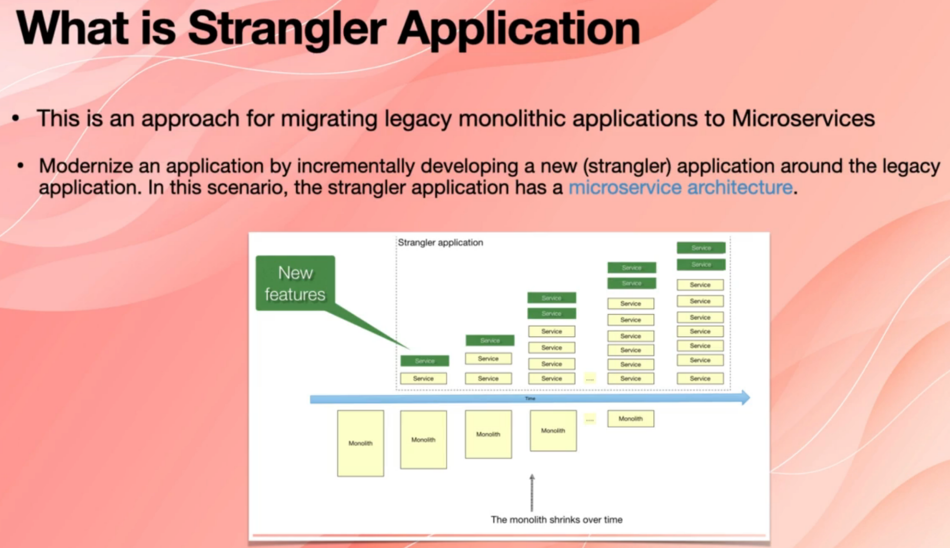

**40. What is API composition.** [Pending]

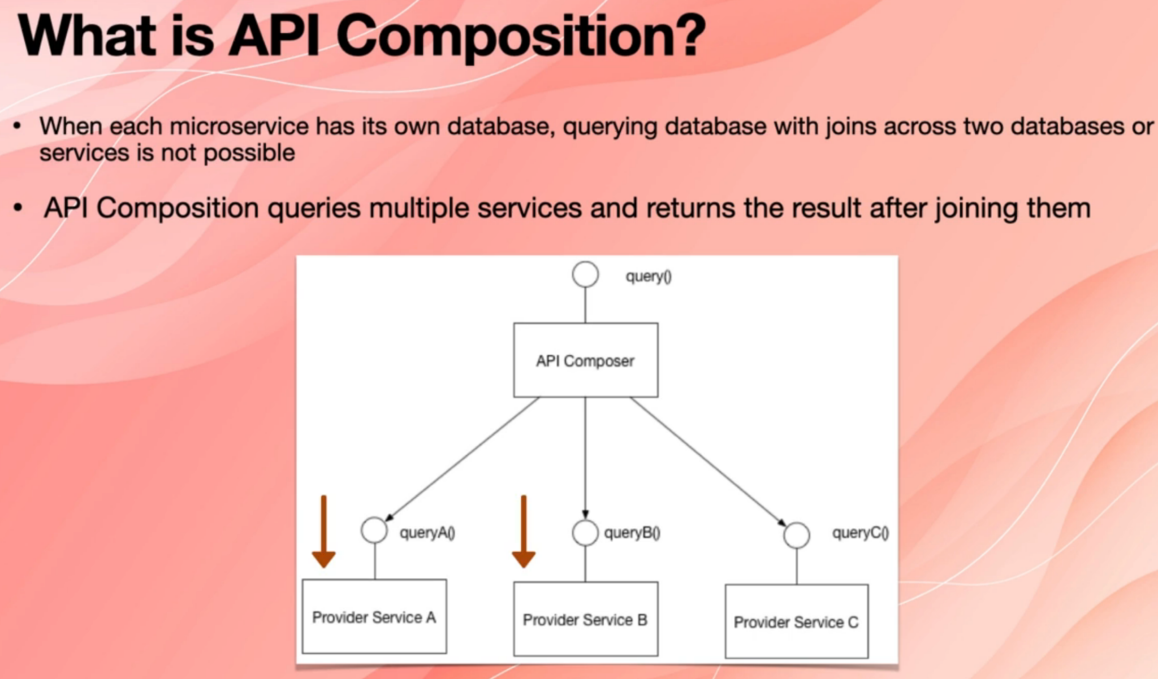

**41. What is cross cutting concerns?** [Pending]

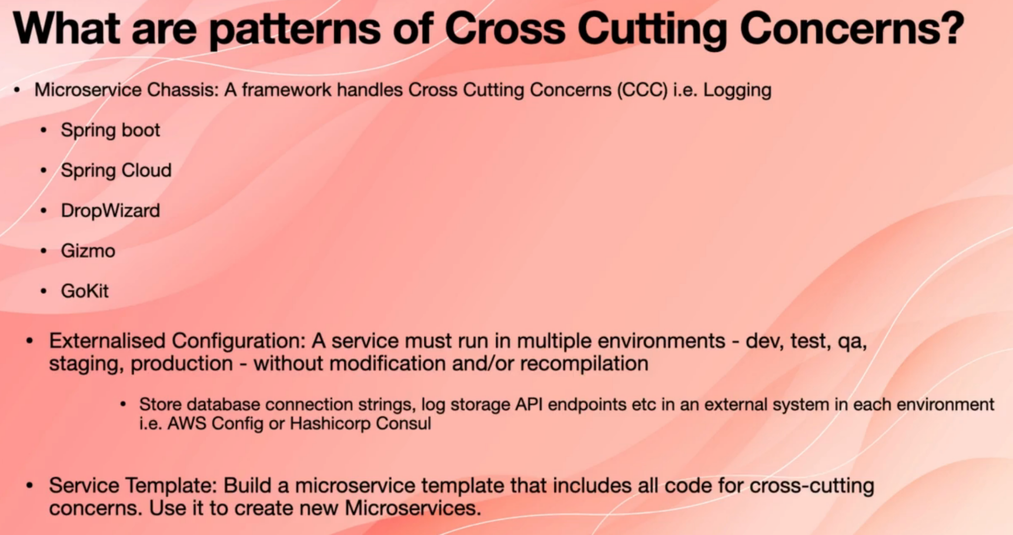

**42. What is transactional outbox?** [Pending]

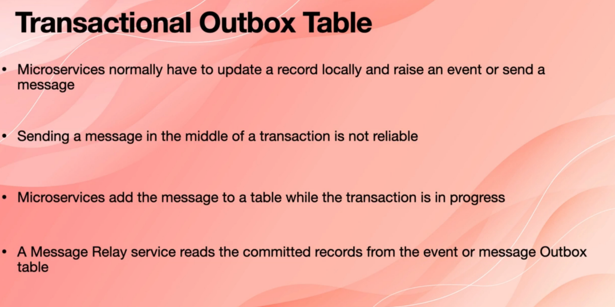

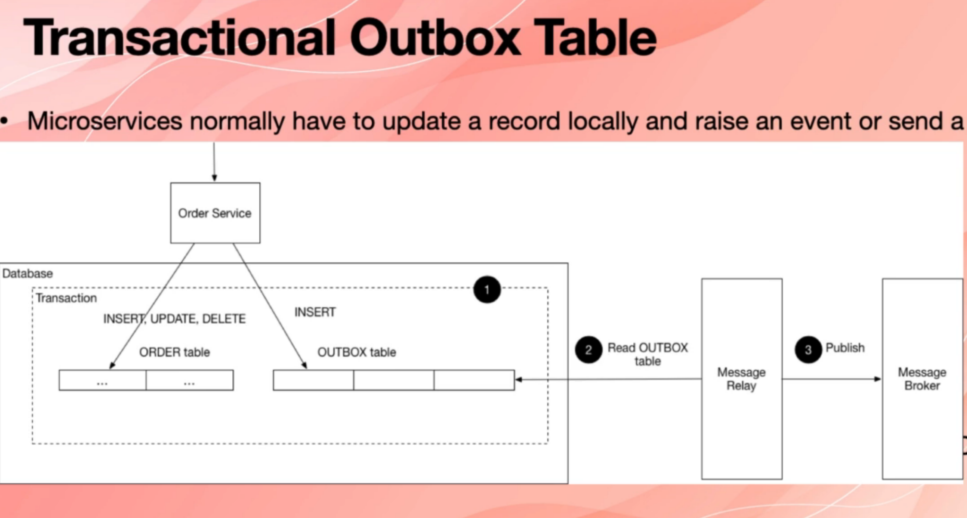

43. What do you mean by micro and macro architecture decision?

Microservices provide much better decoupling. Therefore, they help to modularize and isolate software modules (see Advantages). However, microservices are modules of a larger system. Therefore, they must be integrated. This poses a challenge for the architecture:

On the one hand, the architecture has to ensure that the microservices can work together to form the overall system.

On the other hand, the freedom of the microservices should not be too restricted since this would compromise their isolation and independence which are required for most of the benefits of a microservice architecture.

For this reason, it is advisable to divide the architecture into a micro and a macro architecture.

The micro architecture comprises all decisions that can be made individually for each microservice.

The macro architecture consists of all decisions that can be made at a global level and apply to all microservices.

The following table shows the typical micro and macro architecture decisions:

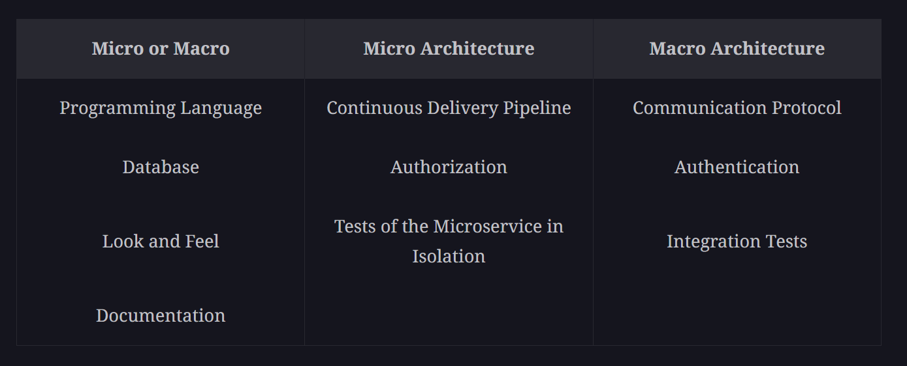

More details available on educative course.

Q. What are NFRs?